Sulphur Dioxide is used in wine (and other drinks) as a preservative to inhibit bacterial and fungal growth. Although not present in concentrations that will affect the general populace, the level of sulphur dioxide can affect sensitive individuals

Determining the SO₂ concentration
The SO₂ content is determined via the following redox titration using starch as indicator:
SO₂ (aq) + I₂(aq) + 2H₂O (l) 4H⁺ (aq) + SO₄²⁻ (aq) + 2I⁻ (aq)
If a standard iodine solution is added to a sample of wine, the iodine will react with the SO₂.
When all of the SO₂ has reacted, the iodine will react with the starch to give a blue-black colour. This is the end-point.
The concentration of SO₂ can be calculated since 1 mole of iodine reacts with 1 mole of SO₂.

You will analyse for 2 types of SO₂: (A) Free SO₂ (B) Total SO₂ (free + combined)
(A) Free SO₂
- Pipette 25cm³ of wine/cider into a 250cm³ conical flask.
- Add 5cm³ of 2 moll⁻¹ sulphuric acid.
- Add 2cm³ of starch solution (1%)
- Titrate the solution with 0.001moll⁻¹ iodine solution. The end point is the appearance of the blue-black colour which persists for ~ 2mins.
- Repeat until concordant results are obtained.
- Use your results to calculate the number of moles of SO₂ present in 25cm³ of wine/cider. Convert this into ppm so that you can compare your results to your research.

(B) Total SO₂ (free and combined)
1. Add 25cm³ of 1 moll⁻¹ NaOH into a 250cm³ conical flask using a measuring cylinder.
2. Pipette 25cm³ of wine/cider into the flask.
3. Shake the flask and let it stand for ~15minutes.
4. Add 10cm³ of 2 moll⁻¹ sulphuric acid and 2cm³ of starch.
5. Titrate with 0.005 moll⁻¹iodine as before.
6. Repeat until concordant results are obtained.
7. Use your results to calculate the number of moles of SO₂ present in 25cm³ of wine/cider. Convert this into ppm so that you can compare your results to your research.
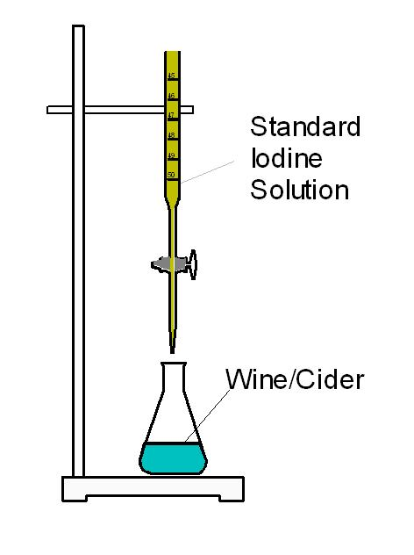
Tips
You may find some trouble seeing the end point. If so, try using a more concentrated starch solution to give a darker final colour.
It also helps to have a reference flask/beaker next to the sample your iodine is running into, containing a sample of your wine/cider with acid and starch.

Converting to ppm
1mg per l = 1ppm

