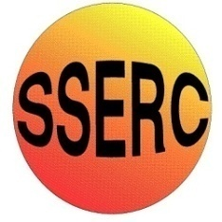

Chemical Demonstrations
Oxidation states of Manganese

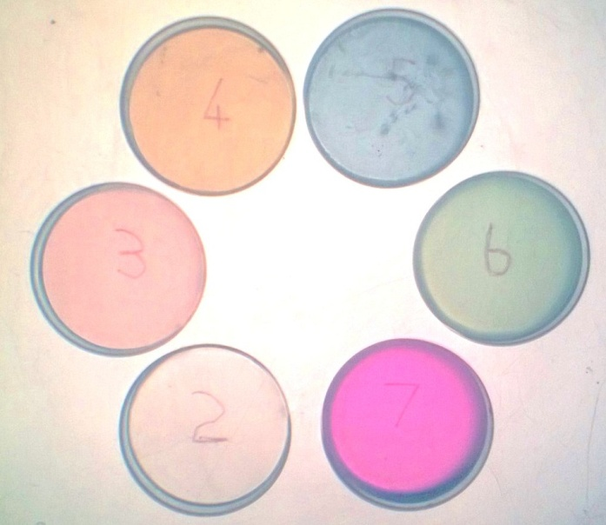
Advanced Higher (CfE) –
Inorganic and Physical Chemistry
Oxidation states of transition metals

Oxidation States of Manganese
In its compounds manganese exhibits oxidation states from +2 to +7. The common oxidation states are +2, +4, and +7, but the less common +3, +5, and +6 states are easily prepared. Since the colours of the six oxidation states are all different, showing them on an overhead projector makes for a colourful display – alternatively using a visualiser against a white background works well
You will need
An OHP/visualiser | 6 small petri dishes (or beakers or other containers that will fit.
MnSO₄ solution 20g per l00 ^{cm3} (1.18 M) (using the 1.H₂O form) | KMnO₄ solution 0.02g per l00 cm³ (0.00125 M)
Na₂SO₃ solution 2g per 100 ^{cm3} (0.07 M) (using the 10.H₂O form) | 6 M H₂S0₄ (33 cm³ conc. H₂S0₄ per 100 cm³)
6M NaOH (24g per l00 cm³) | Pearls of solid NaOH
KMnO₄ solution (0.1 M)

To Do
On the stage of an overhead projector line up six small petri dishes labelled +2, +3, +4, +5, +6, and +7 (using a marking pen on an underlying transparency sheet – or you can test your spatial awareness by writing back to front on the underside).
(1) In the +2 petri dish place 10 cm³ of MnSO₄ solution (enough to cover the bottom). Although the colour is pale pink, it will appear to be essentially colourless.
(2) In the +7 petri dish place 10 cm³ of 0.02% KMnO₄ solution. The colour is the familiar purple colour of permanganate.
(3) In the +4 petri dish place 10 cm³ of MnSO₄ solution, and then, without mixing, add a few drops of 0.02% KMnO₄ scattered over the surface, Brown spots of MnO₂ will form wherever the drops of permanganate fall.
(4) In the +3 petri dish place 10 cm³ of MnSO₄ solution and add 1.5 cm³ of 6 M H₂S0₄, Then add 0.1M KMnO₄ a few drops at a time, swirling the beaker after each addition, until the solution takes on a reddish colour.
(5) In the +6 petri dish place 10 cm³ of 0.02% KMnO₄ solution and add 1.5 cm³ of 6M NaOH. Then add 1.5 cm³ of Na₂SO₃ solution. The colour changes from purple to green as the MnO₄ ion (permanganate) is reduced to MnO₄ ²⁻ (manganate).
Within a few minutes, the solution goes cloudy, which makes it less suitable for use on an OHP.
(6) For the +5 oxidation state, place 10 cm³ of 6M NaOH solution in a small beaker and then add about 10 pearls of solid NaOH. Add 3 cm³ of 0.02% KMnO₄ and swirl the beaker rapidly until the solution turns blue, the colour of MnO₄³⁻ . (This will take about 30s) Pour into the petri dish.
The 5+ oxidation state is not very stable. It will quite rapidly, within a minute or two, change to the green of the 6+ form. You can reverse this by adding a small amount more KMnO₄ and giving a quick swirl again. (If you use a more concentrated solution of KMnO₄, such as 0.1M, you only need to add 2 or three drops)

Some of these oxidation states are rather unstable, but for a while the six beakers will appear as follows:
+2 colourless (or very pale pink), Mn²⁺ (manganous, or manganese (II))
+3 rose coloured, Mn ³⁺ (manganic, or manganese (III))
+4 brown, MnO₂ (manganese (IV) oxide)
+5 blue, MnO4 ³⁻ (manganate (V))
+6 green, MnO₄ ²⁻ (manganate (VI))
+7 purple, MnO4 (permanganate)

Safety Notes
6M H₂SO₄ and NaOH are very corrosive. Wear goggles (BS EN166 3) and gloves.
MnSO₄ is a category 2 specific target organ toxin.
Disposal
You can pour the MnSO₄ and KMnO₄ solutions from containers +2 and +7 back into their bottle and keep them for the next time. (Though the MnSO₄ will not last for more than a day or so before decomposing). The sodium sulphite (Na₂SO₃) is also unstable and will stop working after a few days.
The contents of the other dishes contain only small amounts of manganese salts and can be safely run to waste with copious quantities of water.
References:
[1] D. Kolb (ed) J. Chem. Educ 1988 Vol 65 No 11 p1004
[2] D.W. Brooks. Department of Teaching, Learning, & Teacher Education, University of Nebraska-Lincoln. http://dwb4.unl.edu/Chemistry/DoChem/DoChem055.html

