Chemical Demonstrations
Dry Ice in Indicator Solution
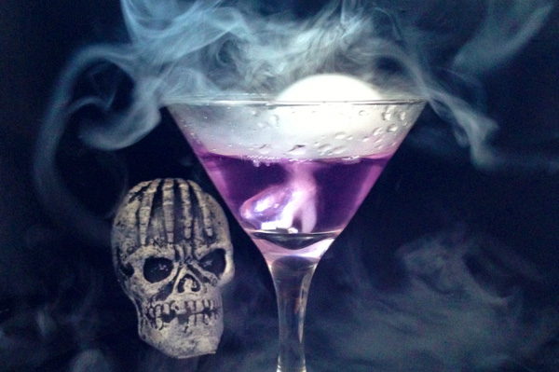
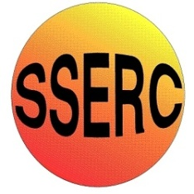
This reaction can be applied to curriculum for excellence.
By contributing to experiments and investigations, I can develop my understanding of models of matter and can apply this to changes of state and the energy involved as they occur in nature. SCN 3-05a
Having taken part in practical activities to compare the properties of acids and bases, I have demonstrated ways of measuring and adjusting pH and can describe the significance of pH in everyday life. SCN 3-18a

N4 – Chemical changes and structure
Acids and alkalis

Introduction
Dry ice is solid carbon dioxide.
When dropped into warm water, it sublimes (It does this in air anyway) rapidly and produces ‘clouds’ of CO₂ and water vapour that sinks due to CO₂ being denser than air.
If you put universal indicator in the water, you can see it changing colour as the CO₂ dissolves in the water to produce carbonic acid, a very weak acid.
You will need
Dry ice | Large flask
Warm water | Universal indicator

What you Do
- Fill the flask about ¾ full with warm water (from the tap).
- Add some universal indicator solution, enough to give a good colour.
- Drop a few pieces of dry ice into the flask
- Watch as the vapour pours out and the indicator changes color,

Safety
Dry ice is extremely cold and can cause burns. Handle with gloves or tongs.

What is happening?
Dry ice sublimes rapidly due to the warmth of the water.
CO₂ dissolves in the water to give carbonic acid.
CO₂ + H₂O H₂CO₃ H⁺ + HCO₃⁻
The production of carbonic acid in turn changes the colour of the universal indicator.

Notes
Dry ice can be purchased easily, though not inexpensively. It may be may be possible to obtain some from a nearby university: in this case it might be easier to co-ordinate with the physics department if they are carrying out the cloud chamber activity.
Dry ice can also be made in small quantities using a ‘snowpack’ adaptor for a CO₂ cylinder. These cost about £100.
You can demonstrate density and fire-extinguishing by placing the flask in a circle of tea-lights which will go out as the CO₂ cascades down the sides of the flask.

It is the responsibility of teachers doing this demonstration to carry out an appropriate risk assessment.

