Researching Chemistry

Higher

**Antioxidants**

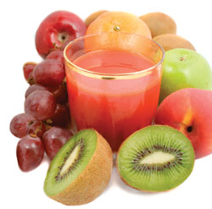

<http://www.mynewsletterbuilder.com/ex/template_content_corner/ex115/images/antioxidants.jpg>

Media Items

# Media Items



The subject of antioxidants continues to be a topical issue as scientific studies are quoted both in support and against health claims for antioxidants. Ever since the famous chemist Linus Pauling attracted the scientific and media spotlight by claiming that high doses of certain antioxidants can protect against disease and treat ailments, scientists have been debating the merits of antioxidants in food and antioxidants as food supplements.

It is worth noting that many clinical trials have looked at the effect of antioxidant supplements on health rather than the effect of consuming food rich in antioxidants.

A simple search for antioxidants on the BBC website throws up stories which show both sides of the coin. Teachers may wish to use some of these news clips/websites to introduce the topic:

1. <http://search.bbc.co.uk/search?go=toolbar&uri=%2F&q=antioxidants>

A wealth of resources and background chemistry for common antioxidants can be found on the Linus Pauling Institute website:

2. <http://lpi.oregonstate.edu/>

An overview of some trials which studied the effects of antioxidants on people’s health (mainly through supplements rather than from food sources)

3. <http://www.nutraingredients.com/Research/New-Scientist-slams-antioxidant-supplement-benefits>

4. [*http://www.youtube.com/watch?v=s3lX67swZWk*](http://www.youtube.com/watch?v=s3lX67swZWk)

This URL is 2 minutes long explaining how free radicals can damage cells and uses a cut apple as a demonstration.

5. [*http://www.youtube.com/watch?v=T_Xo5AaTH8U*](http://www.youtube.com/watch?v=T_Xo5AaTH8U)

This URL is just over a minute long and gives a light hearted approach to explaining how free radicals are formed by using a group a people eating dessert at the dinner table as a demonstration.

6. [*http://www.youtube.com/watch?v=fTBz9ipkWhE*](http://www.youtube.com/watch?v=fTBz9ipkWhE)

This URL is 4 ½ minutes long which gives a more detailed explanation of how radicals are formed, lifestyles that encourage their formation and how antioxidants help to remove the free radicals. It does mention oxidative stress and oxygen radical absorbency testing (ORAC) and places examples of fruits or vegetables in order of their ORAC ranking (their ability to remove free radicals).

7. [www.youtube.com/watch?v=yNsCU-_V0oM](http://www.youtube.com/watch?v=yNsCU-_V0oM)

This URL is about 5 minutes long showing the preparation, the actual visual changes of the oscillating reaction and finally how to dispose the product mixture. Text does accompany the video.

8. <http://www.scienceinschool.org/2009/issue13/antioxidants>

This URL provides further reading on how a tutor and his students were able to detect the levels of antioxidants found in food and drink samples.

The following “media items” card can also be used by pupils to do some fact finding about antioxidants

**Enjoy a Variety of Fruit and Vegetables**

**\\Staffserver1\CDO$\My Pictures\Microsoft Clip Organizer\j0428077.wmf**

Fruit and vegetables provide vitamins,

minerals, fibre and antioxidants that help

protect your heart.

<http://www.bda.uk.com/foodfacts/071102Eating4HealthyHeart.pdf?bcsi_scan_8375741C86C3A424=0&bcsi_scan_filename=071102Eating4HealthyHeart.pdf>

**Antioxidants could promote cancer**

Some research has suggested that tumours can use antioxidants to protect themselves from being destroyed by the body’s natural defence mechanisms.

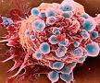

<http://www.rsc.org/chemistryworld/News/2009/August/19080903.asp>

**Do antioxidants increase your life span?** \\Staffserver1\CDO$\My Pictures\Microsoft Clip Organizer\j0437988.wmf

A study has suggested there is no evidence that taking these supplements makes you healthier and could harm your health.

<http://www.dailymail.co.uk/health/article-559952/Vitamins-A-C-E-waste-time-shorten-life.html>

**What are antioxidants?**

These are compounds (non-enzymatic) which remove highly reactive free radicals from our bodies, thus reducing damage to the body cells.

The 4 main non-enzymatic antioxidants are melatonin, vitamin E, Vitamin C and β-carotene. These can be found in fruit and vegetables.



**Carbon footprint**

**V**

**Healthy Diet**

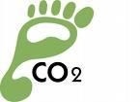

Most blueberries bought in the UK are imported creating a larger carbon footprint. Yet six flavonoid-packed blackberries – picked from a country lane hedgerow have a similar antioxidant levels.

<http://www.bbc.co.uk/food/food_matters/superfoods.shtml>

**Eating too many superfoods can harm health by overdosing on antioxidants**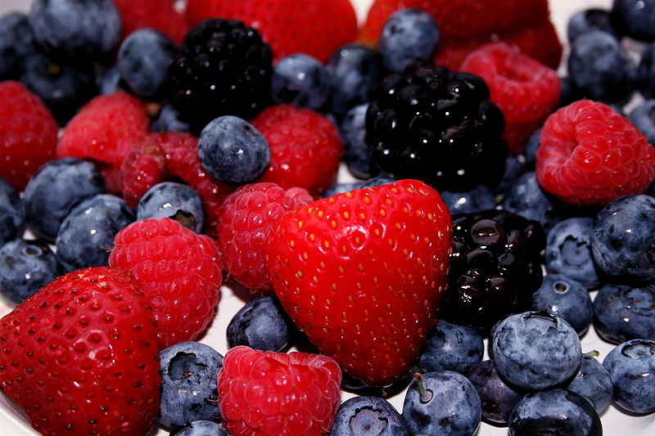

Researchers have claimed that too much consumption of superfoods could mean there are not enough pro-oxidants to maintain the delicate balance the body needs to remain healthy.

<http://www.dailymail.co.uk/health/article-1246542/Eating-superfoods-harm-health-overdosing-antioxidants.html>