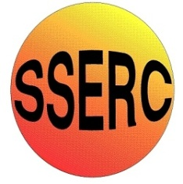

Chemical Demonstrations
Ammonium dichromate volcano
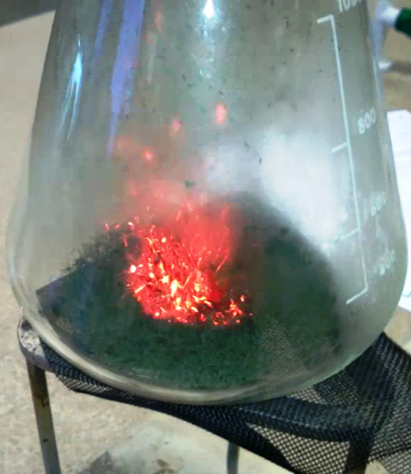
This reaction can be applied to curriculum for excellence.
Through experimentation, I can identify indicators of chemical reactions having occurred ...
SCN 3-19a
CfE Higher – Chemistry in Society
Oxidising or reducing agents

Introduction
In this demonstration experiment, a small conical heap of orange ammonium dichromate VI is ignited and starts to decompose exothermically. The reaction resembles a volcanic eruption, producing sparks, a large volume of green chromium lll oxide 'ash', steam and nitrogen gas.
This demonstration experiment can be used to show chemical change, since the products are dramatically different from the starting material. The reaction is a striking example of an exothermic decomposition reaction. The energy given out heats up the products, and steam and sparks are also produced.
The demonstration itself lasts about 2 minutes, but more time is needed for discussion and explanation before and after the demonstration.
You will need
3g Ammonium dichromate Vl | A 1 litre conical flask
Bunsen burner | tripod
Heatproof mat | Glass or mineral wool
Sheet of rolled up paper

To do
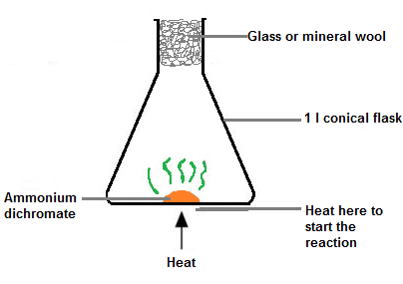
a Weigh out about 3 g of ammonium dichromate VI.
Roll a piece of paper (A4 longways is ideal) into a cylinder about 1 cm or so in diameter.
Stand the paper cylinder in the flask and pour the dichromate down it. (This ensures you get a neat pile in the centre rather than it scattering all over the base of the flask)
Place a loose plug of glass or mineral wool in the mouth of the flask to prevent loss of chromium III oxide powder during the reaction.
Start the reaction by heating the ammonium dichromate VI from underneath with the tip of blue Bunsen flame. The orange solid begins to give off sparks, and decomposes into a flaky green solid. This has a considerably larger volume than the original compound.
Once the reaction has started, remove the flame and place the flask on a heatproof mat in full view of the class.
As the rate of the 'volcanic' reaction increases and continues over a period of 30-45 seconds, the flask will steam up, and a little steam may escape through the wool plug.
The presence of water on the inside of the flask can be confirmed using blue cobalt chloride paper. It will turn pink.
Health and Safety
Ammonium dichromate VI, (NH₄)₂Cr₂O₇, is an oxidiser, acute toxin, (cat 3 by ingestion and cat 2 by inhalation), corrosive, carcinogen, mutagen, reproductive toxin, a skin sensitiser, a specific target organ toxin and is very hazardous to the aquatic environment.
(Wear eye protection and avoid skin contact with ammonium(VI) dichromate. Consider wearing gloves.
Do not mix other chemicals with ammonium dichromate(VI).
Disposal
The product of the reaction, the green chromium III oxide, Cr₂O₃, is low hazard but there may be traces of unreacted ammonium dichromate(VI) dust in the residue after the reaction. Wear gloves when transferring or sweeping up the residue into a plastic bag. Place it in the refuse.
The Chemistry
The equation for this decomposition reaction is:
(NH₄)₂Cr₂O₇(s) → Cr₂O₃(s) + N₂(g) + 4H₂O(g)
At advanced level the redox nature of the reaction could be explored. The dichromate ions oxidise the ammonium ions to nitrogen and water. In the process, chromium is reduced from its +6 oxidation state in dichromate to its +3 oxidation state in the chromium trioxide.
To confirm that this is a decomposition reaction and not combustion, the flask could be flushed with nitrogen gas from a cylinder (if available) before the reaction is started. The reaction is unaffected.
Evidence for the formation of the invisible gas (nitrogen) could be obtained by replacing the wool plug with a loose sandwich of wool and silica gel granules to absorb any steam – see diagram above. Weigh the flask before and after the reaction. A mass loss will indicate that a gas has been lost, although it is difficult to ensure that no steam escapes as well.
Notes
It is possible to carry out this experiment in a fume cupboard. In this case it is possible to use slightly larger quantities and have the ammonium dichromate simply piled on a heat-proof mat. The RSC have details of this method in Classic Demonstrations

