Chemical Demonstrations
Ammonia Fountain
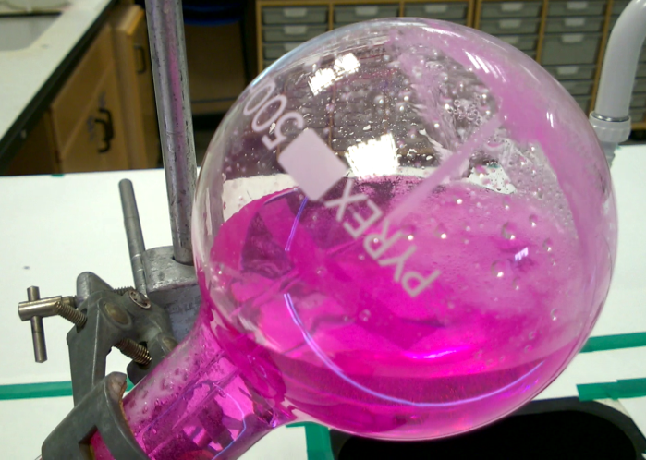
This reaction can be applied to curriculum for excellence.
I have taken part in practical investigations into solubility using different solvents and can apply what I have learned to solve everyday practical problems. SCN 3-16b

National 5 – Chemistry in Society
Fertilisers

Introduction
This demonstration experiment can be used to illustrate the very high solubility in water of ammonia. Ammonia solution is seen to be alkaline and various indicator colour changes can be demonstrated. A flask, fitted with a glass jet, is filled with dry ammonia. Injecting water into the flask dissolves the ammonia and causes a fountain via the jet.
The demonstration itself takes only a few minutes but needs careful advance preparation. With co-operative classes some of the preparation can be woven into the lesson so that the demonstration becomes the focal point.
You will need
For generating the ammonia
100 cm³ .880 ammonia | 250 cm³ conical flask
Bung with delivery tube | Round-bottomed flask (for the fountain)
Bunsen burner & heat proof mat | Stand, clamp and boss
For the fountain experiment
Universal indicator (or another indicator) | Round-bottomed flask (500 cm³ or more)
Rubber stopper, plain, to fit the flask | Two-holed rubber stopper to fit the flask
glass jet fitted into the rubber stopper | Plastic syringe (10 cm³)
Trough or large beaker which can hold more water than the flask | Stand, clamp and boss along with a heavy weight or bench clamp to avoid apparatus toppling over

To Do
Preparing the apparatus
a Use a round-bottom borosilicate flask or a thick-walled Buchner flask for this demonstration (other flasks may implode). Check carefully that the flask has no small cracks.
b. Ensure that the flask is clean and scrupulously dry. The best way to achieve this is to put it in a glassware drying cabinet (or alternative) for an hour or so before it is required. Take it out and stopper it (with a dry stopper!) just before it is filled with ammonia. c. Take a two-holed stopper that fits the flask and insert a glass tube, which has been drawn out into a jet, through one of the holes. The glass tube must fit tightly into the rubber stopper. The tip of the jet should be positioned so that it is in the centre of the flask when the stopper is in place. About 20 cm of tube should protrude out of the flask.
d Select a syringe which will fit tightly into the second hole of the two-holed stopper. If, as may be the case, it is a bit loose, you can use the smallest one-holed rubber bung you have as a ‘step-down’ adaptor.
If this demonstration is to be repeated in future, it is worth making up a set of apparatus to keep for this specific purpose.
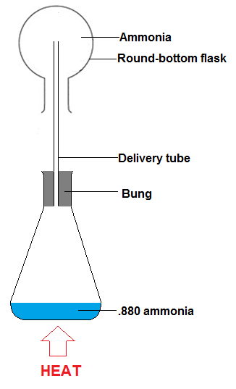
Preparing dry ammonia and filling the flask
This stage could form part of the demonstration.
a. Set up the flasks as shown in the diagram.
b. Working in a fume cupboard, add 100 ml of concentrated ammonia to a 250 cm³ conical flask and insert a bung fitted with 20 cm of glass tubing.
c. Using a retort stand, clamp the round-bottomed flask above the conical flask with the glass tubing from the conical flask reaching inside the upper one.
d. Heat the conical flask on a tripod and gauze so that ammonia gas produced is collected by the upwards displacement of air.
e. If not being used immediately, Stopper the flask with a plain, dry stopper.
It is very important that no water comes into contact with the ammonia until all preparations are complete.

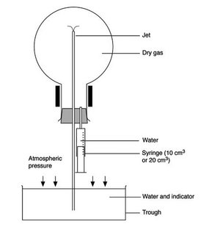
The demonstration
a. Fill a trough (or large beaker) with enough water to fill the fountain flask and add enough indicator to give an easily visible colour - this will be much more than is normally used for a titration.
Almost any acid/base indicator will work. Phenolphthalein is often chosen because of its colourless state in lower pH solutions.
If needed, add a few cm³ of dilute acid so that the indicator starts in its acid colour.

b. Position a clamp so that the flask will be held with the tube well below the level of the water. Bear in mind that the flask will be heavy when filled with water so take care that it will not overbalance.
c. Half-fill the syringe with water, dry the nozzle and carefully fit it into the second hole of the two-holed stopper (see diagram).
d. Remove the plain stopper from the inverted gas-filled flask and quickly fit the stopper which holds the jet and syringe. Be careful not to prematurely inject water from the syringe.
e. Use the syringe to squirt a few cm³of water into the flask.
f. As the gas dissolves, a partial vacuum forms inside the flask and the external air pressure will force water up the tube and through the jet - forming a fountain (see first diagram). The ammonia gas dissolves in the water emerging from the jet and the indicator changes colour.
g. The fountain continues for some minutes, depending on the size of the flask and the width of the jet. When the fountain finishes, a bubble of gas remains. This is air and its volume gives an indication of how well the flask was originally filled.
Health & Safety
Ammonia gas is toxic by inhalation. Wear eye-protection and work in a fume cupboard while preparing the flask of ammonia.
When doing the demonstration, ensure that the flask is securely clamped and that the flask and clamp stand assembly cannot topple over when the flask fills with liquid.
Tips
If you acidify the water in the trough, use only a few drops of acid. If you use too much, the fountain will show the alkali colour of the indicator at first and then change to the acid colour when all the ammonia has been neutralised. (Alternatively you might consider letting this happen and making a point of it.)
Ensure all apparatus is dry before use. It is best to place the round-bottomed flask and the jet in a drying cupboard for an hour or so before use.
Ensure all bungs and glass tubing are air-tight because the slightest leak will cause problems - do not use cork for this reason.
When squirting the water in from the syringe, give the syringe as good hard push to make sure the water goes right up into the flask.
If you find you are not getting a pretty full flask of coloured liquid at the end, it may be that there is moisture getting into the flask with the ammonia. If this is a problem then pass the ammonia gas through a drying tube with calcium oxide in it. (The normal calcium chloride or sulphuric acid are no use as ammonia reacts with them).
The chemistry
This is the equation for the preparation of ammonia:
NH₄Cl(s) + Ca(OH)₂(s) → NH₃(g) + CaCl₂(s) + H₂O(g)
Why is ammonia solution alkaline?
Ammonia dissolves freely in water (1 cm³ of water dissolves at least 800 cm³ of ammonia under normal laboratory conditions). It also reacts reversibly with it.
NH₃(aq) + H₂O(l) ⇌ NH₄⁺(aq) + OH⁻(aq)
It is the presence of OH⁻ ions which make the solution alkaline.
.

