Researching Chemistry
Higher
Alcohol

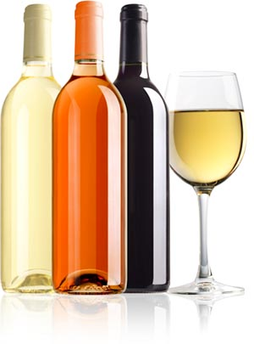 http://login.greatbignews.com/UserFiles/184/images/wineBottles_000.jpg

Media items

Alcohol

This alcohol investigation has been presented as an area of topical chemistry as alcohol has been used and abused for centuries. However, it has become a hot political topic in Scotland with cries for higher prices, lower alcohol % and crackdowns on under-age drinking. The chemists’ role for this investigation is one of quality control: how do we find out how much ethanol/SO₂/sugar is in an alcoholic beverage? Without this information, we cannot pass laws or monitor what companies are producing.

As a general introduction to the problems of alcohol in society, the following video clips could be used to stimulate discussion. The links for SO₂ and sugar in alcopops should also be used to introduce the investigations.

1. Health education board Scotland alcohol advert http://www.youtube.com/watch?v=ymfImBMQWVQ&feature=related
2. Binge drinking boy education advert
http://www.youtube.com/watch?v=EuowE1SXNkA&feature=related
3. Alcohol news item on alcohol abuse in Scotland
http://www.youtube.com/watch?v=TLJkTjvp-9g
4. Scheme in England to cut strength of alcoholic drinks
http://news.bbc.co.uk/player/nol/newsid_7260000/newsid_7263200/7263275.stm?bw=bb&mp=wm&news=1&ms3=6&ms_javascript=true&nol_storyid=7263275&bbcws=2
5. Cider maker to cut alcohol level
http://news.bbc.co.uk/1/hi/england/hereford/worcs/7952713.stm
http://news.bbc.co.uk/1/hi/scotland/3650248.stm
6. Buckfast ban? http://news.bbc.co.uk/1/hi/scotland/10164507.stm

Sulphur dioxide in wine

1. Link to allergies: http://news.bbc.co.uk/1/hi/health/6348001.stm
2. Sulphites as preservatives in foods and drinks http://www.youtube.com/watch?v=XYKJyEqYCEU&feature=related
3. Do sulphites cause headaches? http://www.youtube.com/watch?v=7VnxoOOHVag&feature=related

Alcopops and sugar
1. BBC video clip on conservative plans to curb sales of alcopops
http://search.bbc.co.uk/search?q=alcopops&tab=av&uri=%2F&go=toolbar&scope=all
2. Daily mail news articles on alcopops http://www.dailymail.co.uk/home/search.html?pageOffset=&pageSize=&orderBy=relevDesc&searchPhrase=alcopops&dateupdated=&dateFrom=&dateTo=
3. Alcopops ad http://cspinet.org/alcopops/AlcopopAd.pdf

