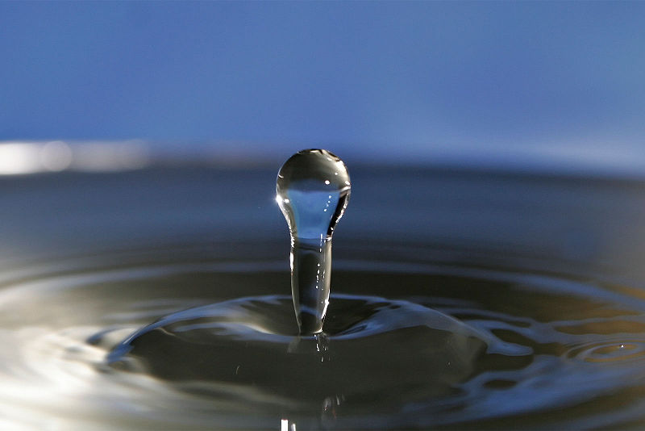
Image copyright Fir0002/Flagstaffotos
Teacher’s Guide
Introduction
This booklet gives a series of short experiments that will enable the investigator to determine the concentration of the following substances in water:
Boron
Calcium
Carbonate
Iron
Magnesium
Nitrate
Nitrite
Phosphate

For the colorimetric analysis, many of the values obtained for water samples may be too low to determine by colorimeter. There are two options to address this:
1. Use visual colorimetry to compare the colour with a range of standards. Looking vertically down the tube gives a longer path length than the 1cm standard in a colorimeter and so will allow easier discrimination.
2. Before analysis, evaporating the water sample to reduce its volume (to about 10%) will give a colour that is 10x as intense and thus easily readable. The only substance likely to be affected by boiling might be the calcium/magnesium or carbonate ions but they can be determined by titration using the undiluted sample.

Where does it fit in the curriculum?
National 5 - Chemistry in Society
Chemical Analysis - Techniques for monitoring the environment and methods for reducing pollution and titration with calculations.

Higher (revised) - Principles to Production
4) Chemical Analysis as part of Quality Control
b) Volumetric titration – the calcium and magnesium tests certainly fit the bill here.
Introduction
Boron is not found naturally in its elemental form but its compounds are widespread with a variety of uses.
Boric acid and borates are used in glass, soaps and detergents, flame retardants, and neutron absorbers for nuclear installations. Boric acid, borates, and perborates have been used in mild antiseptics, cosmetics, pharmaceuticals (as pH buffers), boron neutron capture therapy (for cancer treatment), pesticides, and agricultural fertilizers.
The natural borate content of groundwater and surface water is usually small. The borate content of surface water can be significantly increased as a result of wastewater discharges, because borate compounds are ingredients of domestic washing agents.
Naturally occurring boron is present in groundwater primarily as a result of leaching from rocks and soils containing borates and borosilicates. Concentrations of boron in groundwater throughout the world range widely, from <0.3 to >100 mg/litre. Typical values for the UK are of the order of 0.6 mg/litre.
Boron compounds are toxic by ingestion. The dose required for fatality seems to be arounf 5 – 20g in adults and less than 5g in children.
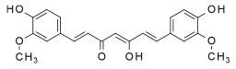
There is a large variation in the various estimates of toxicity and, in the spirit of caution, the UN has suggested a maximum level in drinking water of 5mg/litre.
The test for boron involves borates (the form in which most boron is found in water) forming a coloured complex with cucurmin.

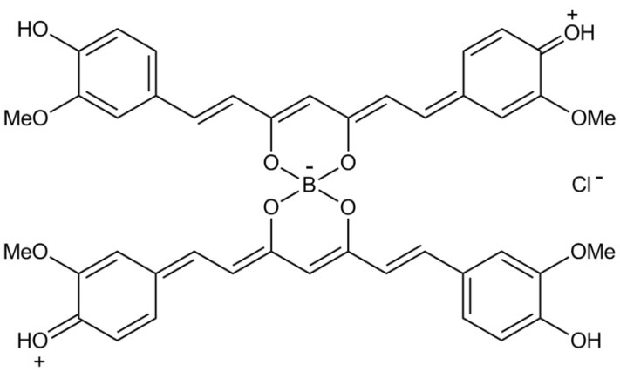
Cucurmin is the colouring agent in the spice turmeric. The yellow cucurmin complexes with the borate to form a red complex called rosocyanine.

Experiment – borate in water
Equipment and Materials Required

Solution of turmeric in water (0.5g of turmeric in 50cm³ of ethanol)
Test tubes (5 for the references plus however many samples you are doing)
Colorimeter & cuvettes
Instructions

- Place 5 cm³ of your sample in a test tube.
- Add 0.5 cm3 of turmeric solution
- Transfer some of the coloured solution to a cuvette and read the absorbance at 490nm
- Compare your results with a standard graph
Results
The values obtained from various mineral waters were low.
There was, however, a clear colour, so the concentration could be effectively determined by eye, looking down the length of the tube to increase the path length, comparing with various standard solutions.
Using a colorimeter at 470 nm obtained the following results (see graph on next page).
Abbey well 1 ppm
Evian 4.8 ppm
Dunfermline Tap water 4.0 ppm

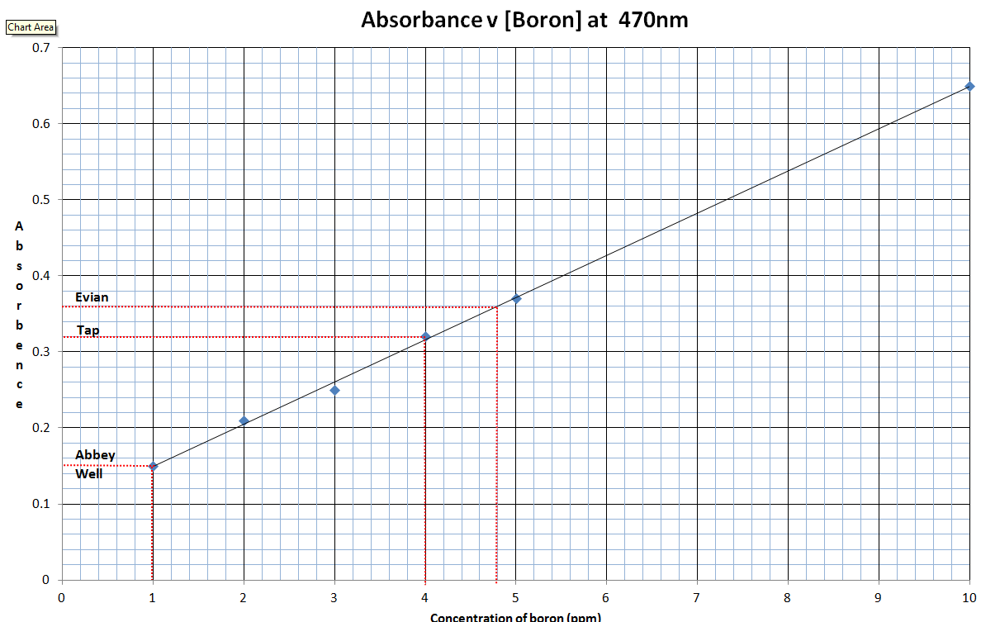
Types of Hardness
There are two types of water hardness, temporary and permanent.
Temporary Hardness is due to the bicarbonate ion, HCO3, being present in the water. This type of hardness can be removed by boiling the water to expel the CO2, as indicated by the following equation:
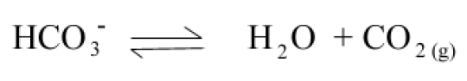

Bicarbonate hardness is classified as temporary hardness.
Permanent hardness is due to the presence of the ions Ca2+, Mg+2, Fe3+ and SO4. This type of hardness cannot be eliminated by boiling. The water with this type of hardness is said to be permanently hard.

The determination of water hardness is a useful test that provides a measure of quality of water for households and industrial uses. Originally, water hardness was defined as the measure of the capacity of the water to precipitate soap. Hard water is not a health hazard. People regularly take calcium supplements.
Drinking hard water contributes a small amount of calcium and magnesium toward the total human dietary needs of calcium and magnesium. In some parts of the UK, consuming extremely hard water could be a major contributor of calcium and magnesium to the diet.
Hard water does cause soap scum, clog pipes and clog boilers. Soap scum is formed when the calcium ion binds with the soap. This causes an insoluble compound that precipitates to form the scum you see. Soap actually softens hard water by removing the Ca2+ ions from the water.
When hard water is heated, CaCO3 precipitates out, which then clogs pipes and industrial boilers. This leads to malfunction or damage and is expensive to remove.
The table below shows the levels of dissolved solids in waters of differing hardness.
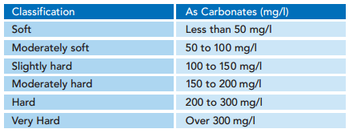
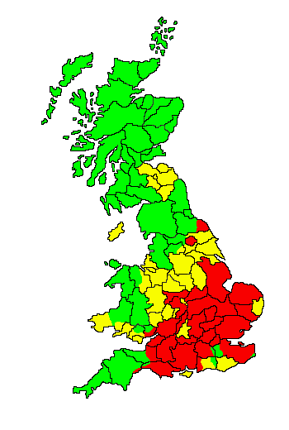
This map shows the hardness of the water supply in different pars of Great Britain.
Red = Hard
Yellow = Medium
Green = Soft

The ions involved in water hardness, i.e. Ca2+(aq) and Mg2+(aq), can be determined by titration with a chelating agent, ethylenediaminetetraacetic acid (EDTA), usually in the form of disodium salt. The titration reaction is:
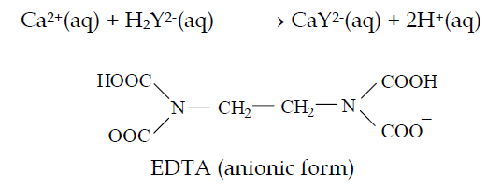

Eriochrome Black T is commonly used as indicator for the above titration. At pH 10, Ca2+(aq) ion first complexes with the indicator as CaIn+(aq) which is wine red. As the stronger ligand EDTA is added, the CaIn+(aq) complex is replaced by the CaY2-(aq) complex which is blue. The end point of titration is indicated by a sharp colour change from wine red to blue.
Titration using Eriochrome Black T as indicator determines total hardness due to Ca2+(aq) and Mg2+(aq) ions. Hardness due to Ca2+(aq) ion is determined by a separate titration at a higher pH, by adding NaOH solution to precipitate Mg(OH)₂(s), using murexide (or hydroxynaphthol blue) as indicator.

0.001 M EDTA solution | 0.5% Eriochrome Black T solution
1M NaOH | 0.5% Murexide
pH 10 ammonia buffer | Burette & associated titration equipment
Clamp and stand

Ammonia Buffer
- Dissolve 17.5g of ammonium chloride (NH₄Cl) in 142ml of concentrated ammonia (0.880).
- Dilute to 250 cm³ with distilled water.
Eriochrome Black T preparation
Instructions
- Put on gloves and protective eyewear and weigh out approximately 0.5 g of solid Eriochrome Black T, (EBT) on a balance and transfer it to a small beaker or flask. Add about 50 cm³ of 95 percent ethyl alcohol and swirl the mixture until the EBT has fully dissolved.
- Weigh out 4.5 g of hydroxylamine hydrochloride on a balance and transfer it to the beaker or flask containing the EBT. Swirl until the hydroxylamine hydrochloride has fully dissolved.
- Transfer the solution containing the EBT and hydroxylamine hydrochloride to a 100 cm³ graduated cylinder. Add enough 95 percent ethyl alcohol to bring the total volume to exactly 100 cm³.
- Transfer the EBT solution from the 100-mL graduated cylinder to a dropper bottle and label the bottle "0.5% Eriochrome Black T in Ethanol."
Tips & Warnings
- EBT indicator solutions typically exhibit very short shelf lives. Always prepare a fresh EBT solution when performing complexometric titrations.
- Hydroxylamine hydrochloride is highly toxic and corrosive to skin and mucous membranes. Avoid direct skin contact. Wear rubber gloves and protective eyewear at all times when handling this compound.
- Ethyl alcohol is flammable. Avoid working near open flames or other possible sources of ignition.

Experiment 1 – Calcium Determination

- Fill a 50 cm³ burette with 0.001 M EDTA solution, making sure the tip is full and free of air bubbles.
- Add 25.00 cm³ of an unknown hard water solution into a 100 cm³ beaker.
- Add 2 cm³ of 1.0 M Sodium Hydroxide.
- Add a spatula tip of Murexide indicator powder
- Titrate with the 0.001 M EDTA until the colour changes from salmon pink to orchid purple. Read burette to +/- 0.10 cm³.
- Repeat the titration until the final volumes agree to +/- 0.20 cm³.

Experiment 2 – Total Hardness Determination

- Fill a 50 cm³ burette with 0.001 M EDTA solution, making sure the tip is full and free of air bubbles.
- Add 25.00 cm³ of an unknown hard water solution into a 100 cm³ beaker.
- Add 5 cm³ of Ammonia buffer to the beaker.
- Add 0.5 cm³ of Eriochrome Black T indicator.
- Titrate with the 0.001 M EDTA until the colour changes from wine red to pure blue. Read burette to +/- 0.10 cm³.
- Repeat the titration until the final volumes agree to +/- 0.20 cm³.

Calcium concentration – take the figure from experiment 1
Magnesium concentration – subtract the result from experiment 1 (calcium) from the result of experiment 1 (total hardness)

MATHEMATICAL RELATIONSHIPS:
(these are given for calcium but the same principle holds for magnesium)
Molarity of EDTA solution is 0.01 M
1cm³ of 0.01 M EDTA = 1 mg of CaCO₃
EDTA molarity x EDTA volume (L) = Ca⁺² molarity x Ca⁺² volume (L)

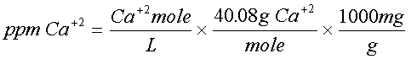
(for magnesium, the relevant RAM is 24.31)

 | Abbey Well | Deeside | Evian | Highland | Tap
 | 7 | 5.3 | 7.2 | 16.4 | 13.2
 | 6.4 | 5.7 | 7.1 | 16.6 | 13.1
 | 6.4 | 5.2
 | 6.60 | 5.40 | 7.15 | 16.50 | 13.15
 | 36 | 1.8 | 42.5 | 6.6 | 9.3
 | 34.6 | 2.4 | 43.2 | 6.5 | 8.9
 | 34.9 |  |  | 7.1
 | 35.17 | 2.10 | 42.85 | 6.73 | 9.10
 | 30.83 | 3.30 | 28.65 | 9.77 | 4.05
 | Abbey Well | Deeside | Evian | Highland | Tap
Total | 0.000066 | 5.4E-06 | 0.0000715 | 0.0000165 | 1.32E-05
 | 0.00264 | 0.000216 | 0.00286 | 0.00066 | 0.000526
Ca | 3.517E-05 | 2.1E-06 | 0.00004285 | 6.7333E-06 | 9.1E-06
 | 0.0014067 | 0.000084 | 0.001714 | 0.00026933 | 0.000364
 | 56.27 | 3.36 | 68.56 | 10.77 | 14.56
Mg | 3.083E-05 | 3.3E-06 | 0.00002865 | 9.7667E-06 | 4.05E-06
 | 0.0012333 | 0.000132 | 0.001146 | 0.00039067 | 0.000162
 | 29.97 | 3.21 | 27.85 | 9.49 | 3.94

(mg/l is equivalent to ppm)
Temporary Hardness of water is due to the bicarbonate ion, HCO3, being present in the water. This type of hardness can be removed by boiling the water to expel the CO2, as indicated by the following equation:

Bicarbonate hardness is classified as temporary hardness.
The determination of water hardness is a useful test that provides a measure of quality of water for households and industrial uses. Originally, water hardness was defined as the measure of the capacity of the water to precipitate soap. Hard water is not a health hazard. People regularly take calcium supplements.
Drinking hard water contributes a small amount of calcium and magnesium toward the total human dietary needs of calcium and magnesium. In some parts of the UK, consuming extremely hard water could be a major contributor of calcium and magnesium to the diet.
Hard water does cause soap scum, clog pipes and clog boilers. Soap scum is formed when the calcium ion binds with the soap. This causes an insoluble compound that precipitates to form the scum you see. Soap actually softens hard water by removing the Ca²⁺ ions from the water.
When hard water is heated, CaCO₃ precipitates out, which then clogs pipes and industrial boilers. This leads to malfunction or damage and is expensive to remove.
The table below shows the levels of dissolved solids in waters of differing hardness.
This map shows the hardness of the water supply in different pars of Great Britain.
Red = Hard
Yellow = Medium
Green = Soft

In a neutral or slightly alkaline solution, hydrogen carbonates are in equilibrium with carbonates. Many bicarbonates are fairly soluble in water but the same cannot be said of carbonates.
The test for carbonate uses the great insolubility of lead carbonate.
A small amount of saturated lead nitrate solution is added to the samples and a precipitate of lead carbonate solution forms.
The turbidity of this solution can be measured with a colorimeter (at any wavelength) and compared to a graph of standard solutions.

Saturated lead II nitrate solution | 500 ppm standard sodium hydrogen carbonate solution
pipettes | colorimeter
Test tubes | cuvettes

Tips & Warnings
- Remember to shake up the sample before transferring it to the cuvettes to ensure the precipitate is evenly distributed.
- As you are just reading the turbidity of the sample, the wavelength is not important but make sure to keep it the same for each sample.
- Lead nitrate, as well as being a reproductive toxin and harmful to the environment (like most lead salts) can also cause eye damage so wear goggles.
- Although the amounts are small, lead compounds are very harmful to the aquatic environment. The samples containing the precipitates can be filtered and the solid lead carbonate kept for disposal by a licensed contractor.

- Take the 500 ppm sodium hydrogen carbonate solution and make a series of dilutions. (400, 300, 200, 100 and 50 ppm).
- Place 5 cm³ of the first solution in a test tube and add 0.25 cm³ of lead nitrate solution. (about 10 drops)
- Shake the solution, pour 3-4 cm³ into a cuvette and read in the colorimeter.
- Repeat with the other reference solutions and plot the figures on a graph.
- Carry out the same test on 5 cm³ samples of the test waters and read the absorptions off the graph to determine the concentration.

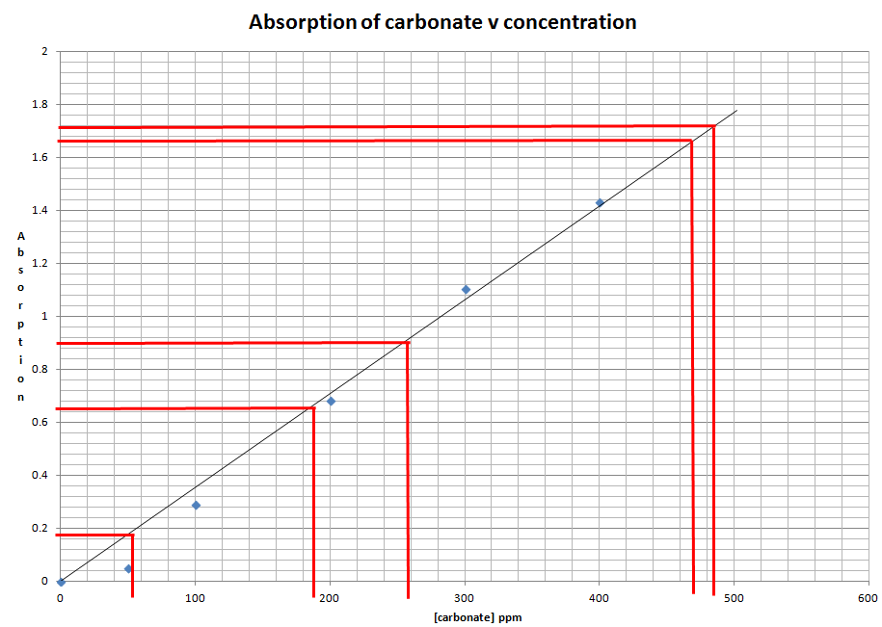

Water | [phosphate] ppm
Abbey Well | 485
Deeside | 205
Evian | 475
Highland Spring | 270
Tap | 75

Iron is the second most abundant metal in the earth's crust, of which it accounts for about 5%. Elemental iron is rarely found in nature, as the iron ions Fe2+ and Fe3+ readily combine with other elements to form oxides, hydroxides, carbonates, and sulphides. Iron is most commonly found in nature in the form of its oxides.
Iron uptake in humans
Food
Iron occurs as a natural constituent in plants and animals. Liver, kidney, fish, and green vegetables contain 20–150 mg/kg, whereas red meats and egg yolks contain 10–20 mg/kg. Rice and many fruits and vegetables have low iron contents (1–10 mg/kg).
Water
The median iron concentration in rivers has been reported to be 0.7 mg/litre. In anaerobic groundwater where iron is in the form of iron(II), concentrations will usually be 0.5–10 mg/litre, but concentrations up to 50 mg/litre can sometimes be found.
Concentrations of iron in drinking-water are normally less than 0.3 mg/litre but may be higher in countries where various iron salts are used as coagulating agents in water-treatment plants and where cast iron, steel, and galvanized iron pipes are used for water distribution.
Estimated total exposure and relative contribution of drinking-water
Reported daily intakes of iron in food - the major source of exposure - range from 10 to 14 mg.
Drinking-water containing 0.3 mg/litre would contribute about 0.6 mg to the daily intake.
Intake of iron from air is about 25 μg/day in urban areas.
EFFECTS ON HUMANS
Iron is an essential element in human nutrition. Estimates of the minimum daily requirement for iron depend on age, sex, physiological status, and iron bioavailability and range from about 10 to 50 mg/day.
The average lethal dose of iron is 200–250 mg/kg of body weight, but death has occurred following the ingestion of doses as low as 40 mg/kg of body weight. Autopsies have shown haemorrhagic necrosis and sloughing of areas of mucosa in the stomach with extension into the submucosa. Chronic iron overload results primarily from a genetic disorder (haemochromatosis) characterized by increased iron absorption and from diseases that require frequent transfusions. Adults have often taken iron supplements for extended periods without deleterious effects, and an intake of 0.4–1 mg/kg of body weight per day is unlikely to cause adverse effects in healthy persons .

This experiment allows for the analysis of iron content in water or food samples. The iron is present in a solution containing Fe³⁺ (ferric) ions. To make the presence of these ions in solution visible, thiocyanate ions (SCN⁻) are added. These react with the Fe³⁺ ions to form a blood-red coloured complex:
Fe³⁺ (aq) + SCN⁻(aq) → [FeSCN]²⁺(aq)
By comparing the intensity of the colour of this solution with the colours of a series of standard solutions, with known Fe³⁺ concentrations, the concentration of iron in the tablet or food sample may be determined. This technique is called colorimetry.

Equipment and Materials Required
ferric ammonium sulphate FeNH₄(SO₄)₂•12H₂O standard solutions:
2, 4, 6, 8 and 10 × 10−5 M (see below for preparation)
1 M ammonium thiocyanate solution (see below for preparation)
1 M sulphuric acid
1 M hydrochloric acid
100 cm³ beaker
200 and 500 cm³ volumetric flasks
5 cm³ pipette
100 cm³ conical flask
Test tubes (5 for the references plus however many samples you are doing)
Colorimeter & cuvettes
distilled water
Preparation of 1 M ammonium thiocyanate solution
Weigh 38 g of solid ammonium thiocyanate into a 500 cm³ volumetric flask and make up to the mark with distilled water.
Preparation of Fe3+ standard solutions
NB: It may take several days to dissolve the Fe3+ salt used here, so carry out this preparation well in advance of the rest of the experiment.
Weigh out about 3.0 g of ferric ammonium sulphate (FeNH4(SO4)2•12H2O). Use a mortar and pestle to grind the salt to a fine powder. Accurately weigh 2.41 g of the powder into a 100 cm³ beaker and add 20 cm³ of concentrated sulphuric acid [corrosive]. Leave powder to soak in acid overnight.
The next day, carefully pour the acid/powder slurry into a 500 cm³ volumetric flask, rinsing the beaker into the flask a few times with water, then make up to the mark with distilled water. Let this solution stand for several days until the ferric ammonium sulphate powder has fully dissolved. If possible, insert a magnetic stirrer bar and stir the solution to speed up this dissolving process.
Use a pipette to transfer 20 cm³ of ferric ion solution to a 200 cm³ volumetric flask and make up to the mark with distilled water. This gives a solution with [Fe3+] = 0.001 M.
To prepare a 2 × 10−5 mol L−1 standard solution pipette 10 cm³ of the 0.001 mol L−1 solution into a 500 cm³ volumetric flask, add 10 cm³ of 1 M sulphuric acid, and then make up to the mark with distilled water.
Repeat this procedure in separate 500 cm³ volumetric flasks*, pipetting in 20, 30, 40 and 50 cm³ of 0.001 M Fe3+ solution in turn, to obtain 4, 6, 8 and 10 × 10−5 M solutions respectively.
(* if you do not have five 500 cm³ volumetric flasks you can use one flask to prepare each standard in turn. After preparing each standard, pour the solution into a labelled glass vessel which has a lid (eg: a glass bottle). Then rinse your 500 cm³ volumetric flask thoroughly with distilled water before using it to prepare your next standard solution.)

Experiment 1 – Water
Colorimetric analysis
1. Accurately measure 2 cm³ of your sample solution into a clean, dry test tube*.
2. Next, measure 2 cm³ of each Fe³⁺ standard solution into separate test tubes (one standard per tube) in order of increasing concentration, beginning with the 2 × 10−5 M standard. It is a good idea to first rinse your pipette or measuring cylinder with a few cm³ of the 2 × 10−5 M standard.
NB: Make sure you label each boiling tube appropriately with the name of the sample or standard it contains.
3. Add 2 cm³of 1M ammonium thiocyanate solution to each iron solution in sequence, with 2 minutes between each addition**. These additions must be carefully timed so that all samples react for the same period of time.
4. Mix the solutions by swirling. A stable red colour will appear over the next few minutes.
5. As near as possible to 15 minutes after adding thiocyanate***, pour your samples into a cuvette and measure the absorbance at a wavelength of 490 nm for each coloured solution using your colorimeter. These measurements will be made in sequence − one sample every two minutes − reflecting the timing of the thiocyanate additions above. The measured absorbance of light is a direct measure of the intensity of the solution’s colour.

* You can, if you wish, simply add the solutions and mix in a cuvette.
** If you have a colorimeter to hand, you should be able to do it faster than this. 1 sample per minute is easily achievable and with practice, one every 30s is quite possible.
*** As long as you are reasonably close to the time, all should be well. When left for another 5 minutes, the darkest of the reference samples only dropped from a reading of 0.44 to 0.42. An extra 10 minutes caused a further drop to 0.40.

Calculations
- Using only the absorbance results obtained for your Fe³⁺ standard solutions (not your unknown iron sample), prepare a graph with [Fe³⁺ ] (in 10⁻⁵ mol/l) as the horizontal axis and absorbance (at 490 nm) as the vertical axis.
- Draw a line of best fit for your data points that goes through the origin (because absorbance must be zero when Fe³⁺ concentration is zero).
- You can use this graph to determine the iron content of your water samples.

The concentration of substances in drinking water is usually given as parts per million (ppm). 1ppm = 1 mg per l (for low concentrations at least).

To work out the concentration in ppm:

- Multiply the figure in mol/l by the Atomic mass of Iron - 55.845
- This gives the number of g/l
- Divide by 1000
- This gives the value in mg/l = ppm

The concentrations in ppm Fe³⁺ of your standard solutions are:
x10⁻⁵ mol/l | [Iron] ppm
10 | 5.68
8 | 4.55
6 | 3.41
4 | 2.27
2 | 1.14

Here is the curve obtained from the standard solutions.
Analysis of the samples gave no colour change for any of the mineral waters or tap water.
The waters were then boiled down to reduce their volume by a factor of 10 and re-tested. Again, there was no sign of any colour.

Method adapted from
The College of Science, University of Canterbury, Christchurch, New Zealand
Experiment 2 – Food
Preparation of food sample for analysis
1. Accurately weigh a few grams (typically 2 − 5 g is required, depending on iron content of sample) of your food sample into a crucible.
2. Heat the crucible over a bunsen burner until the sample is reduced completely to ash, or (preferably) combust the sample directly in the bunsen flame reducing it to ash.
NB: be very careful with the bunsen flame while heating/combusting your sample. Also beware that the crucible will become very hot during this process, so handle it only with crucible tongs − or preferably not at all − until it has cooled.
3. When the sample and crucible have cooled, use a stirring rod to crush the ash to a fine powder. Use a measuring cylinder to add 10 cm³ of 1 M hydrochloric acid and stir for 5 minutes, making sure that all the ash is soaked.
4. Add 5 cm³ of distilled water and then filter the solution into a 100 cm³ conical flask to remove the ash. This filtered solution will be used for colorimetric analysis.
Colorimetric analysis
Take 2 cm³ of your filtrate above and proceed as for the water samples above.
Calculations
- Take the readings from the graph as in the experiment for water
- Use this concentration to calculate the mass of iron (in mg) in your original tablet or food sample (NB: the molecular weight of iron is 55.8 g mol−1). Remember to take into account any dilutions that you performed while preparing your sample solution.
- If the absorbance value you measured for your unknown iron sample is greater than the absorbance value for your highest concentration Fe³⁺ standard you will need to modify the above procedure. In the case of an iron tablet, you should repeat the analysis with a more dilute solution of the dissolved iron tablet. In the case of a food sample, you should repeat the analysis using a smaller mass of your food.

Introduction
Nitrite is an, intermediate stage in the nitrogen cycle and. Thus, biochemical processes can cause a rapid change in the nitrite concentration in a water sample. In natural waters nitrite is normally present only in low concentrations (a few tenths of a milligram per litre). Higher concentrations may be present in sewage and industrial wastes, in treated sewage effluents and in polluted waters.
Nitrite nitrogen occurs as an unstable, intermediate stage in the biological decomposition of compounds containing organic nitrogen. It is formed in water either by the oxidation of ammonia or by the reduction of nitrate. Nitrite-forming bacteria convert ammonia under aerobic conditions to nitrites. The bacterial reduction of nitrates can also produce nitrites under anaerobic conditions.
Nitrites are often used as corrosion inhibitors in industrial process water and cooling towers; the food industry uses nitrite compounds as preservatives.
Because nitrites readily oxidize to nitrates, they are not often found in surface waters. The presence of large quantities of nitrites indicates partially decomposed organic wastes in the water being tested. Drinking water concentrations seldom exceed 0.1 mg/L of nitrite.
Higher concentrations may be present in sewage and industrial wastes, in treated sewage effluents and in polluted waters.
Nitrites in Food
Sodium nitrite is used for the curing of meat because it prevents bacterial growth and, in a reaction with the meat's myoglobin, gives the product a desirable dark red colour. Because of the relatively high toxicity of nitrite (the lethal dose in humans is about 22 milligrams per kilogram of body weight), the maximum allowed nitrite concentration in meat products is 200 ppm. Under certain conditions - especially during cooking - nitrites in meat can react with degradation products of amino acids, forming nitrosamines, which are known carcinogens.
Nitrite is readily absorbed into the blood where it combines irreversibly with haemoglobin to form methaemoglobin, which is ineffective as an oxygen carrier in the blood. In severe cases a condition known as infantile methaemoglobinaemia may occur which can be fatal for young babies.

Experiment 1 - Nitrites
This experiment allows for the analysis of nitrite content in water samples.
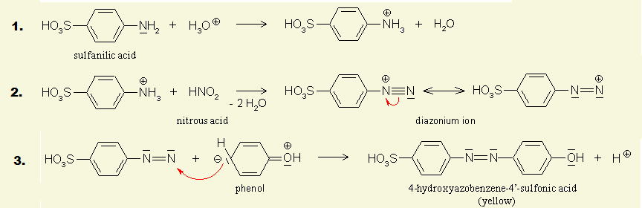
To make the presence of the nitrite (NO₂⁻) ions in solution visible, they are reacted with suphanilic acid and phenol which, in alkaline conditions, produces a bright yellow azo-dye.

By comparing the intensity of the colour of this solution with the colours of a series of standard solutions, with known NO₂⁻ concentrations, the concentration of nitrites in the water sample may be determined. This technique is called colorimetry.

Equipment and Materials Required

0.5% sulphanilic acid in H₂O
0.5% phenol in water
1M NaOH in water
5 cm³ pipette
Test tubes (5 for the references plus however many samples you are doing)
Colorimeter & cuvettes
distilled water

Instructions

- Place 3 cm³ of your sample in a test tube.
- Add 1 cm³ of sulphanilic acid solution and mix
- Add 0.5 cm³ of phenol solution and mix
- Add 0.5 cm³ of 1M NaOH and mix
- Transfer the sample to a cuvette and read in a colorimeter at around 470 nm

Results

For solutions containing more than about 20mg/l of nitrates, you will need to dilute the solution before (or after) the diazotisation reaction.
Even using a 10 x concentration of the various water samples tested, there was no trace of coloration that would imply the presence of nitrites.
As the test is sensitive down to about 1ppm, that means the water samples contain less than 0.1 ppm of nitrites.

Experiment 2 – Nitrates
Nitrate is commonly present in surface and ground waters, because it is the end product of the aerobic decomposition of organic nitrogenous matter. In addition nitrates are produced for use as fertilizers in agriculture because of their high solubility and biodegradability. Several million kilograms are produced annually for this purpose.
Unpolluted natural waters usually contain only minute amounts of nitrate. In surface water, nitrate is a nutrient taken up by plants and assimilated into cell protein. Stimulation of plant growth, especially of algae, may cause water quality problems associated with eutrophication. The subsequent death and decay of algae produces secondary effects on water quality, which may also be undesirable.
Significant sources of nitrate in water are chemical fertilisers from cultivated land and drainage from livestock feedlots, as well as domestic and some industrial waters.
High concentrations of nitrate in drinking water may present a risk to bottle-fed babies under three months of age because the low acidity of their stomachs favours the reduction of nitrates to nitrites by microbial action. Nitrite is readily absorbed into the blood where it combines irreversibly with haemoglobin to form methaemoglobin, which is ineffective as an oxygen carrier in the blood. In severe cases a condition known as infantile methaemoglobinaemia may occur which can be fatal for young babies.
This experiment involves the reduction of nitrate to nitrite and the subsequent estimation of the nitrite by colorimetry of an azo-dye product.
The traditional method of reducing nitrate to nitrite has been the use of a cadmium column. Due to its high toxicity, however, it is desirable to avoid using cadmium wherever possible. This method uses zinc as the reducing material.

Equipment and Materials Required
Zinc / potassium chloride mixture (1 : 6 ratio)
0.5% sulphanilic acid in H₂O
0.5% phenol in water
1M NaOH in water
5 cm³ pipette
Test tubes (5 for the references plus however many samples you are doing)
Colorimeter & cuvettes
distilled water

Instructions

- Place 5 cm³ of your sample in a test tube
- Add 0.5g of the Zn/KCl mixture.
- Leave for 5 minutes, shaking from time to time
- Transfer 3 cm³ of the now reduced sample to another test tube. (Allow to settle before taking it to avoid getting zinc particles)
- Add 1 cm³ of sulphanilic acid solution and mix
- Add 0.5 cm³ of phenol solution and mix
- Add 0.5 cm³ of 1M NaOH and mix
- Transfer the sample to a cuvette and read in a colorimeter at around 470 nm

Results
The reduction process does not seem to reduce 100% of the nitrate to nitrite but it does produce proportional results. It is important, therefore, to produce the standard graph from solutions of nitrate that are reduced to nitrite by this process rather than just using nitrite solutions.
Using a 10x concentrated solution of the waters, there were hints of colour that gave results as follows.
Water | [nitrate] ppm
Abbey Well | 0.8
Deeside | 0.7
Evian | 1.0
Highland Spring | 0.5
Tap | 0.3

It should be stressed that these are from very low absorbance readings (around 0.1 or less) so may not be all that reliable.
What is clear from these results is that these waters contain a very low concentration of nitrates.

Introduction
Introduction
Phosphates may occur dissolved in water in two forms.
The first form—orthophosphate—are produced by natural processes such as decay and are found in sewage. This very useful form of phosphorus is the one used by plants and animals for growth.
The second form of phosphate— polyphosphate—are used for treating boiler waters and are found in many household detergents and soaps. In water, they change into the ortho form.
Organic phosphates are important in nature. Their occurrence may result from the breakdown of organic pesticides which contain phosphates. They may exist in solution, as particles, loose fragments or in the bodies of aquatic organisms.
Rainfall can cause varying amounts of phosphates to wash from farm soils into nearby waterways. Phosphate will stimulate the growth of phytoplankton and aquatic plants which provide food for fish. This may cause an increase in the fish population and improve the overall water quality. However, if an excess of phosphate enters the waterway, algae and aquatic plants will grow wildly, choke up the waterway and use up large amounts of oxygen. This condition is known as eutrophication or over-fertilization of receiving waters. This rapid growth of aquatic vegetation eventually dies and as it decays it uses up oxygen. This process in turn causes the death of aquatic life because of the lowering of dissolved oxygen levels.
Phosphates are not toxic to people or animals unless they are present in very high levels. Digestive problems could occur from extremely high levels of phosphate. Phosphate itself does not have notable adverse health effects. However, phosphate levels greater than 1.0 may interfere with coagulation in water treatment plants. As a result, organic particles that harbour microorganisms may not be completely removed before distribution.
The Environment Agency for England and Wales has suggested that discharge from sewage treatment plants should have no higher than 1-2 ppm phosphate.

Experiment – phosphate in water

Equipment and Materials Required
2.5M sulphuric acid
0.00844m potassium antimonyl tartrate (Dissolve 1.3715 g K(SbO)C₄H₄O₆. ½H₂O in 400 cm³ distilled water in a 500 cm³ volumetric flask and dilute to volume.)
0.0162M Ammonium molybdate solution: Dissolve 20 g (NH₄)₆Mo₇O₂₄. 4H₂O in 500 cm³ distilled water.
0.1M Ascorbic acid: Dissolve 1.76 g ascorbic acid in 100 cm³ distilled water
Cuvettes
Colorimeter

Instructions
- Make up your combined reagent: Mix the above reagents in the following proportions for 100 cm³ of the combined reagent:
50 cm³ 2.5M H₂SO₄,
5 cm³ potassium antimonyl tartrate solution,
15 cm³ ammonium Molybdate solution, and
30 cm³ ascorbic acid solution.
Mix after addition of each reagent.
Let all reagents reach room temperature before they are mixed and mix in the order given. If turbidity forms in the combined reagent, shake and let stand for a few minutes until turbidity disappears before proceeding. The reagent is stable for 4 h.
- Put 5.0 cm³ of your sample in a test tube
- Add 1 cm³ of the combined reagent and mix thoroughly.
- Leave the solution for between 10 and 30 minutes.
- Transfer some of the coloured solution to a cuvette and read the absorbance at 590nm
- Compare your results with a standard graph

Results

Some of the values obtained from various mineral waters were too low to get a reading from the colorimeter. There was a definite colour, however, so the concentration was most effectively determined by eye, looking down the length of the tube, comparing with various standard solutions.

Repeating the experiments with water samples that had been concentrated 10 x by evaporation, gave the following results.
Water | [phosphate] ppm
Abbey Well | 0.3
Deeside | 0.4
Evian | 0.0
Highland Spring | 0.2
Tap | 0.65

