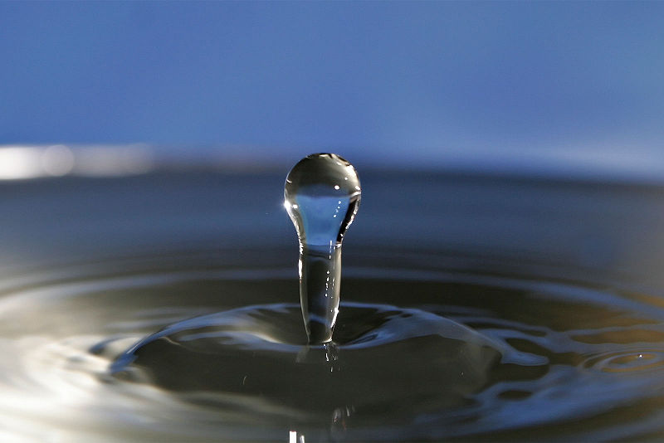
Image copyright Fir0002/Flagstaffotos
Pupil Guide
Introduction
This booklet gives a series of short experiments that will enable the investigator to determine the concentration of the following substances in water:
Boron
Calcium
Carbonate
Iron
Magnesium
Nitrate
Nitrite
Phosphate

Testing for Boron
Introduction
The natural borate content of groundwater and surface water is usually small. The borate content of surface water can be significantly increased as a result of wastewater discharges, because borate compounds are ingredients of domestic washing agents.
Typical values for the UK are of the order of 0.6 ppm.
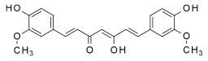
There is a large variation in the various estimates of toxicity and, in the spirit of caution, the UN has suggested a maximum level in drinking water of 5 ppm.
The test for boron involves borates (the form in which most boron is found in water) forming a coloured complex with cucurmin.

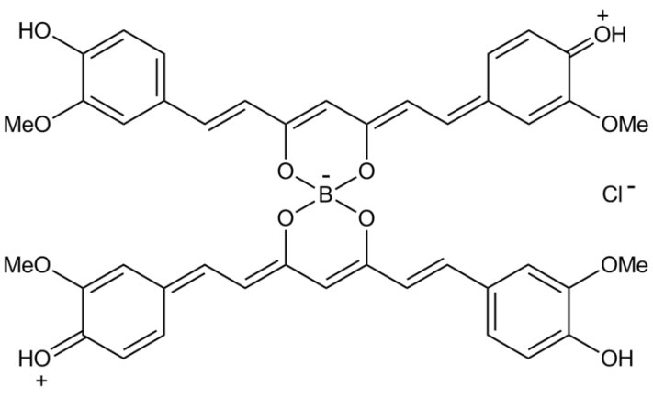
Cucurmin is the colouring agent in the spice turmeric. The yellow cucurmin complexes with the borate to form a red complex called rosocyanine.

Equipment and Materials Required
Solution of turmeric in water (0.5g of turmeric in 50cm³ of ethanol) | Test tubes (5 for the references plus however many samples you are doing)
Colorimeter & cuvettes | 20 ppm solution of sodium tetraborate

Instructions
- Create a series of dilutions of your sodium tetraborate solution.
- Place 5 cm³ of your first sample in a test tube.
- Add 0.5 cm³ of turmeric solution
- Transfer some of the coloured solution to a cuvette and read the absorbance at 490nm
- Use your dilutions to create a standard graph.
- Repeat the experiment with your water samples and compare your results with a standard graph
Testing for Calcium and magnesium
Introduction
Permanent hardness of water is due to the presence of the ions Ca^{2+,} Mg ⁺², Fe ³⁺ and SO₄ ²⁻ This type of hardness cannot be eliminated by boiling. The water with this type of hardness is said to be permanently hard.
The determination of water hardness is a useful test that provides a measure of quality of water for households and industrial uses.
Hard water causes soap scum, clog pipes and clog boilers. Soap scum is formed when the calcium ion binds with the soap. This causes an insoluble compound that precipitates to form the scum you see. Soap actually softens hard water by removing the Ca ²⁺ ions from the water.
When hard water is heated, CaCO3 precipitates out, which then clogs pipes and industrial boilers. This leads to malfunction or damage and is expensive to remove.
The ions involved in water hardness, i.e. Ca²⁺ (aq) and Mg²⁺ (aq), can be determined by two titrations with a chelating agent, ethylenediaminetetraacetic acid (EDTA), usually in the form of disodium salt. The titration reaction is:
Ca⁺² + EDTA⁻⁴ ⁻-----> CaEDTA⁻²
Total hardness (calcium and magnesium) is determined by titrating at pH 10 (using an ammonia buffer) with Eriochrome black T as the indicator.
Calcium alone can be determined using the same EDTA solution but this time using sodium bydroxide (to make the solution more alkaline) and Murexide as the indicator.

Equipment and Materials Required

0.001 M EDTA solution | 0.5% Eriochrome Black T solution  (This has a very short shelf life – prepare fresh each day).
1M NaOH | 0.5% Murexide
pH 10 ammonia buffer | Burette & associated equipment for titrations
Clamp and stand

If your water is from a hard water area, you may need to use a more concentrated solution of EDTA – 0.01M

Method
Experiment 1 – Total Hardness Determination
- Fill a 50 cm³ burette with 0.001 M EDTA solution, making sure the tip is full and free of air bubbles..
- Add 25.00 cm³ of an unknown hard water solution into a 100 cm³ beaker.
- Add 5 cm³ of Ammonia buffer to the beaker.
- Add 0.5 cm³ of Eriochrome Black T indicator.
- Titrate with the 0.001 M EDTA until the colour changes from wine red to pure blue. Read burette to +/- 0.10 cm³.
- Repeat the titration until the final volumes agree to +/- 0.20 cm³.

Experiment 2 – Calcium Determination
- Fill a 50 cm³ burette with 0.001 M EDTA solution, making sure the tip is full and free of air bubbles.
- Add 25.00 cm³ of an unknown hard water solution into a 100 cm³ beaker.
- Add 2 cm³ of 1.0 M Sodium Hydroxide.
- Add a spatula tip of Murexide indicator powder
- Titrate with the 0.001 M EDTA until the colour changes from salmon pink to orchid purple. Read burette to +/- 0.10 cm³.
- Repeat the titration until the final volumes agree to +/- 0.20 cm³.

Calculations
From the equation, 1 mole of calcium complexes with 1 mole of EDTA, so it is easy to work out the concentrations.
Molarity of EDTA solution is 0.001 M
1cm³ of 0.001 M EDTA = 0.1 mg of CaCO₃
Calcium– take the figure from experiment 2
Magnesium– subtract the result from experiment 2 (calcium) from the result of experiment 1 (total hardness)

Testing for Carbonate / Hydrogen Carbonate
Introduction
Temporary Hardness of water is due to the bicarbonate ion, HCO₃, being present in the water.
When hard water is heated, CaCO₃ precipitates out, which then clogs pipes and industrial boilers. This leads to malfunction or damage and is expensive to remove.
The table below shows the levels of dissolved solids in waters of differing hardness.
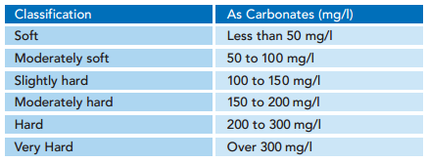

In a neutral or slightly alkaline solution, hydrogen carbonates are in equilibrium with carbonates. Many bicarbonates are fairly soluble in water but the same cannot be said of carbonates.
The test for carbonate uses the great insolubility of lead carbonate.
A small amount of saturated lead nitrate solution is added to the samples and a precipitate of lead carbonate solution forms.
The turbidity of this solution can be measured with a colorimeter (at any wavelength) and compared to a graph of standard solutions.
Equipment and Materials Required
Saturated lead II nitrate solution | 500 ppm sodium hydrogen carbonate solution
pipettes | colorimeter
Test tubes | cuvettes

- Remember to shake up the sample before transferring it to the cuvettes to ensure the precipitate is evenly distributed.
- As you are just reading the turbidity of the sample, the wavelength is not important but make sure to keep it the same for each sample.

Instructions
- Take the 500 ppm sodium hydrogen carbonate solution and make a series of dilutions. (400, 300, 200, 100 and 50 ppm).
- Place 5 cm³ of the first solution in a test tube and add 0.25 cm³ of lead nitrate solution. (about 10 drops)
- Shake the solution, pour 3-4 cm³ into a cuvette and read in the colorimeter.
- Repeat with the other reference solutions and plot the figures on a graph.
- Carry out the same test on 5 cm³ samples of the test waters and read the absorptions off the graph to determine the concentration.
Do not pour your solutions down the sink.

Testing for Iron
Introduction
Concentrations of iron in drinking-water are normally less than 0.3 mg/litre but may be higher in countries where various iron salts are used as coagulating agents in water-treatment plants and where cast iron, steel, and galvanized iron pipes are used for water distribution.
This experiment allows for the analysis of iron content in water or food samples. The iron is present in a solution containing Fe³⁺ (ferric) ions. To make the presence of these ions in solution visible, thiocyanate ions (SCN⁻) are added. These react with the Fe³⁺ ions to form a blood-red coloured complex:
Fe³⁺ (aq) + SCN⁻(aq) → [FeSCN]²⁺(aq)
By comparing the intensity of the colour of this solution with the colours of a series of standard solutions, with known Fe³⁺ concentrations, the concentration of iron in the tablet or food sample may be determined. This technique is called colorimetry.
Equipment and Materials Required
ferric ammonium sulphate FeNH₄(SO₄)₂•12H₂O standard solutions: | 2, 4, 6, 8 and 10 × 10−5 M (see below for preparation)
1 M ammonium thiocyanate solution (see below for preparation) | 1 M sulphuric acid
1 M hydrochloric acid | 100 cm³ beaker
200 and 500 cm³ volumetric flasks | 5 cm³ pipette
100 cm³ conical flask | Test tubes (5 for the references plus however many samples you are doing)
Colorimeter & cuvettes | distilled water

Instructions
1. Accurately measure 2 cm³ of your sample solution into a clean, dry test tube*.
2. Next, measure 2 cm³ of each Fe³⁺ standard solution into separate test tubes (one standard per tube) in order of increasing concentration, beginning with the 2 × 10−5 M standard. It is a good idea to first rinse your pipette or measuring cylinder with a few cm³ of the 2 × 10−5 M standard.
3. Add 2 cm³of 1M ammonium thiocyanate solution to each iron solution in sequence, with 2 minutes between each addition**. These additions must be carefully timed so that all samples react for the same period of time.
4. Mix the solutions by swirling. A stable red colour will appear over the next few minutes.
5. As near as possible to 15 minutes after adding the thiocyanate***, pour your samples into a cuvette and measure the absorbance at a wavelength of 490 nm for each coloured solution using your colorimeter. These measurements will be made in sequence − one sample every two minutes − reflecting the timing of the thiocyanate additions above. The measured absorbance of light is a direct measure of the intensity of the solution’s colour.
* You can, if you wish, simply add the solutions and mix in a cuvette.
** If you have a colorimeter to hand, you should be able to do it faster than this. 1 sample per minute is easily achievable and with practice, one every 30s is quite possible.
*** As long as you are reasonably close to the time, all should be well. Do not worry if you are 30s or even a minute late.
Calculations
- Using only the absorbance results obtained for your Fe³⁺ standard solutions (not your unknown iron sample), prepare a graph with [Fe³⁺ ] (in 10⁻⁵ mol/l) as the horizontal axis and absorbance (at 490 nm) as the vertical axis.
- Draw a line of best fit for your data points that goes through the origin (because absorbance must be zero when Fe³⁺ concentration is zero).
- You can use this graph to determine the iron content of your water samples.
The concentration of substances in drinking water is usually given as parts per million (ppm). 1ppm = 1 mg per l (for low concentrations at least).
To work out the concentration in ppm:
- Multiply the figure in mol/l by the Atomic mass of Iron - 55.845
- This gives the number of g/l
- Divide by 1000
- This gives the value in mg/l = ppm
The concentrations in ppm Fe³⁺ of your standard solutions are:
x10⁻⁵ mol/l | [Iron] ppm
10 | 5.68
8 | 4.55
6 | 3.41
4 | 2.27
2 | 1.14

Testing for Nitrites
Introduction
Because nitrites readily oxidize to nitrates, they are not often found in surface waters. The presence of large quantities of nitrites indicates partially decomposed organic wastes in the water being tested. Drinking water concentrations seldom exceed 0.1 mg/L of nitrite.
Higher concentrations may be present in sewage and industrial wastes, in treated sewage effluents and in polluted waters.
This experiment allows for the analysis of nitrite content in water samples.
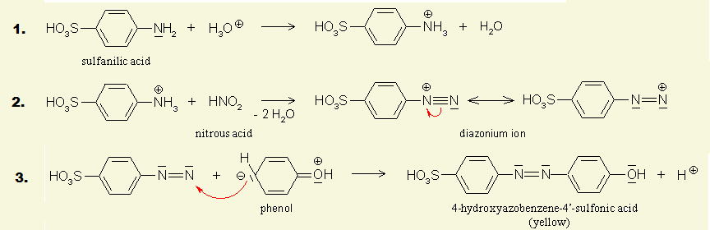
To make the presence of the nitrite (NO₂⁻) ions in solution visible, they are reacted with suphanilic acid and phenol which, in alkaline conditions, produces a bright yellow azo-dye.

By comparing the intensity of the colour of this solution with the colours of a series of standard solutions, with known NO₂⁻ concentrations, the concentration of nitrites in the water sample may be determined. This technique is called colorimetry.

Equipment and Materials Required
0.5% sulphanilic acid in H₂O | 0.5% phenol in water
1M NaOH in water | 5 cm³ pipette
Test tubes (5 for the references plus however many samples you are doing) | Colorimeter & cuvettes
distilled water | Solution of sodium or potassium nitrite 50 ppm

Instructions
- Make a series of dilutions of your potassium nitrate solution.
- Place 3 cm³ of your reference samples and samples in a test tubes.
- Add 1 cm³ of sulphanilic acid solution and mix
- Add 0.5 cm³ of phenol solution and mix
- Add 0.5 cm³ of 1M NaOH and mix
- Transfer the sample to a cuvette and read in a colorimeter at around 470 nm

Testing for Nitrates
Introduction
Nitrate is commonly present in surface and ground waters, because it is the end product of the aerobic decomposition of organic nitrogenous matter. In addition nitrates are produced for use as fertilizers in agriculture because of their high solubility and biodegradability.
This experiment involves the reduction of nitrate to nitrite and the subsequent estimation of the nitrite by colorimetry of an azo-dye product (the same method as described under nitrites).
The traditional method of reducing nitrate to nitrite has been the use of a cadmium column. Due to its high toxicity, however, it is desirable to avoid using cadmium wherever possible. This method uses zinc as the reducing material.
Equipment and Materials Required
Zinc / potassium chloride mixture (1 : 6 ratio) | 0.5% sulphanilic acid in H₂O
0.5% phenol in water | 1M NaOH in water
5 cm³ pipette | Test tubes (5 for the references plus however many samples you are doing)
Colorimeter & cuvettes | distilled water
Solution of potassium nitrate (50 ppm)

Instructions
- Make a series of dilutions of your potassium nitrate solution.
- Place 5 cm³ of your reference solutions and your sample in test tubes.
- Add 0.5g of the Zn/KCl mixture to each
- Leave for 5 minutes, shaking from time to time (about once per minute).
- Transfer 3 cm³ of the now reduced sample to another test tube. (Allow to settle before taking it to avoid getting zinc particles)
- Add 1 cm³ of sulphanilic acid solution and mix
- Add 0.5 cm³ of phenol solution and mix
- Add 0.5 cm³ of 1M NaOH and mix
- Transfer the sample to a cuvette and read in a colorimeter at around 470 nm

The reduction process does not seem to reduce 100% of the nitrate to nitrite but it does produce proportional results. It is important, therefore, to produce the standard graph from solutions of nitrate that are reduced to nitrite by this process rather than just using nitrite solutions.
Testing for Phosphates
Introduction
Phosphates get into water from two sources:
1) natural decay and sewage
2) household detergents and soaps
Phosphates do not have notable adverse health effects. However, phosphate levels greater than 1.0 may interfere with coagulation in water treatment plants. As a result, organic particles that harbour microorganisms may not be completely removed before distribution.
The Environment Agency for England and Wales has suggested that discharge from sewage treatment plants should have no higher than 1-2 ppm phosphate.
Equipment and Materials Required
0.00844m potassium antimonyl tartrate | (Dissolve 1.3715 g K(SbO)C₄H₄O₆. ½H₂O in 400 cm³ distilled water in a 500 cm³ volumetric flask and dilute to volume.)
0.0162M Ammonium molybdate solution | Dissolve 20 g (NH₄)₆Mo₇O₂₄. 4H₂O in 500 cm³ distilled water.
0.1M Ascorbic acid | Dissolve 1.76 g ascorbic acid in 100 cm³ distilled water

Cuvettes

Colorimeter

Preparation

Make up your combined reagent: Mix the above reagents in the following proportions for 100 cm³ of the combined reagent:

50 cm³ 2.5M H₂SO₄,

5 cm³ potassium antimonyl tartrate solution,

15 cm³ ammonium Molybdate solution, and

30 cm³ ascorbic acid solution.

Mix after addition of each reagent.

Let all reagents reach room temperature before they are mixed and mix them in the order given. If turbidity forms in the combined reagent, shake and let stand for a few minutes until turbidity disappears before proceeding. The reagent is stable for 4 h.

Instructions
- Make a series of dilutions of your phosphate solution
- Place 5 cm³ of each dilution of the reference solution and of your sample(s) in a series of test tubes.
- Add 1 cm³ of the combined reagent to each and mix thoroughly.
- Leave the solutions for between 10 and 30 minutes.
- Transfer some of the coloured solutions to cuvettes and read the absorbance at 590nm
- Plot the absorbences of your diluted reference solution on a graph. This is your reference graph
- Read off the results for your water samples from the standard graph you obtained in 7.

