|  |  |  |
| --- | --- | --- |
| **SSERC_jpg.jpg**  **Part 1** |  |  |

**Ensuring bacteria are in an active stage of growth**

Bacteria from the slopes have been streaked onto nutrient agar plates and incubated at 30 oC for 24 hrs to make stock plates of the cultures.

**Materials**

Lab coat Bunsen burner and mat

Eye protection Pen for labelling

Disinfectant (1% bleach solution) Discard jar with VirkonTM

Two Disposable sterile loops Two 10cm3 bottles of sterile nutrient Broth stock plates: *E.Coli* J-53R and *E.Coli* HT-99

**Method**

1. Wear a lab coat and use eye protection.
2. Wash your hands and clean your work area with 1% bleach.
3. Work with all your equipment close to the bunsen burner with a blue flame.
4. Label the bottles with initials, date and *E. coli* strain. At this stage it is useful to loosen the bottle lids slightly – they are often very tight after autoclaving.
5. Use aseptic technique (i.e. flaming the neck of the bottle after removal and before replacement of its lid). Using a sterile loop, pick up one colony of *E.coli* J-53R from the stock plate and put it into a bottle of sterile nutrient broth. Tilt the bottle and swirl the loop in the media to transfer all of the cells into the solution. Discard the loop into the VirkonTM
6. Shake the culture gently from side to side to separate the clumps of cells and ensure they are distributed evenly throughout the liquid.
7. Repeat for the *E.coli* HT-99 strain.
8. Incubate the two bottles at 30 o C for 24 hours to ensure that the bacteria are in the active growth stage.

|  |  |  |
| --- | --- | --- |
| **Part 2** |  |  |

**Mating the bacteria - conjugation**

**Materials**

Overnight culture of *E.coli* J-53R Bottle containing 10 cm3 sterile nutrient broth

Overnight culture of *E.coli* HT-99 Two Sterile 1cm3 syringes

Disinfectant (1% bleach solution) Bunsen burner

Marker pen Incubator or water bath set to 30 oC

Discard jar with VirkonTM

**Method**

1. Wash your hands with soap and water.
2. Wipe down the bench surface with disinfectant (1% bleach).
3. There should be a lit Bunsen burner on the bench near where you are working to create an upward flow of warm air to carry away potentially contaminating microorganisms.
4. Label the bottle containing sterile nutrient broth, ‘Mating’. Open a sterile syringe at the end of the packet *furthest from the tip*, taking care not to touch the barrel of the syringe or the tip.
5. Use the syringe to aseptically remove 1.8 cm3 of an overnight culture of *E. coli* J-53R and transfer it to the nutrient broth in the bottle you have just labelled. (Since you have a 1 cm3 syringe, you will need to transfer 2 x 0.9 cm3 .)
6. Discard the used syringe into the waste container of VirkonTM
7. Taking care as before, use a new sterile syringe to aseptically transfer 0.2 cm3 of the *E. coli* HT-99 culture to the nutrient broth.
8. Discard the second syringe into the waste container of disinfectant.
9. Place the mixed culture and the other two cultures in an incubator at 30 °C (where they should be left for 4–16 hours).
10. Wipe down the bench with disinfectant.
11. Wash your hands with soap and water.

**Part 3 Plating out the bacteria**

**Materials**

* The three microbial cultures which have been incubated
* Plate of nutrient agar containing rifampicin
* Plate of nutrient agar containing chloramphenicol
* Plate of nutrient agar containing rifampicin and chloramphenicol

Disinfectant (1% bleach solution) Discard jar (1% Virkon™)

3 Sterile disposable loops Waterproof marker pen

Bunsen burner

**Method**

1. Wash your hands with soap and water.
2. Wipe down the bench with disinfectant (1% bleach).
3. Turn over each plate so that the base is uppermost. With the marker pen divide each plate into three segments as shown in the diagram. Label the top two segments ‘Donor’ [HT-99] and ‘Recipient’ [J-53R] and the third segment as ‘Mating’.

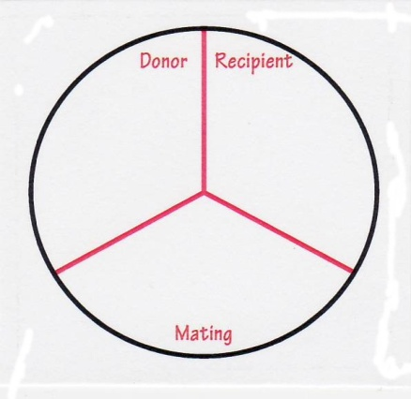

1. Arrange the three plates on the bench in front of you. Use a new sterile loop to aseptically streak each segment of each of the plates with culture from the appropriate bottle. Use a new loop for each of the different cultures, and dispose of the loops into

the Virkon TM as you use them. The inoculation plan is shown below.

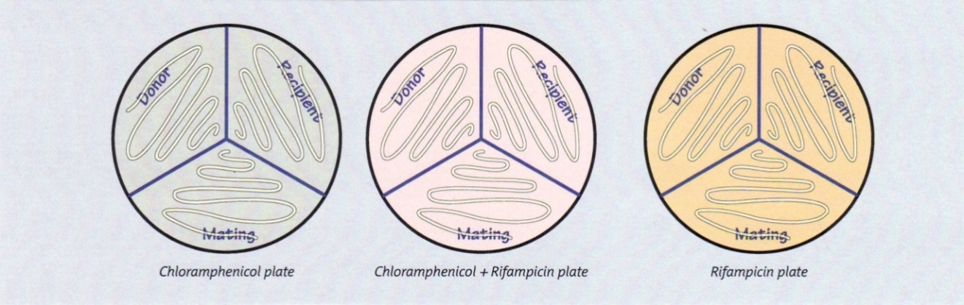

1. When the agar has absorbed any excess liquid, invert the plates and incubate them for 24 hours at 30 °C.
2. Wipe down the bench with disinfectant.
3. Wash your hands with soap and water.