That Uncertain Feeling
Planck’s Constant is inconveniently small when it comes to carrying out classroom experiments on the Uncertainty Principle. However, considering the behaviour of classical waves can give us insight into phenomena usually considered to be quantum in nature. Here we use apps running on tablets to investigate classical uncertainty, then relate our findings to quantum physics.
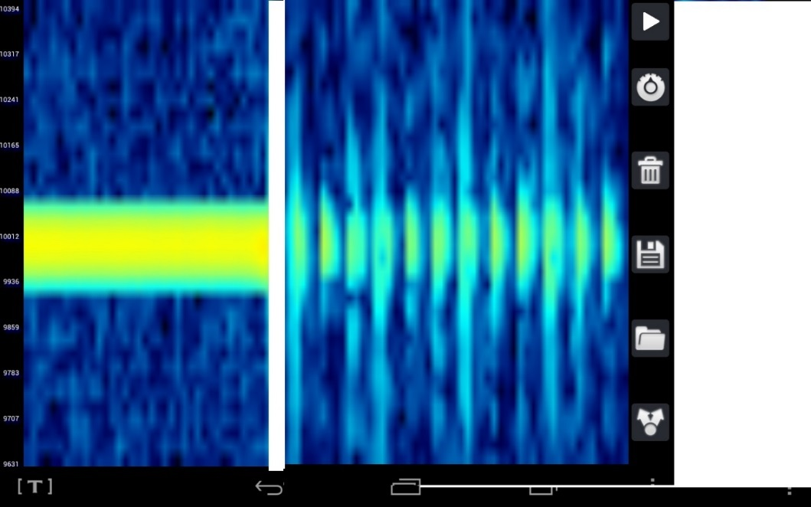
In Bulletin 244 [1] we looked at the use of frequency spectrum analysis software as a tool for investigating the Doppler Effect. More recently, we have found apps [2] that do the same job.

Figure 1 – frequency spectrum analyser trace
The left hand part of Figure 1 shows the frequency spectrum analysis of a steady sinusoidal tone generated by a function generator app set to 10 KHz. The tablet running the function generator app was connected to an active loudspeaker. The frequency spectrum analyser is running on a second tablet. Frequency is on the y-axis, time on the x. Looking closely at the width of the frequency trace, an uncertainty of a few tens of Hertz can be seen. The uncertainty in time – when, exactly was the frequency 10 kHz? – is very large because the wave is continuous.
On the right of the image, the function generator has been set to produce bursts of sound of the same frequency. 10 bursts per second, each 200 wavelengths long, were created. Looking at an individual burst, the uncertainty in time is much smaller. Conversely, the uncertainty in frequency is much greater – the trace is much more spread out in the y-direction.
The best explanation is in terms of Fourier components. An infinite sinusoidal wave is made of a single Fourier component, i.e. a wave of one frequency. Any other wave train is made up of a sum of Fourier components, i.e. a sum of waves of different frequencies.
In summary, as Δt decreases, Δf increases.
If your students have no knowledge of Fourier analysis, they may gain some understanding from a simulation such as the one shown in Figure 2 [3].

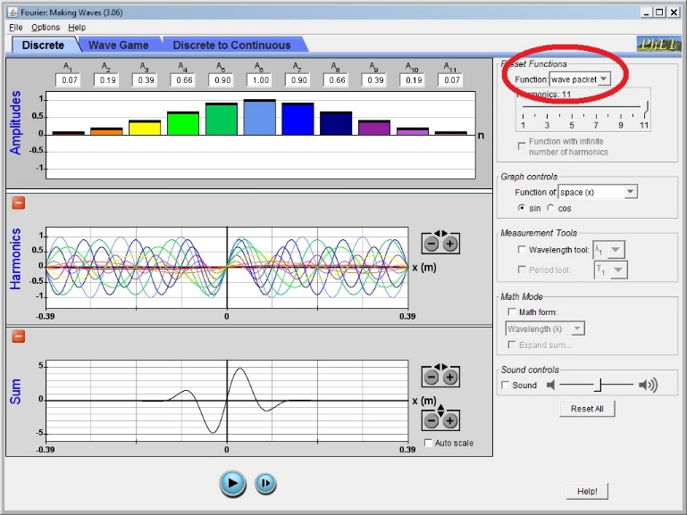
Figure 2 – simulating adding Fourier components
Students can start with a sine wave and add in harmonics. The preset “wave packet” function shows how a range of different frequencies are needed to create something that is localised in space or time.
If this is beyond your students, they should at least be able to appreciate that the longer the wave train, the easier it will be to accurately determine frequency. Ask them to think of the relative difficulty in identifying the pitches of long and short-lived musical tones.
None of this is quantum physics. However, at a quantum level, particles display wave-like properties and these waves behave exactly like classical waves. The link is the equation E = hf where E is the energy of the particle, f is the frequency and h is Planck’s Constant. Because h is constant, we can now say,
as Δt decreases, ΔE increases
We are lucky at SSERC, and indeed in Scottish physics education in general, to be able to call upon the wisdom of some top class Higher Education personnel for guidance. When we asked our “go to” quantum physicist about this activity, she reminded us that, “each individual quantum particle has these uncertainties associated with it - it's not just that there are many particles with a spread of exactly-known energies. Each particle's energy is uncertain.”

Guidance on using both of the apps featured in this article is contained in the document accessed via the link in reference [2] below. The original idea for this activity came from Harvard Natural Sciences Lecture Demonstrations [4]. The Harvard version does not use a function generator app, but we felt that few, if any schools in Scotland would have the necessary hardware to do this any other way. We believe that our use of a frequency spectrum analyser is a worthwhile enhancement.
[1] http://www.sserc.org.uk/images/Bulletins/244/SSERC%20bulletin%20244-p2-3.pdf
[2] http://tinyurl.com/physics-apps
[3] https://phet.colorado.edu/en/simulation/fourier (accessed April 2017)
[4] http://sciencedemonstrations.fas.harvard.edu/presentations/uncertainty-principle (accessed April 2017)

