The X-Bacteria: some additional safety advice
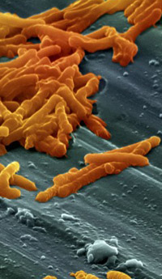
X-Bacteria [1] is a practical kit, funded by The Wellcome Trust, which forms part of the Survival Rivals [2] series of activities to celebrate Darwin Year. These excellent activities, which are available free to schools, enable pupils to examine different aspects of evolution. The dramatic increase in numbers and types of antibiotic-resistant bacteria is a striking and important modern example of evolution which has impact on medical practice and society. The X-Bacteria practical involves allowing two strains of bacteria, each of which is resistant to a different antibiotic, to conjugate. After transferring aseptically to media that contain different combinations of antibiotics, the bacteria are then incubated to look for any that now demonstrate double antibiotic resistance.
Guidance for Scottish schools on the safe use of microorganisms is provided in the SSERC publication, Biology / Biotechnology Safety in Microbiology: a Code of Practice for Scottish Schools and Colleges [3]. When practical microbiological work is carried out within this Code of Practice (CoP), no additional risk assessment is required. As with many new practicals, X-Bacteria raises some technical issues with regard to ‘Health and Safety’. In this article, we would like to address these.
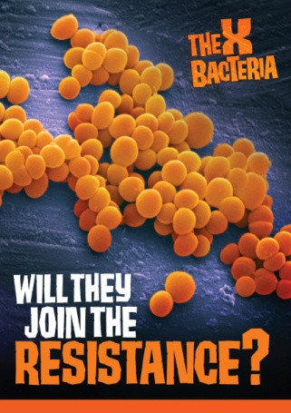
Two strains of E. coli are used, HT-99 and J-53R, neither of which is included per se in the ‘selected organisms’ list [4] within the CoP. However, HT-99 is a derivative of E coli strain B, and J-53R is a derivative of E. coli strain K12, both of which are included in the list so use of the organisms is permitted and there is no need to carry out an additional risk assessment [5].

Growth media incorporating antibiotics are required. This is contrary to the guidance provided in Section 4.32 of the CoP which states that ‘antibiotics should not normally be incorporated into growth media’. In the case of X-Bacteria (as is also the case for a number of commercially available bacterial transformation kits), relaxation of this section can be applied providing that:

  - appropriate Personal Protective Equipment is worn when making up the antibiotics
  - preparation of the antibiotic for incorporation in plates is carried out in a fully functional, approved fume hood
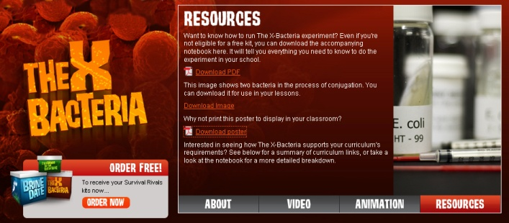
  - the guidance in the X-Bacteria manual [6] is followed closely with respect to the technique for dissolving the powdered antibiotic and preparing the plates.
This interesting, relevant and reliable practical allows young people to investigate the horizontal spread of antibiotic resistance between bacteria and to consider the resulting selective advantages conferred to following generations in vertical transfer. There is then significant scope for consideration of the threat to health of this modern, rapid example of evolution.

Note: in addition to the above, it is essential that good microbiological practice is observed throughout. (See Code of Practice and Microbiological Techniques Cards [7])
1. http://survivalrivals.org/the-x-bacteria/about (accessed 28th July 2009)
2. http://survivalrivals.org/ (accessed 28th July 2009)
3. http://www.sserc.org.uk/members/SafetyNet/Microbio2/Main_Menu.HTM (accessed 28th July 2009)
4. http://www.sserc.org.uk/members/SafetyNet/Microbio2/MOOS/intro.htm (accessed 28th July 2009)
5. http://survivalrivals.org/content/documents/MicrobiologySafetyDataSheet.pdf (accessed 31st July 2009)
6. http://survivalrivals.org/Content/documents/TheXBacteriaNotebook.pdf (accessed 28th July 2009)
7. http://www.sserc.org.uk/members/SafetyNet/Microbio2/Documents/Techniques%20Cards.pdf

