The Reaction Timer

**Thinking distance**

Thinking distance = speed of the car x the reaction time of the driver.

* Will the thinking distance change as the speed of the car changes?
* Write down what you think and give a reason for why you think this.

MCTN01269_0000[1]

**Braking distance**

* Braking distance is the distance a car travels once the brakes have been applied by the driver until the car stops.

MCBD07306_0000[1]

**Stopping distance**

* Can you think how you could work out the stopping distance?

Stopping distance = \_\_\_\_\_\_\_\_\_\_\_\_\_\_\_\_\_\_\_\_\_\_\_\_\_\_\_\_\_\_\_\_\_\_\_\_

* Do you think your reaction time will change if you are concentrating?
* How will it change? Write a sentence saying how your reaction time

will change and why you think it changes in this way.

**What is your reaction time?**

The driver sees a child run out and the eyes send a signal to the brain.

**MCj02905780000[1]**

The brain sends a signal to the foot to press down on the brake pedal.

****

The foot presses down on brake pedal.

The time it takes from the driver seeing the child to the driver pressing his foot down on the brake pedal is called the **reaction time.**

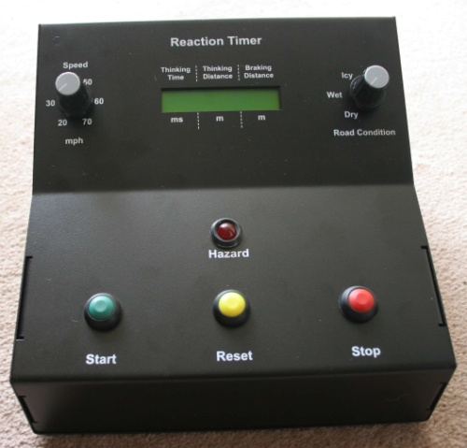You are going to measure your reaction time for such a hazard. **The hazard for you is a flashing light.**

**Apparatus**

* The Reaction Timer box.
* A sheet of paper.
* A pencil.

**Method**

* Press the start button. The light starts flashing.
* Press the stop button as soon as you are sure the light has stopped flashing.
* Record the reaction time displayed on the reaction timer.
* You will need to repeat the experiment to check your result is reliable.
* Press the re-set button. When you are ready press the start button.
* Press the stop button as soon as you are sure the light has stopped flashing.
* Record the reaction time displayed on the reaction timer.
* Repeat the experiment with various distractions....