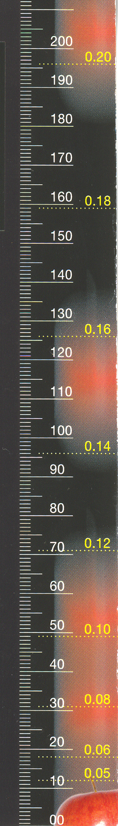

- To measure your reaction time, you will need a partner and a ruler like the one shown.

- Now, sit in a chair with your arm resting on a table so that your wrist hangs off the edge.

- Your partner will hold the ruler so that it dangles above your hand. The ruler must have the 0 cm end nearest to your hand. Make sure the end of the ruler is hanging between your thumb and finger.

- When your partner lets go of the ruler, try to catch it between your thumb and finger as quickly as you can.

- Note the yellow number on the ruler nearest to your thumb. This number gives you your reaction time.

- Your reaction time is how long it took for your eyes to tell your brain that the ruler was falling and then for your brain to tell your fingers to catch it.

- Record your result.

- Try catching the ruler twice more. Record your result for each reaction time.

