Protein Electrophoresis

This protocol is based on materials provided by The National Centre for Biotechnology Education to support their ‘Protein Power!’ practical activity. Available at:
http://www.ncbe.reading.ac.uk/ncbe/materials/dna/proteinpower.html
The protocol should be read in conjunction with the NCBE teacher and student guides where safety information and further background information can be found.
CfE Curriculum links
Genes encode proteins and proteins determine an organism’s form, function and phenotype.

Higher Biology Unit 1 Higher Human Biology Unit 1

The phenotype is determined by the proteins produced as the result of gene expression…..

One gene, many proteins as a result of RNA splicing and post-translational modification…..

Post-translation protein structure modification by cutting and combining polypeptide chains or by adding phosphate or carbohydrate groups to the protein.

Proteins are held in a three-dimensional shape — peptide bonds, folded polypeptide chains, hydrogen bonds, interactions between individual amino acids.

Suggested learning activity: Separation and identification of fish proteins by agarose gel electrophoresis.
Background
Electrophoresis is a technique that uses electricity to separate out electrically charged molecules. Here we are using electrophoresis to separate proteins on an agarose gel. Large proteins move slowly through the gel and small proteins move more quickly, therefore the proteins are separated according to their size.
There are many different types of proteins. For example, structural proteins such as the proteins found in hair and skin, catalytic proteins such as enzymes and messenger proteins like hormones which act as signalling molecules. Proteins are formed as long chains of amino acids. The order of the amino acids in the protein is determined by a specific DNA sequence, or gene.
Proteins do not remain in long amino acid chains (known as the primary structure). The chemical composition of amino acids in the chain causes bonds to form between the molecules. This causes the chain of amino acids to fold and coil, resulting in a protein with a 3D shape. This is called the tertiary protein structure. Protein molecules, therefore, differ in size and shape, but they also differ in electrical charge; positive, or negative. In the following practical, one of the steps involves boiling the proteins in a specific buffer (Laemmli buffer). This process denatures (or unfolds) the proteins returning them to their primary structure and also gives them a negative charge. Thus the proteins vary only in size (molecular weight). All proteins of the same size will run to the same part of the agarose gel. This is what forms the bands.

Method
For this workshop you will work with a partner.
You will be provided with small samples of crushed, dried lentils and dried peas and small pieces of white fish and prawns. This means that you will have four protein samples with which to carry out protein gel electrophoresis. Our suggestion is that each person prepares one animal and one plant protein to be loaded into a shared electrophoresis tank.

- Label four micro centrifuge tubes to show which sample will be in each. Place the tubes in the foam tube holder.

- Using a clean weighing boat on each occasion, carefully weigh out 0.02 g of each sample.

- Transfer each weighed sample to the appropriately labelled tube.

- Add 0.5 cm³ blue marker dye (Laemmli buffer) to each tube.

- Close each tube in turn and ‘flick’ the base 15 times to mix the contents and return the tube to the tube holder.

- Place the tube holder in a beaker of boiling water for 3 minutes. Make sure the base of each tube is in contact with the water.

- Transfer the tube holder to an ice bath. Leave the tubes on ice until you are ready to load your electrophoresis gels.

Preparing the gels

- Label the end of the tank to show which sample is going into each well.

- Pour enough buffer solution into the electrophoresis tank to cover the gel. The buffer solution should form a layer 2-3 mm deep over the gel.

- Taking care not to tear the gel, remove the comb from the tank leaving 6 ‘wells’.

- Fit a carbon fibre electrode at each end of the tank.

Loading the gels

- Place the tank on the yellow / black card so that the wells are over the black area. This will make it easier to see the wells when loading the samples. The yellow card allows the dye front to be seen more easily.

- Using a microsyringe fitted with a fresh syringe tip for each sample draw up 10 μl of liquid from the top of the sample.

- Load the sample into the appropriately labelled well. Do this by holding the syringe tip above the well just in the buffer solution. The marker dye is ‘heavy’ so it will drop into the well. Be careful not to puncture the gel.

- Once all the samples are loaded in their wells, and taking care not to disturb the tank, attach the power supply – negative electrode to the ‘well’ end, positive electrode to the opposite end.

- Leave the gel to ‘run’ undisturbed for 2 hours.

Staining the proteins

- On completion of the electrophoresis, switch off the power supply and remove the electrodes.

- Pour off the buffer solution leaving the gel in the tank.

- Carefully rinse the gel several times with distilled water to ensure that all buffer is removed.

- Cover the gel with Coomassie blue stain to a depth of 2-3 mm above the gel (about 12 cm³).

- Cover the tank with parafilm and leave to stain overnight.

- Remove the parafilm, pour off the blue stain and rinse the gel carefully several times with distilled water.

- Flood the gel with distilled water and leave to de-stain for several hours.

- The pattern of bands on the gel can then be studied. The different bands are different proteins (or fragments of proteins).

The molecular weight of proteins
Different proteins are different sizes (or molecular weights). These weights are so tiny that we cannot measure them in grams or even nanograms. The unit for the molecular weight of proteins is a dalton. A dalton is defined as an atomic mass unit approximately equal to the mass of a hydrogen atom. There are ‘protein standards’ which provide examples of proteins of specific molecular weights (in daltons).
It is interesting to estimate the sizes of particular protein bands in your gels and make suggestions as to what the specific proteins may be.
You can estimate the size of unknown protein bands by two methods.

1)Estimate the size by eye, i.e. it is bigger than 66kD but smaller than 45kD. Then make an approximation.

2) Measure the distance (mm) each band in the protein standard solution has migrated.

Plot distance travelled on the x-axis and the molecular weight of each band (kD) on the y-axis.

The size of unknown proteins can then be estimated by measuring their migration distance and plotting on the standard curve.

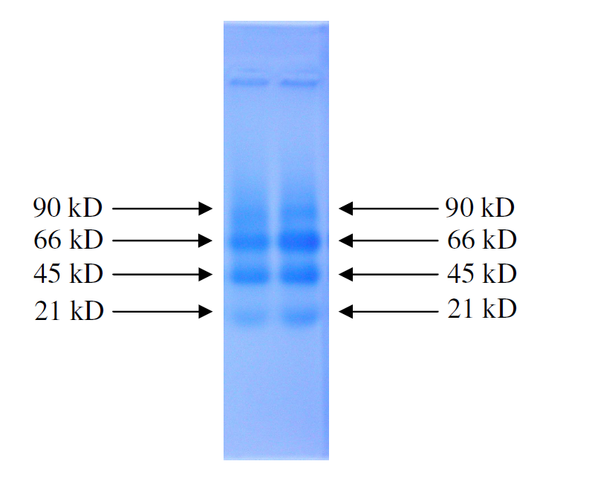

As a reference here are some sizes of common proteins:
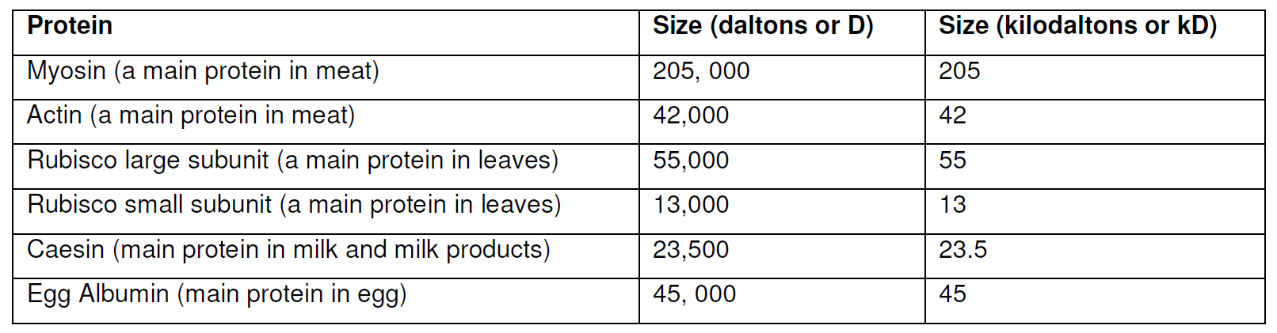
Thanks to Jan Barfoot who now works as Public Engagement, Outreach and Communications Manager for OptiStem.

