Climate change:
Are plants the answer?

Activity 1. Algae and Photosynthesis
This activity is a simple demonstration of photosynthesis in green algae. It also addresses the much-neglected fact that plants also carry out respiration. We will use an indicator which is very sensitive to changes in levels of acidity. An increased level of dissolved carbon dioxide makes the solution more acidic; decreased levels of dissolved carbon dioxide make the solution less acidic. Changes in colour of the indicator can therefore be used to estimate levels of dissolved carbon dioxide. The colours displayed by hydrogencarbonate indicator at different levels of acidity are shown below.

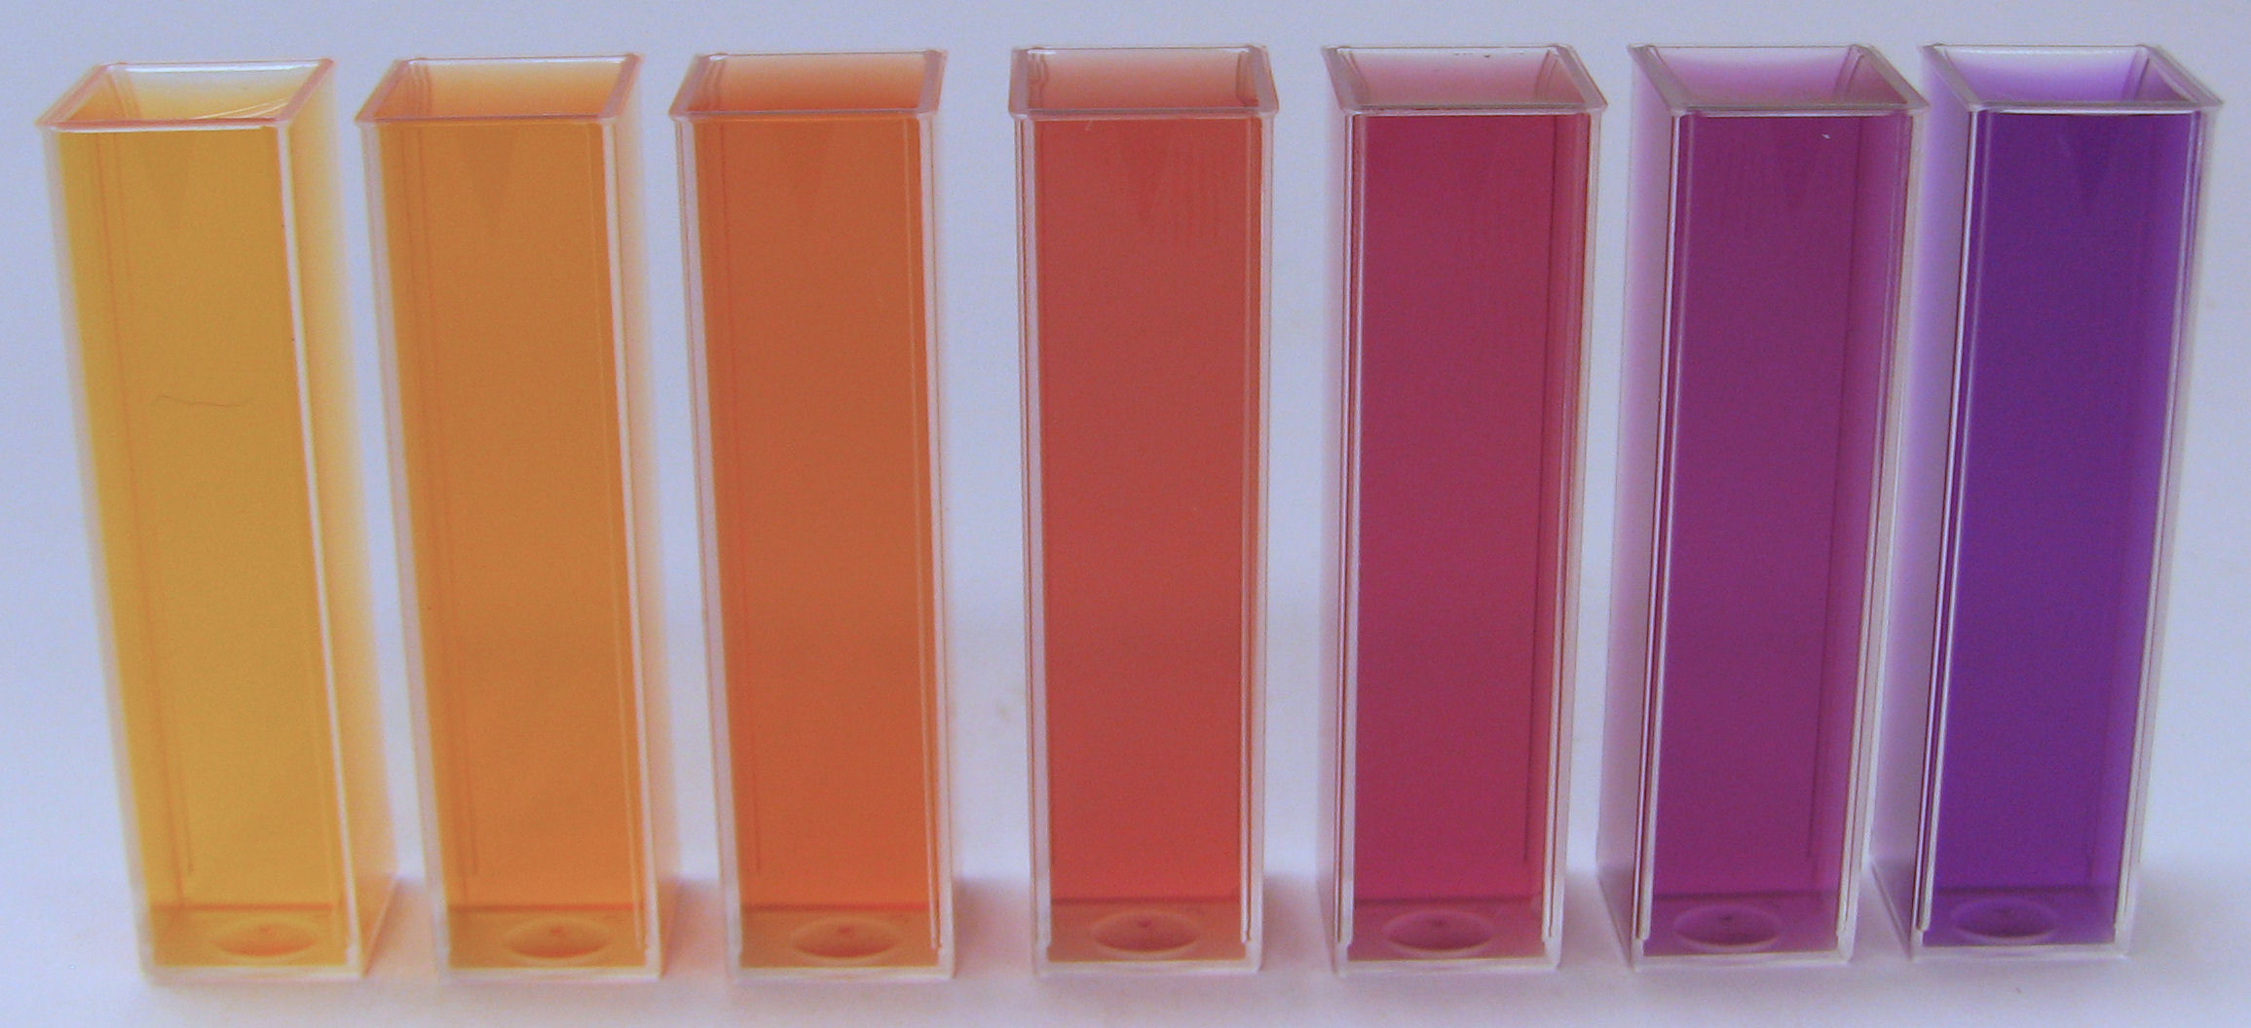
Figure 1: Hydrogencarbonate indicator solutions in the range pH = 6.8 (pale yellow) to pH = 9.2 (purple). pH increases in increments of 0.4 units

- The indicator is orange at normal atmospheric levels of CO₂.

- An increase in CO₂ concentration causes the solution to become more acidic and so the indicator to become yellow.

- A decrease in CO₂ concentration causes the solution to become less acidic and so the indicator to become purple.

Materials
The alga Scenedesmus quadricauda 2 pipettes
Hydrogencarbonate indicator 1 black paper tube
3 x Bijou bottles

Method
- Using one of the pipettes add 6 cm³ of hydrogencarbonate indicator to each Bijou bottle.
- Replace the lid on one of the Bijou bottles – this is your ‘control’ to show that without the algae the indicator does not change.
- Using the other pipette add 0.5 cm³ of Scenedesmus to the indicator in each of the other two Bijou bottles.
- Cover one of the bottles containing Scenedesmus with the tube of black paper.
- Place all three bottles in bright light for 20 min.

Activity 2. The hanging drop
In this activity you will make a hanging drop to observe microscopic algae. A hanging drop preparation does not dry out easily and so organisms can be observed for a long time. The method described here uses two slides to make a hanging drop and has several advantages over using cavity slides: 1. the use of thin coverslips is avoided (younger pupils can find these fiddly to use and coverslips can easily be broken into tiny shards which could cause cuts) and 2. standard microscope slides are significantly cheaper than cavity slides.
Materials
Microscope Lens tissue
Pipette Blu-takTM
Paper towels Two glass slides
Mixed algae culture

Method
- Clean two glass slides by rubbing each of them gently with a piece of lens tissue. Do not throw away the lens tissue.

- Stick two small pieces of blu-takTM on one slide, about 2 cm apart.

Using the pipette, squeeze the bulb of the pipette first and draw up some of the culture from the bottom of the container. Make sure you have collected some of the gunge from the bottom where you are most likely to get a good number of organisms.

- Place a single drop of the liquid from the pipette in the middle of the second glass slide.

- Working as quickly as you can, turn the slide over so that the drop hangs down from the slide.

- Place the slide over the first slide and stick it down on the blu-takTM.

- The hanging drop should hang between the two slides without touching the bottom one.

- You are now ready to observe algae under the microscope.

Once you have made some observations of the organisms in the cultures, think about how you might use this in the classroom. This activity lends itself to developing the skills of scientific enquiry and investigation and use of the microscope. A hanging drop sample from two or more environments could be used to help support the learning and teaching of several experiences and outcomes from biodiversity and interdependence, and body systems and cells. We are using the observation of microscopic algae to make the link for children to phytoplankton and their role in photosynthesis at a global level.
Using the Motic Microscope
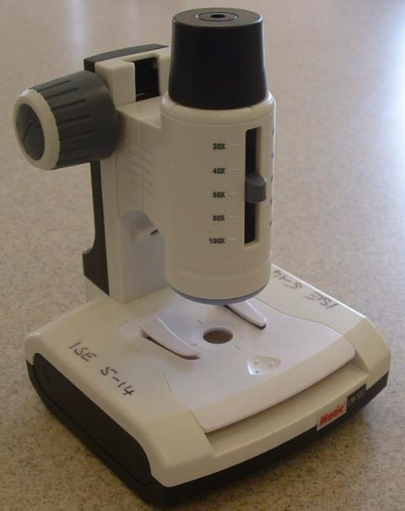

- Turn the focus knob until the lens is at its furthest point from the stage.
- Switch on the bottom light.
- Select the lowest magnification to begin with.
- Remove the ‘pond’ stage and replace it with the hanging drop slide you have made.
- Look down the eyepiece lens and turn the focus knob gently until the drop comes into focus.
- Note – you will probably have to focus up and down through the drop.

Check the results of the Scenedesmus in hydrogencarbonate indicator.
Note the colour of the indicator in each tube.

- What is the dominant process carried out by the algae in bright light / darkness.
- Which process do you think is proceeding most quickly?
- How can we link the process of photosynthesis to CO₂ levels in the atmosphere?
- Why are scientists talking about artificially encouraging the growth of phytoplankton as a way of reducing the greenhouse effect?

