Observing plasmolysis using the Veho^{tm} VMS-001 USB Microscope
Materials:

1 x red onion
1 pair forceps
1 scalpel
Microscope slides and coverslips
Blu tack^{tm}
Distilled water
Rock salt crystals
Petri-dish or gallipot
USB microscope and PC

Method:
- Remove the two ends of the onion and as many layers as is necessary to expose a fresh and unblemished layer.
- Using the scalpel, cut a square shape approximately 0.25cm x 0.25cm in the fresh layer of onion.
- Using the forceps tease away the red epidermis from the onion tissue and place this explant onto a microscope slide (figure 1).
- Make four small pieces of Blu tack and work them into spheres. Place the spheres at the four corners of a coverslip and place over the onion tissue (figure 2).
- Using a Pasteur pipette, flood the gap between the slide and the coverslip with distilled water. The piece of onion tissue will move when this is done. If it settles near any of the Blu tack, use one arm of the forceps to move it to a more central position.
- Using the USB microscope, locate the piece of tissue and focus on the edge. The cell walls and cytoplasm of individual cells are easily observable at a magnification of around x 200 (figure 3).
- Pour rock salt crystals into a Petri-dish or gallipot and select 4-6 which are flat enough to fit through the gap between the slide and the coverslip.
- Slip the crystals into the distilled water between the microscope slide and the coverslip (figure 4). This will result in the tissue being surrounded by a strong sodium chloride solution, allowing the observation of plasmolysis within a few minutes.
- As water leaves the onion cells, the cytoplasm of cells will shrink away from the cell wall (figure 5).

Hints and Tips

The larger the piece of onion tissue, the longer the effects of plasmolysis may take to become visible, so smaller pieces are more desirable.
The field of view of the microscope, as displayed on the laptop, is in a different orientation to the slide that you are looking at. As a consequence, it is not always easy to know which side of the coverslip is closest to the tissue edge that is in view. In order to minimise the time taken for the effects of plasmolysis to be seen, sliding rock salt crystals under the coverslip on all four sides is recommended.
Rehydration can also be observed with this set up. The salt solution should be bled out, using an absorbent paper towel, while at the same time adding more distilled water from the opposite side of the coverslip. This process will move the onion tissue. It is important to find it with the microscope again as quickly as possible or the phenomenon can be missed.

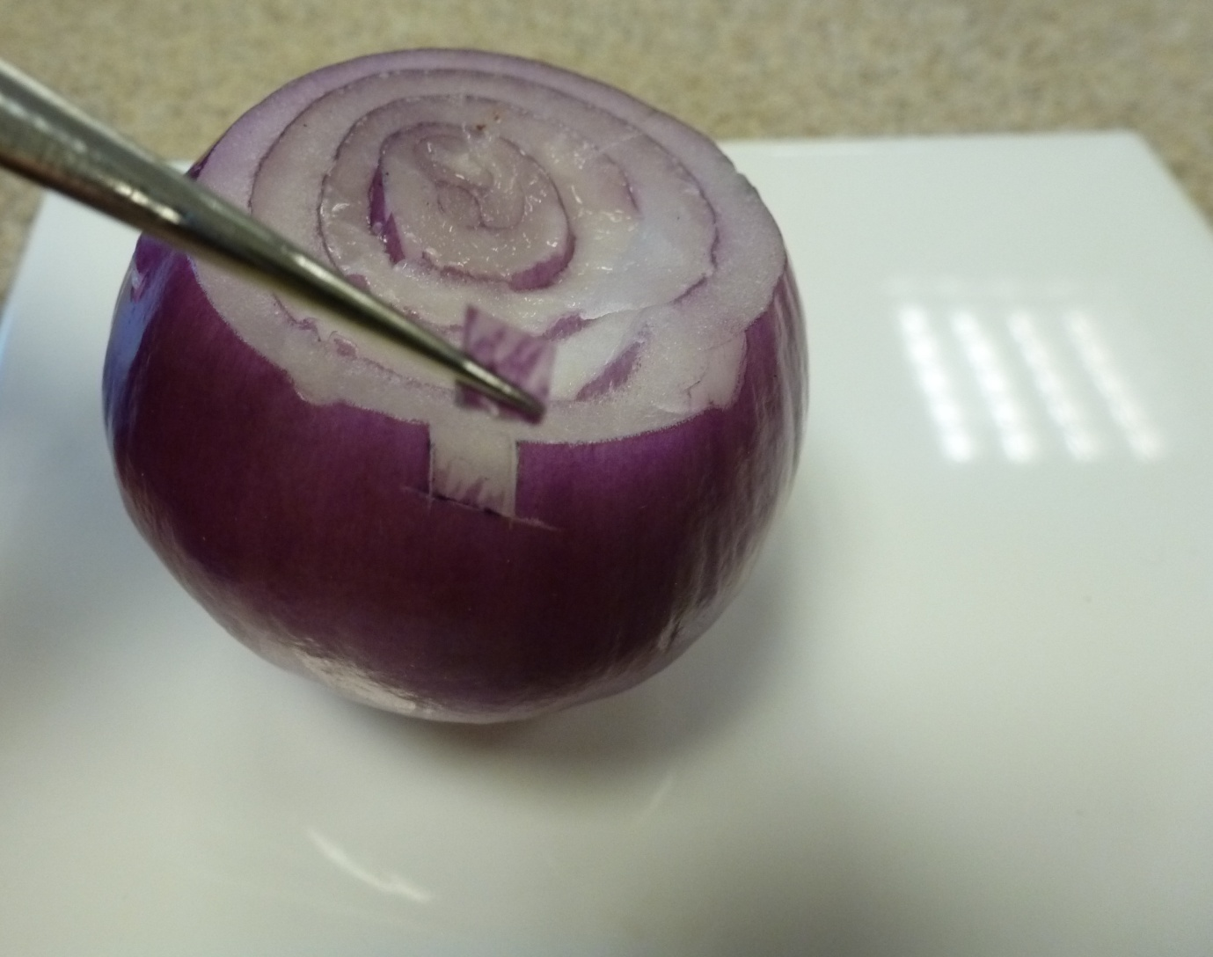
Figure 1: Removal of onion epidermis.

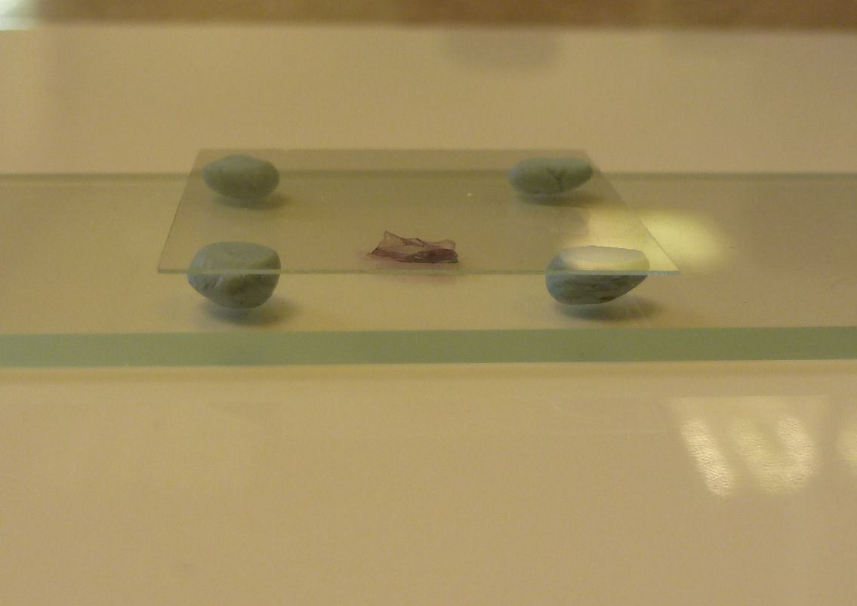
Figure 2: Coverslip on Blu-tack.
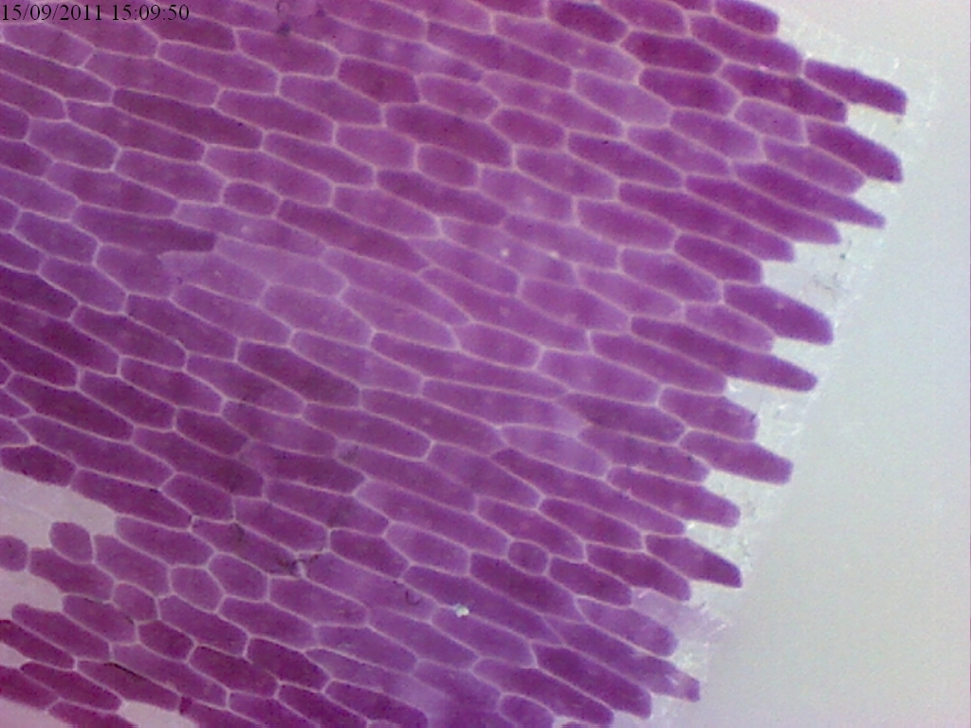
Figure 3: Red onion epidermis cells (x 200 magnification).
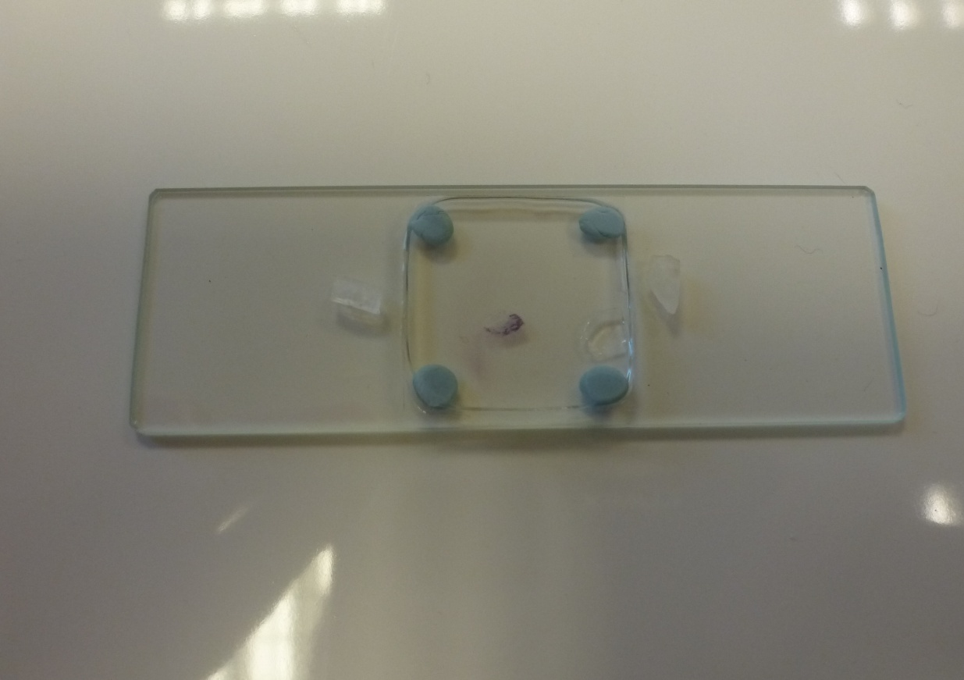
Figure 4: Salt crystal insertion.
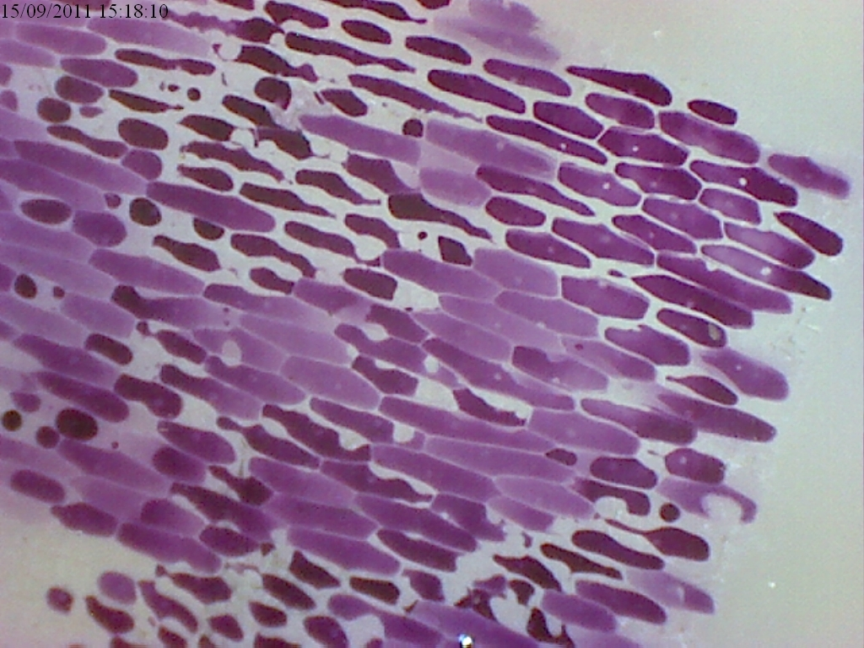
Figure 5: Plasmolysed cells.

