Looking at the heart
The purpose of this procedure is:
- to investigate the general structure of the heart
- to appreciate the differences between the muscles in different parts of the heart, and the structures such as valves and tendons that make the heart work
- to appreciate the differences in the structures of the blood vessels associated with the heart.

Procedure
SAFETY: Wear eye protection whenever there is a risk to the eyes, for example, when changing scalpel blades, cutting cartilage or if the heart you are working with has been preserved.
Clean the work area carefully after the investigation.

Investigation 1 – Looking at the outside of a heart
- Note the general shape and size of the heart.
- Measure its size and mass. Estimate its external volume.
- Identify the vessels entering and leaving the heart. Arteries have thick, rubbery walls. Veins have much thinner walls. Feel inside these vessels with your fingers and feel the texture and strength of both vessels. Try to describe what you feel.
- Look inside the main arteries and veins. If you see any structures attached to the walls, try to decide what they are, what they might do and how they might work.
- Identify the atria and ventricles. Try to describe any differences in the structures of the walls of the atria and ventricles.
- Decide which you think is the right side of the heart and which is the left. What has helped you to decide?
- Examine the surface of the heart for blood vessels.
- Note the colour and texture of the different parts of the heart.

Investigation 2 – The internal structure of the heart
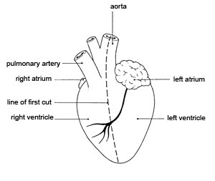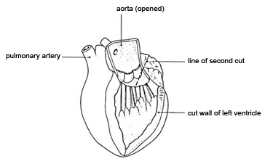
Diagram 1 Diagram 2
- Look at the first diagram. Make a long cut down through the aorta and the left ventricle to the tip of the heart (‘apex’), as shown in the diagram. The position of the blood vessels on the surface will help you to make this cut in the right place.
- Pull the edges of the ventricle apart and examine the inside of the ventricle and the aorta. At the base of the aorta, you will see the structures mentioned in d. Examine them carefully.
- Look at the second diagram. Cut upwards carefully into the left atrium along the line shown in the diagram.
- Measure and record the thickness of the walls of the atrium and the ventricle.
- Examine the right side of the heart in a similar way.
- Look at the areas where an atrium joins a ventricle. Examine the structures there. These are valves separating the chambers of the heart. You should see flaps of thin tissue, with tough ‘threads’ attached to the base of the flaps. Count how many threads there are on each side of the heart. Think about how these valves might work.

Record sheet for student observations

The Heart
Overall size:
Mass:
Estimated external volume:
Vessel type 1 | Vessel type 2
Atrium  Thickness of wall: | Ventricle  Thickness of wall:
Valve type 1  Position:  Way of working: | Valve type 2  Position:  Way of working:

