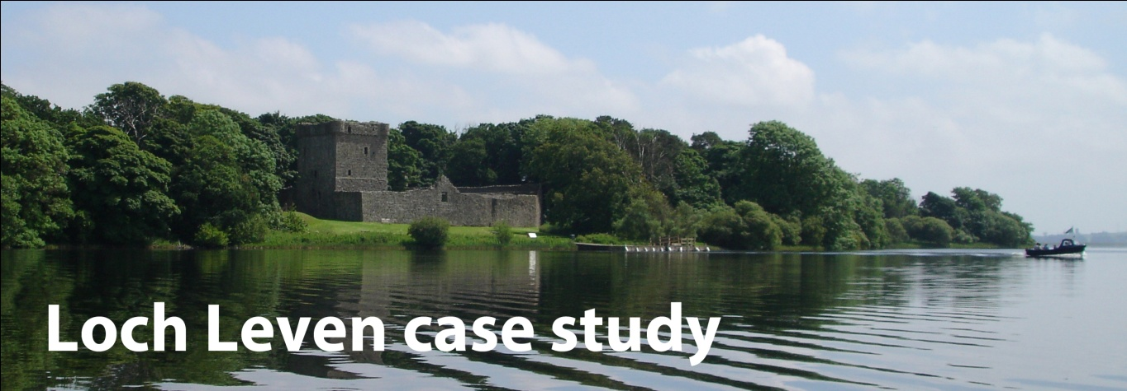
Overview
Pressures
Management responses
Monitoring the environment
Environmental responses

Overview
Loch Leven is a large shallow loch. It is near Kinross in Scotland.
(surface area 13.7km², average depth 3.9m)
It is an excellent example of a loch which has a wide range of ecosystems. It has a history of many pressures on its use.
Pressures
In the early 1800s, growing industries wanted a more stable water supply from the loch. Landowners also wanted to increase agricultural production by reclaiming land around the shores of the loch.
Fishery management: Loch Leven is managed as a world famous trout fishery.
Eutrophication: Industrial development, increase in agriculture and population growth caused phosphorus (P) inputs to Loch Leven to increase from 5t y⁻¹ in the early 1900s to 20t y⁻¹ by 1985. (t y⁻¹ - tons per year )
This caused algal blooms and reductions in water clarity that decreased the growing depths of aquatic plants and reduced biodiversity.

Management responses

Flow regulation and land reclamation: Flow regulation began in 1850 when sluice gates were installed on the outflow. This lowered the loch level by 1.5m and exposed 265 ha (ha – hectare = 10,000 sq metres) of land. The sluice gates still control the outflow.
Fishery management: Loch Leven was stocked with brown trout from the 1880s to the 1930s and then from 1983. The aim was to boost the economic value of the fishery. Stocking with rainbow trout began in 1993. All stocking ceased in 2004.
Eutrophication: Phosphorus inputs to Loch Leven were reduced significantly between 1985 and 1995 by reducing discharges from local industry and waste water treatment works.
Monitoring the environment
The Centre for Ecology and Hydrology has monitored Loch Leven regularly since 1968. The results of this work have provided data for many research projects. When additional sources of data are included, the Loch Leven data set spans more than 150 years and a wide range of variables including hydrology, algae, zooplankton, macro-invertebrates, fish and wildfowl.

Environmental responses
Eutrophication: When the external Phosphorus loading to the loch was reduced, open water Phosphorus concentrations fell. The water clarity increased (especially in spring) and submerged plants re-colonised deeper areas of the loch. Ecological recovery was delayed by internal Phosphorus cycling for about 15 years.
Questions
- Describe the pressures on Loch Leven in the early 1800s which were caused by human impact?
- a) What were the causes and effects of eutrophication of Loch Leven?
CAUSES: EFFECTS:
b) Why does reduced water clarity cause a decrease in aquatic plants?
c) Why does this decrease in aquatic plants reduce the biodiversity of the loch?
3. Why were the sluice gates installed around Loch Leven?
4. Describe the management of the fisheries in Loch Leven
5. How was the phosphorus input into Loch Leven reduced between
1985 and 1995?
6. How has the environment of Loch Leven responded to the drop in
phosphorus levels?
Complete this time-line:
Phosphate input increases
Industry grows Algal blooms
1800 1900 2000

