Producing a key – a different perspective
Introduction
Use and production of classification keys is an integral part of many school Biology courses. Keys also play an important role in fieldwork. Unfortunately, activities involving their use are often relegated to book-based exercises whereby pupils are required to look at pictures rather than get hands-on experience of real organisms either within the classroom or in the field.
The activity described below extends a familiar exercise for teachers and pupils and explores it from a slightly different angle. This exercise helps pupils to develop observational skills and allows for engagement in teamwork. The activity also highlights the potential of the ‘Outdoor Classroom’ for teachers, whether it be part of the school grounds, or the wider local area. In addition, through this activity, we aim to challenge teachers in terms of thinking about inclusion of different learners and different styles of learning.
The Activity
Pupils are initially presented with the challenge of producing a key that could be used by people who are blind. They should be encouraged to think about the problems that a blind person would encounter and the skills they would be able to use in trying to identify specimens. Working in groups of three, pupils are then required to produce a ‘paired statements’ classification key which they would read out. From this, a blind person should be able to identify a number of biological specimens, either in the classroom or out in the field. It is important, therefore, that descriptions should relate to the sense of touch. Pupils would also have to think about the use of precise language in the production of the paired statements.
Setting up the Activity
The keys activity can take place outdoors or in the classroom using specimens that have been collected beforehand should outdoor conditions not permit. However, access to suitable school grounds or a local area would be the preferred option. The instructions below are for use of the activity in the classroom. Modifying the activity for outdoor use would depend very much on facilities available to individual schools, and would require careful forward planning.
Equipment required for each group
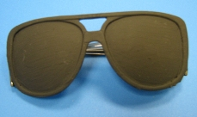
Figure 1 - A ‘blindfold’ made from old safety glasses and black paint. Alternatively, pupils’ scarves may also be used.
Pen/pencil
Plain paper
Tray of 4-5 bagged specimens identified by letter only
(Specimens used could be deciduous leaves or twigs if done during the winter months, deciduous fruits, conifer needles, cones, bark, seashells, supermarket fruit. Some thought should be given as to easily identifiable differences in shape and texture of the specimens.)
Blindfold (See Figure 1)

When trying out this activity in November, we used fruits from deciduous trees such as horse chestnuts, hazelnuts, and beech mast which could be kept reasonably well-preserved. A selection of common seashells such as mussels, cockles, and whelks were also used. These were soaked in 1% bleach solution and dried before use (see Figure 2).

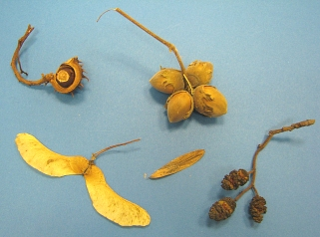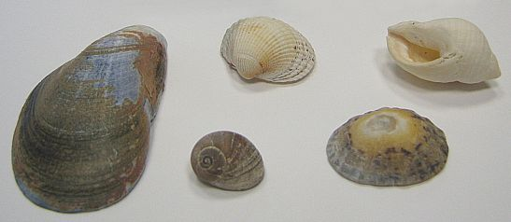
Figure 2 - A small selection of (a) deciduous fruits and (b) common seashells used in the activity.
Pupil procedures
Pupils can be organised into groups of three in advance of the activity. This allows for one member of the group to move to another group to play the ‘blind’ person once the keys have been completed.
The groups are each given a tray of labelled specimens. We recommend that each group be given different specimens, and that the exercise is the same for each group.
Pupils are then encouraged to examine the specimens and try to think carefully about how each one feels in terms of shape and texture (Figure 3). Wearing a blindfold while doing this is recommended as it removes the sense of sight from the preparation of the key and focuses in on touch. In initial trials we found that using the sense of sight often got in the way; in that instance, specimens were described in ways that were very much influenced by sight as well as touch.
The activity described above is suitable for use with groups of pupils in S1/2 Science. It would also provide a meaningful exercise for those studying Standard Grade Biology, particularly through the Biosphere and World of Plants topics.
Use of different types of keys and different varieties of specimens would allow differentiation within the keys activity. For example, creation of branching key might allow less able pupils to engage with the activity more successfully Types of specimens used could also be altered depending on the target group: a selection of common supermarket fruits might be of use with a SEN group, where the sense of smell may also be used to help with identification.
The methodologies used in this activity support Curriculum for Excellence in a variety of ways. They will encourage creative thinking and pupils will apply their learning in a different context. The activity should also help children to relate to others who cannot see.
Note: this article is taken from SSERC Bulletin 224

