 | THE MEASUREMENT OF COMPENSATION POINT  Laboratory Protocol | 

Procedure- in pairs

- You are provided with two small bottles, one containing a concentrated solution of Scenedesmus quadricauda and the other a solution of sodium alginate.

- Shake the Scenedesmus quadricauda and add it to the sodium alginate solution.

- Place about 30 cm³ of CaCl₂ solution into the plastic cup.

- Clamp the barrel of your syringe (you will not need the plunger) so that it is about 20 cm above the top of your plastic cup.

- Making sure that you have thoroughly mixed the solution prepared in 2 above, pour the algae/alginate mixture into the syringe.

- As the algae/alginate mixture flows into the CaCl₂ solution you should see that small spherical beads of immobilised algae are formed.

- Once all of the liquid has flowed from the syringe leave the newly formed beads for about 5 min. Transfer them to the tea strainer and wash them (gently!) with cold tap water for about 1 min. Give them a final rinse with distilled water.

- Line up 8 empty Bijou bottles. Rinse the first bottle with approximately 2 - 3 cm³ of hydrogencarbonate indicator and transfer the indicator to the second bottle. Repeat this process until all bottles have been rinsed.

- Repeat step 8 on 2 further occasions.

- Transfer 15 algal balls into each of the 8 Bijou bottles.

- Using a syringe add 4 cm³ of hydrogencarbonate indicator to each Bijou bottle.

- You are provided with 7 pre-formed filter sleeves:

71%, 50% (2 samples), 25%, 12.5%, 6.25% and 0% (black paper)

These pre-formed filters will fit over your Bijou bottles. You are also provided with an additional piece of filter which will allow 71% of light to be transmitted.

Over/

- Place each of the pre-formed filter sleeves around 7 of the Bijou bottles and leave 1 bottle without filter (this sample will receive 100% of the incident light).

- Take the additional piece of 71% filter and wrap this around one of the Bijou bottles which has a 50% filter in place. This will provide you with a combination which will allow 35.5% of light to be transmitted.

- Write your initials on the lids of all 8 bottles and also record the %light transmission.

- Place all 8 bottles in front of one of the fluorescent tubes making sure that all samples are close to, and equidistant from, the lamp.

- Leave the samples in front of the lamp for a period of 90 min.

- Thoroughly mix the contents of each Bijou bottle.

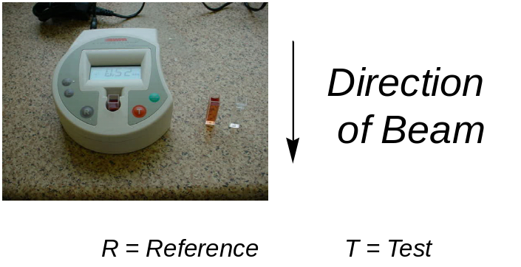 | 19. Switch on the colorimeter and set the filter to 580 nm. Rinse out a cuvette with hydrogencarbonate indicator. Add approximately 3 cm³ of hydrogencarbonate indicator to the cuvette and zero the colorimeter using this solution.  20. Discard the hydrogencarbonate indicator and gently pour into the cuvette the hydrogencarbonate indicator from the Bijou which received 0% of the light. Measure and record the absorbance.

- Using the same cuvette as in step 20, measure and record the absorbance of each of the solutions in the remaining 7 Bijou bottles.

- Plot absorbance against % light transmitted and from the plot estimate the compensation point.

Percentage light tranmsitted | Absorbance (580 nm) | Percentage light tranmsitted | Absorbance (580 nm)
0.0 |  | 35.5
6.25 |  | 50.0
12.5 |  | 71.0
25.0 |  | 100.0

