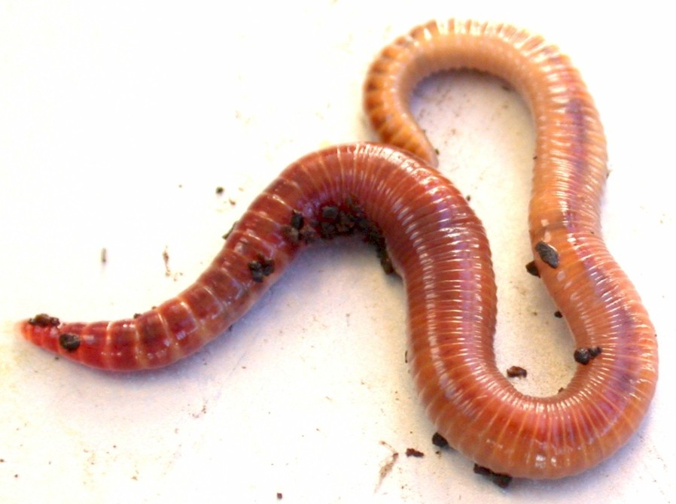
How to Make a Wormery

(Adapted from a protocol by Glasgow City Council, Countryside Ranger Service)

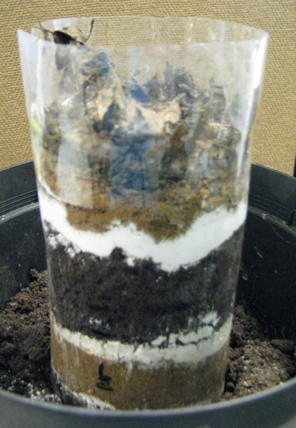
What you will need
- One large , clear plastic drinks bottle
- Plastic container (or plant pot) filled with soil
- Black paper, or card
- Crushed chalk
- Sand
- Soil
- Dead leaves
- 6-10 earthworms

Method
- Cut the top and bottom from the plastic bottle, creating a clear cylinder
- Put your earthworms into the soil in the plant pot
- Place the clear cylinder on top of the soil and fill it with alternate layers of soil, chalk and sand (thin layers of chalk and sand)
- Place some dead leaves which have been broken in to small pieces on top
- Cover the clear cylinder with black paper, or card, to keep out the light
- Keep everything damp – not wet – and leave for several days. Lift the cover and observe what has happened.

- There should be roughly 85% soil and 15% other materials in the wormery.
- The wormery needs to be kept somewhere cool and, once set up, left for about two weeks
- The worms can then be released where they were caught.

Earthworm facts

- The body of an earthworm is made of segments which look like rings along its length. The pointed end is the snout and the blunt end it the tail.
- Earthworms have no head, brain, or eyes.
- They have nerves under the surface of their skin all the way along the body. They are sensitive to light and so can sense, but not see, light and dark.
- Earthworms breathe through their skin. They have lots of blood vessels under their skin to absorb oxygen from air spaces in soil. Their skin must remain moist so that oxygen can dissolve and pass through into the blood vessels.
- Earthworms have no teeth or jaws, but they do have lips. They suck food in. They can’t eat food bigger than 2mm. They find food using their sense of smell and taste – they have 700 taste buds on each millimetre of snout. They eat leaves and drag them underground, improving the soil for plants. Every bit of soil in a garden has probably been through a worm several times.
- Earthworms move with the help the four tiny claw-like bristles (setae) on each segment of their body. Contractions and relaxation of muscles shorten and lengthen the earthworm’s body enabling it to move through the soil.
- Every earthworm is both male and female (hermaphrodite). This gives them the advantage of being able to mate with any worm they meet.
- If an earthworm is cut in two, and if the cut is near one of the ends, it might carry on living. It can grow the missing bit back after a while. However, if the worm is cut in half it will die.

Earthworms as recyclers
Bacteria, fungi and larger organisms such as beetles, centipedes and earthworms are decomposers. By breaking down dead plant and animal material, decomposers release nutrients back into the soil so that they can be used by other plants and animals. Earthworms help with this process by pulling organic matter like dead leaves down into the soil. They use this either for food, or to plug a burrow. Once in the burrow, the earthworm will shred the leaf and partially digest it. This mixture of partially digested leaves, soil and digestive juices then passes out of the earthworm through the anus in the form of ‘worm casts’. Earthworms help to improve soil fertility by breaking down and mixing in organic matter. Their burrowing also helps the mixing process as well as creating air pockets and drainage channels which help other organisms to live and improve soil drainage

