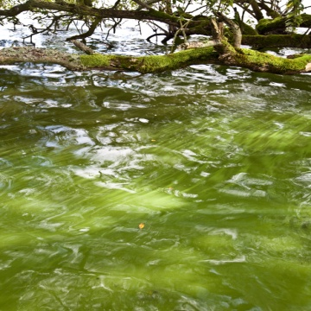
Eutrophication – Investigating the effects of fertilisers on the growth of an algal population.

Algal bloom, Loch Leven

All algae carry out the process of photosynthesis. In this way they use light energy from the sun to manufacture food which they can use immediately in the process of respiration to produce energy, or store as starch.
Algae also require essential nutrients from their surroundings for healthy growth. Phosphorous and nitrogen are examples of these nutrients.
An increase in the concentration of nutrients in an aquatic environment is called eutrophication. This will cause algae to reproduce at a faster rate and cause other aquatic plants to grow rapidly. Eutrophication can lead to a severe reduction in water quality. This is because when algae (and other plants) die they sink to the bottom of a river, or pond where they are decomposed by bacteria. The decomposition process uses oxygen and deprives the deeper waters of oxygen leading to the death of fish and other organisms.
Eutrophication is a natural process, but can be increased by human activity. For example, fertilisers from fields can be washed into rivers, streams and ponds. Fertilisers are composed mainly of nitrogen, phosphorous and potassium and if these are washed by rain from fields into a waterway they will provide the additional nutrients which will lead to an increase in algal and plant populations.
In this practical you will investigate the effect of a plant fertiliser, such as
Baby BioTM on the growth of a population of algae. The alga you will use is called Euglena gracilis. This is a common species of algae that can bloom due to the effects of fertilisers.
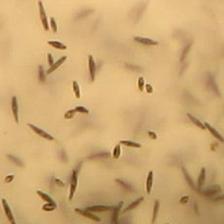

Euglena gracilis

The aim of the activities involved in this practical is to investigate the effects of a plant fertiliser on the growth of algae. This can be done by:
- Comparing algal populations by comparing absorbance using a colorimeter
- Comparing algal populations by using a light microscope
You will set up two populations of Euglena gracilis. One population will be grown in distilled water, the other will be grown in a solution of plant fertiliser. You will compare the populations at regular intervals over a period of 3 – 4 weeks.
Materials:
- Measuring cylinder
- 2 x conical flasks
- Distilled water
- Baby BioTM (or other suitable liquid plant fertiliser)
- Colorimeter
- 2 x cuvette
- 3 x plastic pipette
- Access to a discard jar
- Culture of Euglena gracilis
- Control cuvette 1 – containing distilled water. Control cuvette 2 containing fertiliser solution. (These should be retained and frozen after each colorimeter reading).
Method
Setting up the algal cultures
- Label the conical flasks:
Flask 1 – Distilled water; Flask 2 – Distilled water and fertiliser

- Put 250 cm³ of distilled water into each flask.

- Use a plastic pipette to put 3 drops of fertiliser into Flask 2.

- Add 25 cm³ of algal culture to each flask.
Comparing the algal populations using a colorimeter
- Use control cuvette 1 to calibrate the colorimeter for Flask 1(665 nm). Retain the control cuvette to be frozen for use with subsequent colorimeter readings.
- Gently swirl Flask 1 to mix the contents and, using a clean pipette, put
3 cm³ algal suspension into a clean cuvette. Place the pipette in the discard jar.
- Place the cuvette in the colorimeter, read and record the absorbance. Empty the cuvette back into Flask 1.
- Repeat steps 1 – 4 using control cuvette 2 and Flask 2.

You will repeat this process once per week for the next 3 - 4 weeks and use absorbance as an indication of the size of each of the algal populations. The greater the absorbance, the greater the number of Euglena present in the suspension.
You may also note a change in colour of the suspensions as time goes on.

Comparing algal populations by observing hanging drops of the two cultures
In this activity you will make a hanging drop of each culture and observe Euglena using a microscope. (See Preparing a Hanging Drop Help Card)
You can use this method to compare the two populations each week for the next 3 – 4 weeks.

Preparing a Hanging Drop HELP CARD
Materials
Microscope Lens tissue
Pipette Blu-takTM
Paper towels Two glass slides

Method
- Clean two glass slides by rubbing each of them gently with a piece of lens tissue. Do not throw away the lens tissue.

- Stick two small pieces of blu-takTM on one slide, about 2 cm apart.

- Gently swirl the flask to mix the contents. Using a pipette, draw up some of the algal suspension.

- Place a single drop of the liquid from the pipette in the middle of the second glass slide.

- Working as quickly as you can, turn the slide over so that the drop hangs down from the slide.

- Place the slide over the first slide and stick it down on the blu-takTM.

- The hanging drop should hang between the two slides without touching the bottom one.

- You are now ready to observe the algae under the microscope. Start with the x10 objective lens.

- When you are finished observing the algae, the pipettes and slides should be placed in a discard jar.

