Do you know your DNA? Teacher Guide
This is a card sort activity which might be used to support various levels of the curriculum.
The activity comprises four sets of cards:
Headings (Name, Description, Image) – three cards provide headings under which the other cards can be set out.
Name – names of six structures associated with the location of DNA.
Description – a definition of each structure.
Image – images of the structures referred to.
There is more than one way of setting the cards out. With pupils at National 5 level the task could be used as an evaluation of prior learning from National 4 and the task may be simply to examine the cards and set them out in a meaningful way.
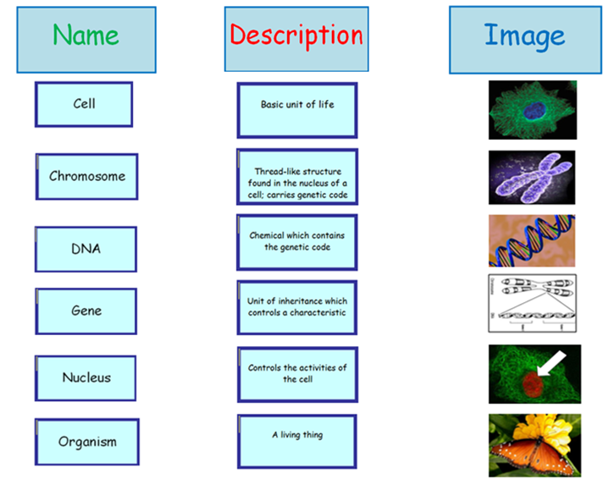
For example:

Pupils could then be asked to think about the size of the various structures in reality and rank the picture according the actual size of the structures shown.

