Counting cells workshop August, 2015

- Getting to know the microscope:
- “Finding your way round the microscope”
- Observe a prepared slide – adjust light, focus at x40, x100 and x400.
- Practise moving the slide around

- Prepare a slide of yeast suspension.
- Observe at x40, x100, x400

- “Finding your way round the haemocytometer”
- Identify sample injection area

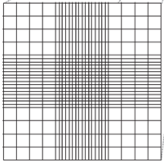
- Look at grids in the detection area with the naked eye
- Observe one detection area at x40 and identify the central grid

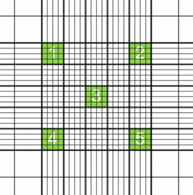
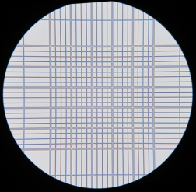
- Observe at x100 and identify ‘sample’ squares

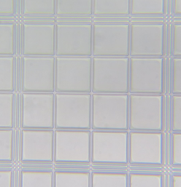
- At x400, find the top left and right, central and bottom left and right sample squares.
Notice the boundary lines

- Practise moving the haemocytometer around to find the sample squares.
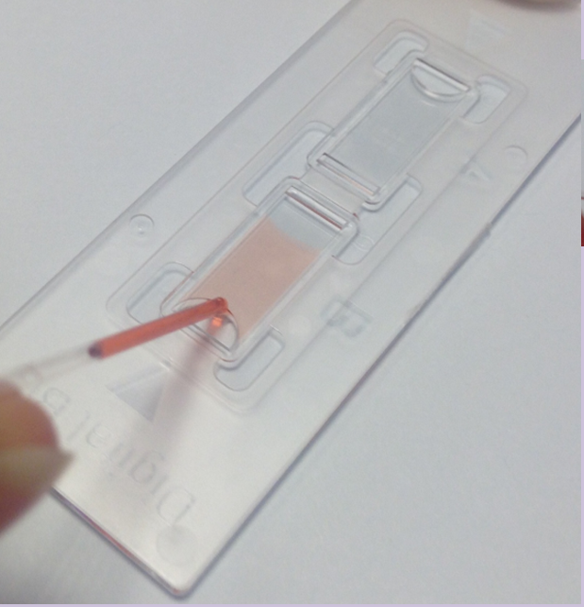
- Use a coloured dye to practise loading the haemocytometer using a capillary tube (load one sample injection area).

- Load the other sample injection area of the haemocytometer with yeast suspension
- Observe at x40, x100 and x400
- Check that you can find the sample squares at x400

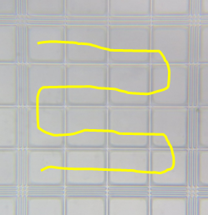
- Counting the cells
- Count systematically

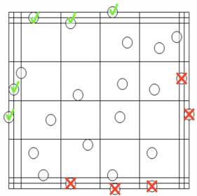
- Count all the cells within the sample square and those touching the top and left middle boundary lines

- Count the cells in all 5 sample squares

Square 1 ___________ Square 2 ___________
Square 3 ___________
Square 4 ___________ Square 5 ___________

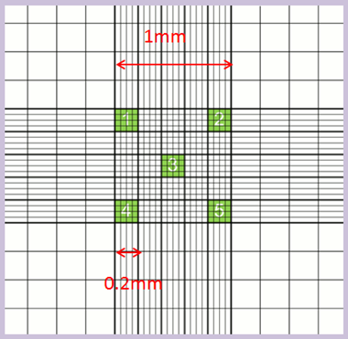
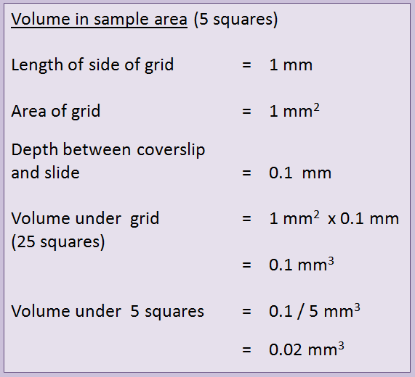
- Estimating the number of cells

