Biology on your doorstep

Activity 1
This activity allows pupils to establish that life is all around us, often in unexpected places. It first requires pupils to establish the ‘key characteristics of living things’ using ‘MRS GREN’.
- Discuss characteristics of living things – examples.
- In pairs, walk round the building and grounds looking for examples of each characteristic – note examples in MRS GREN table.
- Note living things in unusual places on the ‘more observation’ table.
- If doing this with a class, you might take photos for later discussion / display.
Activity 2
The idea of this activity is to encourage pupils to observe closely and to begin to think about biodiversity and abundance. It is based on the work of Nicky Souter, Strathclyde University, according to whom, ‘Observation is a significant – arguably the most significant science skill.’ (ASE Scotland Conference, March 2006).
Choose a grassy area for this.
- Working on your own, you have 2 minutes to collect as many different leaves as you can find.
- The person who has found the greatest number of different leaves sets them out in a row. Each person then puts their leaves on top of similar leaves in the row creating piles. The row may be extended for examples not already present.
- Discuss how we could use this activity with a class to begin to establish the concepts of ‘biodiversity’ and ‘abundance’. Could we use it for further observation and identification activities?
Activity 3
Sampling
This can be very simple or can use more involved techniques:
- Simply identifying some habitats within the school grounds and using identification guides to establish what lives there.
- Random sampling of an area using a quadrat.
- Carrying out a line transect using quadrats, then relating abundance and distribution to other factors by using light / moisture / pH meters.

Random sampling using a quadrat

This would be done where –
- The habitat is fairly uniform eg a field, lawn, playing field
- Randomly collected data is needed eg estimating the number of daisies in a lawn
- A large area needs to be covered quickly

A random sample will allow pupils to come up with some descriptions that characterise an area. This is useful if you want to compare two habitats such as two areas in the school grounds – a playing field and an open area that gets less foot traffic, for example.
Decide how to describe and record observations.
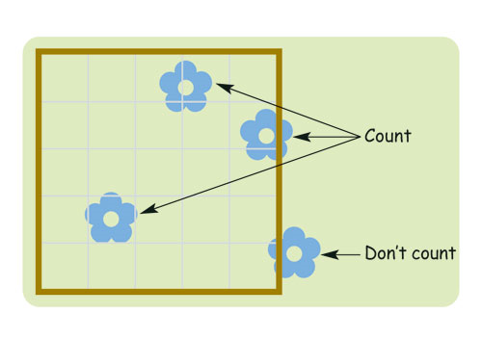
Abundant Common Frequent Occasional Rare
Or
Abundance score – count the squares containing any of the species being sampled
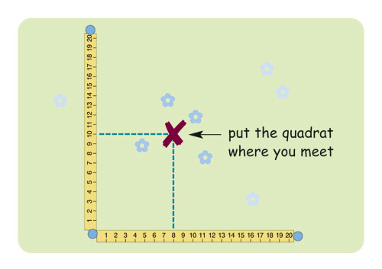

The Field Studies Council (FSC) Playing Field Guide suggests this method of randomly placing quadrats.
www.field-studies-council.org/resources

This kind of random sampling will not show up trends or changes across one area. There are systematic sampling techniques which allow changes along a line within one area to be investigated. For example, using a line transect.

Systematic sampling using a line transect

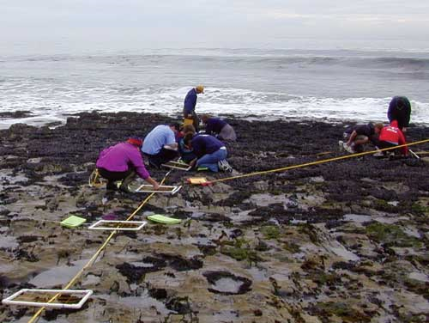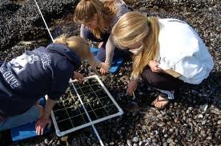

A line transect can be used for systematic sampling with a quadrat –
- To show zonation (for example, down a seashore, or across a woodland edge)
- To show a linear habitat (for example, a roadside verge)
A rope, or string, is used to mark out the line. Quadrats are placed at regular intervals along the line. Organisms’ presence, or abundance, can be noted.

What influences the distribution of organisms?
This can be related to biotic and abiotic factors.
Biotic factors – to do with other living things. For example, predators / grazers, disease, competition etc.
Abiotic factors – non-living / physical factors. For example, moisture, light intensity, wind direction etc.
Some abiotic factors could be measured at the sample points along the transect. For example, light intensity, moisture and pH can be measured using simple meters.

