Climate Change:
Are plants the answer?
Background Information
These activities are intended to allow pupils to gain an understanding of the role of photosynthesis in the carbon dioxide balance of the atmosphere.
Since most of the photosynthesis on the planet is done by aquatic plants, we are using microscopic algae and making the link for pupils to the role of phytoplankton in the ocean as a ‘biological carbon pump’.
The practical activities are engaging –
- Pupils will enjoy seeing and trying to identify the algae.
- Using hydrogencarbonate indicator is a very immediate and visual demonstration of carbon dioxide production / consumption.
- Comparing satellite images of phytoplankton blooms to microscopic images of algae illustrates that there are micro and macro ways of studying phytoplankton – wow!

Other activities –

- Matching activities address misunderstandings about photosynthesis and respiration in relation to plants.
- Carbon cycle activities can be done at various levels and allow opportunities for discussion of these complex processes.
- There are also opportunities to explore misconceptions about the greenhouse effect.
- Pupils can do their own research into the use of satellite images and the controversial notion of ‘seeding’ the ocean with iron to encourage phytoplankton growth

What are phytoplankton?
- Phytoplankton are microscopic organisms which live in watery environments both salty and fresh.
- Phytoplankton are a diverse group – microscopic algae, photosynthesising bacteria, cyanobacteria, plant-like diatoms and calcium carbonate-coated coccolithophores.
- They use chlorophyll to capture light energy from the sun and turn it into chemical energy during photosynthesis.
- Like all plants, phytoplankton carry out both photosynthesis and respiration. Respiration uses up oxygen and produces carbon dioxide. In darkness only repiration happens. In normal light photosynthesis proceeds more quickly than respiration, therefore, overall, plants use up more carbon dioxide than they produce and they produce more oxygen than they use up.
- Phytoplankton growth depends on the availability of carbon dioxide, sunlight and nutrients (nitrate, phosphate and calcium).
- They also require trace amounts of iron. Lack of iron limits phytoplankton growth in large areas of the ocean where iron concentrations are very low.
- Mixing of ocean water is crucial to bringing all these nutrients from ocean depths to the surface waters where they are used by phytoplankton.
- Phytoplankton form the basis of the ocean food web and are critical to the health of nearly everything that lives there.

Phytoplankton and the Greenhouse Effect
- Warming of the planet by the greenhouse effect is crucial to the survival of life on Earth. However fossil fuel emissions have greatly increased the levels of carbon dioxide in the atmosphere magnifying the greenhouse effect.
- Phytoplankton are responsible for most of the transfer of carbon dioxide from the atmosphere to the ocean. Carbon dioxide consumed during photosynthesis is incorporated (‘fixed’) in the phytoplankton, just as carbon is stored in the wood and leaves of a tree. Most of the carbon is returned to near-surface waters when phytoplankton are eaten or decomposed, but a significant quantity falls to the ocean depths. This is why scientists refer to phytoplankton as a carbon ‘sink’ or ‘sponge’. Phytoplankton, therefore, play a crucial role in reducing levels of the atmospheric carbon dioxide which cause the greenhouse effect.

- Scientists are currently investigating the possibility of releasing iron dust into the sea in an effort to increase the numbers of phytoplankton. The idea being that more phytoplankton would mean more photosynthesis leading to more carbon being taken form the atmosphere and stored in the deep oceans. This is a controversial idea because it is not yet clear whether it would be safe, effective or practical.

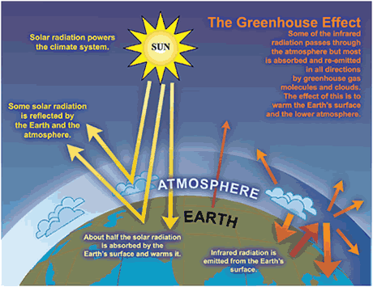
Image - Source IPCC, 2007: Climate Change 2007: The Physical Science Basis. Contribution of Working Group I to the Fourth Assessment Report of the Intergovernmental Panel on Climate Change [Solomon, S., D. Qin, M. Manning, Z. Chen, M. Marquis, K.B. Averyt, M. Tignor and H.L. Miller (eds.)]. Cambridge University Press, Cambridge.

Phytoplankton are sensitive to environmental change
- Phytoplankton depend on mixing of ocean waters to bring nutrients to the surface. As the ocean warms it becomes more stratified, with warmer remaining on top – thus mixing is reduced.
- Many phytoplankton species are also sensitive to changes in ocean acidity.
- As phytoplankton numbers decline, they will do less to keep global temperatures down.
- Because phytoplankton are so crucial to ocean biology and climate, any change in their productivity could have a significant influence on biodiversity, fisheries and the human food supply, and the pace of climate change.

Studying phytoplankton
- Phytoplankton can be studied by directly sampling water. They can then be identified by microscopic investigation or genetic analysis
- Satellites play a key role in global-scale monitoring of phytoplankton and their role in climate change. When they bloom by the billions, the high concentrations of chlorophyll and other light absorbing pigments change the way the ocean surface reflects light. Scientists can use colour sensing instruments to detect phytoplankton blooms and track their progress. However fluorescence data provides more specific information about how the phytoplankton use light. Phytoplankton can do three things with the light energy they absorb –
use it to carry out photosynthesis;change it into heat energy; or emit light (glow) in the red portion of the spectrum (fluorescence). It is the relative balance of these processes that indicates the health of phytoplankton.
When phytoplankton absorb light efficiently for photosynthesis, there is less light energy available for fluorescence. Therefore, relatively low fluorescence indicates a healthy phytoplankton population. Different species of phytoplankton fluoresce at different rates. Phytoplankton use light differently as the amount of sunlight varies from day to day, and season to season. As they age, or the availability of nutrients decreases, phytoplankton become less healthy and fluorescence may increase. This information is giving scientists a better idea of how ecosystem changes are affecting phytoplankton populations.

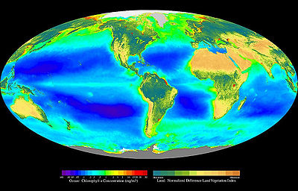
Composite image showing the global distribution of photosynthesis, including both oceanic phytoplankton and land vegetation. Provided by the SeaWiFS Project, NASA/Goddard Space Flight Center and ORBIMAGE.

Useful resources

- Material on photosynthesis and biodiversity can be found on SSERC 3-18 website. www.sserc.org.uk

- A guide to facts and fictions about climate change is available from The Royal Society, www.royalsociety.org/climate-change

- Ways You can Improve Earth’s health www.livescience.com/environment

- Information on phytoplankton and satellite images www.earthobservatory.nasa.gov

- There is an interesting article – Ocean Iron Fertilization, Capturing carbon to slow climate change, in last month’s edition of Catalyst (Vol 21, October 2010) www.sep.org.uk/catalyst

- The photosynthesis song (and other free science resources) available from www.simplescience.net

