Simple Chemical Experiments
Micro - electrolysis
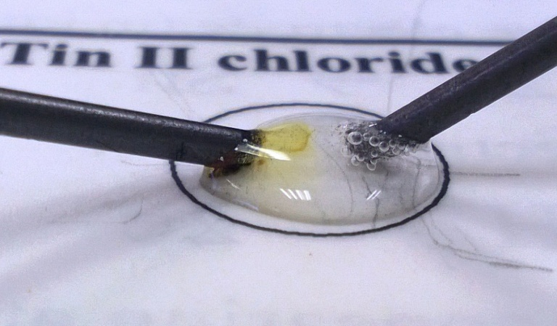
CfE
Through experimentation, I can identify indicators of chemical reactions having occurred.
SCN 3-19a
National 5 - Chemical Changes and Structure
Atomic Structure and Bonding related to properties of materials.
Introduction
This is a series of simple electrolysis reactions that can be carried out on a very small scale. Like the Iron Drops reactions, the experiments are carried out in drops on the laminated instruction sheet.
The electrodes used for testing were just pencil leads, extracted from a pencil. It might be easier to use leads from a packet for a propelling pencil but they tend to be thinner and thus more fragile.
The trials used a 9V dc power source but they could easily be done using a 9V PP3 type battery.
Microscale chemistry is a familiar concept but the method employed here takes it a step further. The reactions are all carried out using drops of reagents on a laminated sheet of paper. This has a few advantages:
- The instructions are built into the workspace (the sheet) so are more easily followed.
- At the end of the experiment, clearing up simply involves wiping the sheets with paper towel. No fiddly, small tubes or dimple trays to wash up.
- Because such small amounts of reagents are being used, a kit for the experiment will take up a very small amount of space.
If the explanations of the reactions are printed on the reverse of the sheet, pupils will not be able to check their answers until they have finished.
You will Need
Laminated sheets | Power supply / battery
Leads with crocodile clips | 2 graphite electrodes
1.5 % KI / 0.5% starch solution | 0.1% phenolphthalein solution
0.1M silver nitrate solution | 0.1M tin II chloride*
0.1M sodium sulphate | 0.1M sodium chloride
Blue food colouring

* Tin II chloride should be made up in 2M HCL (it hydrolyses in water to the oxychloride). Once made up, place a small piece of tin in the solution. The solution will not keep for more than a few weeks.

To do
Place a few drops of solutions on the laminated sheet, as directed.
Connect the electrodes to the power supply or battery and apply them to opposite edges of the drops. Observe what happens.

Micro Electrolysis - Explanations
- You see blue/black colour appearing at the positive electrode where iodide ions are being oxidised to iodine
2I⁻ I₂ + 2e⁻
At the other electrode, you see bubbles, and when phenolphthalein is added you get a purple colour, signifying alkaline conditions – due to the OH ions.
H₂O + 2e⁻ H₂ + 2OH⁻
- At the negative electrode tin ions are reduced to metallic tin
Sn²⁺ + 2e⁻ Sn
At the other electrode,
H₂O 2H⁺ + 2e⁻
- You see bubbles appearing at the negative electrode where iodide ions are being reduced to iodine
H₂O + 2e⁻ H₂ + 2OH⁻
Addition of blue food colour has no effect.
- You see bubbles appearing at the negative electrode where chloride ions are being reduced to chlorine
2Cl⁻ Cl₂ + 2e⁻
When blue food colour is added, the colour disappears as it is bleached by the chlorine. You may also be able to smell the chlorine gas.
- You see bubbles appearing at the negative electrodea gain where chloride ions are being reduced to chlorine
2Cl⁻ Cl₂ + 2e⁻
This time, when phenolphthalein is added you get a purple colour, signifying alkaline conditions – due to the OH ions.
H₂O + 2e⁻ H₂ + 2OH⁻
- You see bubbles appearing at the positive electrode where oxygen is being produced
4OH⁻ H₂O + O₂ + 4e⁻
At the negative electrode, you see silver forming.
Ag⁺ + e⁻ ⁻ Ag

