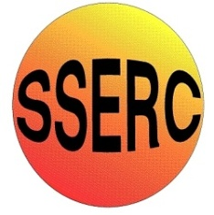

Chemical Demonstrations
Silver Mirror
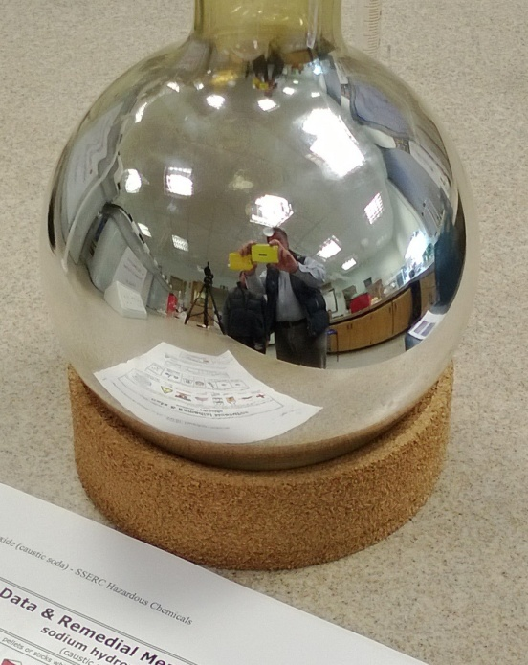
This reaction can be applied to curriculum for excellence.

Through experimentation, I can identify indicators of chemical reactions having occurred ...
SCN 3-19a
CfE Higher – Nature’s Chemistry
- Oxidation of Food
Introduction
This is a tremendous demonstration which is actually a test for reducing sugars such as glucose. The gradual appearance of the silver coating in the flask has a magic all its own.
This procedure can be done as an experiment, probably using test tubes for the pupils, depending on the amount of silver nitrate available.
NB Do NOT make up the solution more than an hour in advance and dispose immediately after use. On standing, ammoniacal silver nitrate can form a touch sensitive explosive.
You will need
A round-bottomed flask – the bigger the better (you can get the silver off and re-use it) | 1 x 100 cm³ beaker
Stirring rod (or magnetic stirrer | Concentrated (16 M) nitric acid (from a dropping bottle*)
0.10 M silver nitrate | concentrated (0.880) aqueous ammonia solution, (from a dropping bottle*)
0.80 M sodium hydroxide | 0.5 M glucose solution
Hot water | * You can use a Pasteur pipette rather than a dropping bottle.

Preparing the flask
Pour about 3 cm³ of concentrated nitric into the flask and stopper it. Swirl the acid around to dampen the entire interior surface of the flask. Pour the acid from the flask, and flush it down the drain with water. Rinse the flask and stopper it.
No more than ten minutes before presenting the demonstration, fill the flask with hot water to warm it. (Hot tap water is fine)
Preparing the mixture
Pour 30 cm³ of 0.10 M AgNO₃ into the 100 mL beaker.
While stirring the solution, add drops of 0.880 ammonia until the brown precipitate which forms initially has just dissolved.
Add 15 cm³ of 0.80 M sodium hydroxide to this mixture. A precipitate forms again,
Add drops of 15 M 0.880 ammonia again until it dissolves once more
Presentation:
Empty the hot water from the flask.
Pour 10 cm³ of 0.5 M glucose into the flask.
Add the contents of the beaker, and stopper the flask.
Swirl the flask continuously to cover its entire surface with a thin coating of the liquid.
Within about a minute, the flask will begin to darken as a film of metallic silver forms on its inside surface.
Continue to swirl the flask until the entire interior of the flask is covered with a film of silver, and the flask looks like a mirror.
After the demonstration, do NOT save the silver solution in a silver residues container. The solution must be disposed of down the sink with plenty of cold water within 30 minutes of mixing at the start of the demonstration. This is to avoid any chance of the formation of a deposit of silver fulminate, a dangerously explosive substance.

