

|  |
| --- |
| Chemical Demonstrations |
| Thermit |

### Introduction

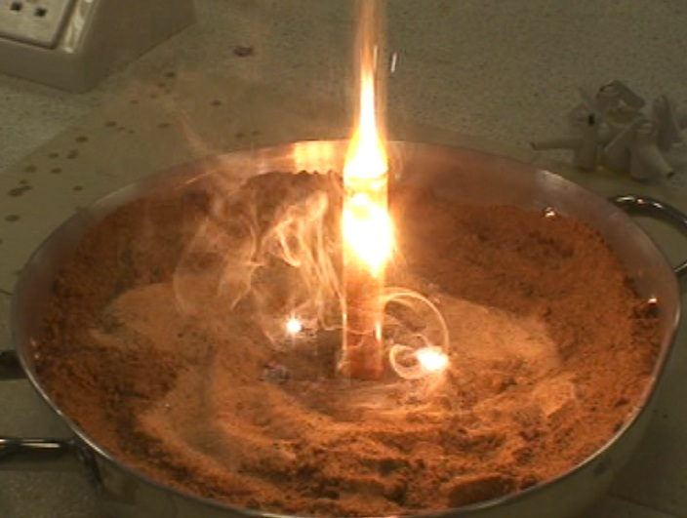

This experiment can be used to support the Curriculum for Excellence

*Through experimentation, I can identify indicators of chemical reactions having occurred … and can relate my findings to the world around me.*

SCN 3 19a

National 4 – Chemistry in Society

*The properties of metals and alloys*

CfE Higher - Chemistry in Society

*Oxidising or reducing agents*



### A stoichiometric mixture of iron(III) oxide and aluminium powder is placed in a test-tube standing in a tray of sand. It is ignited using a fuse of magnesium ribbon and a spectacular exothermic reaction follows producing molten iron.

### Apparatus you will need

# Several heat-proof mats to protect the bench.

# Small bucket of sand (a metal tray, biscuit tin or catering size coffee tin would do instead).

# One 16 mm x 150 mm test-tube. This will be destroyed so others will be needed if the demonstration is to be repeated.

# Safety screens.

# Access to oven set at between 75 °C and 100 °C.

# Desiccator (optional).

# A magnet.

# Chemicals you will use

The quantities given are for one demonstration.

11 g of fine aluminium powder.

32 g of powdered iron(III) oxide. Precipitated ‘red iron oxide, 85 % Fe2O3’.

About 6 cm of magnesium ribbon.

A little magnesium powder (optional).

# Safety

The apparatus must be surrounded by safety screens.

Demonstrator must wear goggles or a face shield.



Audience must wear safety goggles and be at a distance of several metres from the safety screens.

Do not use a fume cupboard to carry out this reaction.

Do not carry out this procedure outdoors.

# Procedure

# Before the demonstration

# Twenty four hours before the demonstration, weigh out the aluminium and the iron oxide separately and place them in the oven. Shortly before the demonstration mix the two powders thoroughly and return the mixture to the oven (or place it in a desiccators).*

# Protect the demonstration bench with heat-proof mats and place the container of sand in the middle of these.

# The demonstration

# Fill the test-tube with the stoichiometric mixture of aluminium and iron oxide.

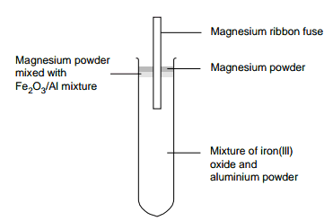

# Tap the tube to ensure good packing. Leave about 2 mm space at the top. Add about 1 mm depth of magnesium powder and mix this into the top millimetre of the mixture.

# Fill the remaining space with magnesium powder but do not mix this with the powders.

# Take about a 6 cm length of magnesium ribbon and straighten it out.

# Insert 1–2 cm of the ribbon into the mixture in the test-tube leaving the remaining 4 cm sticking out to act as a fuse (Fig. 1).

# Place the tube in the container of sand so that about two-thirds of the tube protrudes.

# Set up safety screens to protect the audience and the demonstrator and ensure that the audience is at least 2 m from the test-tube

# NB: A fuse longer than that described tends to ‘droop’ when ignited and the burning end may break off and fail to ignite the mixture. The length suggested leaves ample time for retreating to a safe distance!

# Using a roaring Bunsen flame, light the tip of the magnesium fuse.

# Stand well back as soon as it is lit. The magnesium will burn down to the mixture and ignite it. It will glow spectacularly and shoot out sparks leaving red hot molten iron. The test tube will melt.

# Allow the experiment to cool (this will take several minutes) and break away the remains of the tube. Examine the lump of iron that remains and show that it is attracted to the magnet. Show that neither the iron oxide nor the aluminium powder is magnetic.

# Note. If the mixture fails to ignite, take great care when approaching it and do not touch it unless you are absolutely certain that it has gone out completely. The mixture has been known to ignite some minutes after apparently failing. If in doubt, pour sand over the whole test-tube and leave it for several minutes.

**Tip**

You need to make sure the tube is filled right to the brim (or slightly above). If the magnesium ‘wick’ has to go down between the sides, it is very likely to go out.