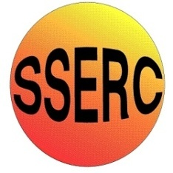

|  |
| --- |
| Chemical Demonstrations |
| Methanol Flame Tests |

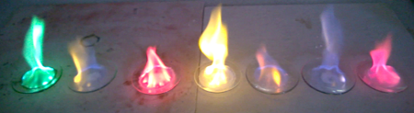Methanol Flame Tests

This reaction can be applied to curriculum for excellence.

*Through experimentation, I can identify indicators of chemical reactions having occurred ...*

SCN 3-19a

N4 Chemistry in Society

*- Chemical Analysis.*

N5 Chemistry in Society

*- Chemical Analysis.*

# Apparatus you will need

* Heat proof mat
* Pyrex watch glasses or petri dishes
* lighter

# Chemicals you will use

* Methanol
* 1g samples of various salts

sodium chloride, lithium chloride, potassium chloride, barium chloride, strontium chloride, calcium chloride, copper chloride

## Safety

Wear eye protection

GHS-pictogram-Warning_smallGHS-pictogram-skull_small

Care with solids – toxic and irritants

GHS-pictogram-flamme_small

Care with methanol - highly flammable

**If you want to repeat this, you must wait until the containers have completely cooled or use fresh ones. DO NOT add methanol to a hot container.**

**It is the responsibility of teachers doing this demonstration to carry out an appropriate risk assessment.**

# What you will do

## Before the demonstration:

1. Set out your watch glasses/petri dishes on the heatproof mat(s). (Make sure they are not likely to get knocked over.)
2. Place about a gram (a spatulaful) of the salts on the dishes (different ones on each container).
3. Place 3 cm3 of methanol on top of each of the salt piles (a 3 cm3 pipette is the easiest way to do it.
4. Put the top back on the methanol and move it several metres away.

## The demonstration:

1. Dim the lights
2. Using a lighter or a splint, light the methanol on each of the dishes

The flame will start off very pale blue but as it heats up, the colours of the elements will start to appear.

## Salts to try:

|  |  |
| --- | --- |
| Compound | Flame colour |
| sodium chloride | Bright yellow/orange |
| lithium chloride | Crimson |
| potassium chloride | Pale lilac |
| barium chloride | Yellowish green |
| strontium chloride | Bright red |
| calcium chloride | Pale brick red |
| copper chloride | Bright green |