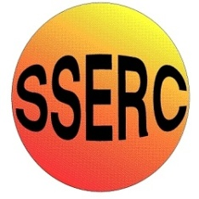

Chemical Demonstrations
Equilibrium and Le Chatelier
This reaction can be applied to curriculum for excellence.
Through experimentation, I can identify indicators of chemical reactions having occurred. ...
SCN 3-19a
CfE Higher – Chemistry in Society
Equilibria

Equilibrium and Le Châtelier.
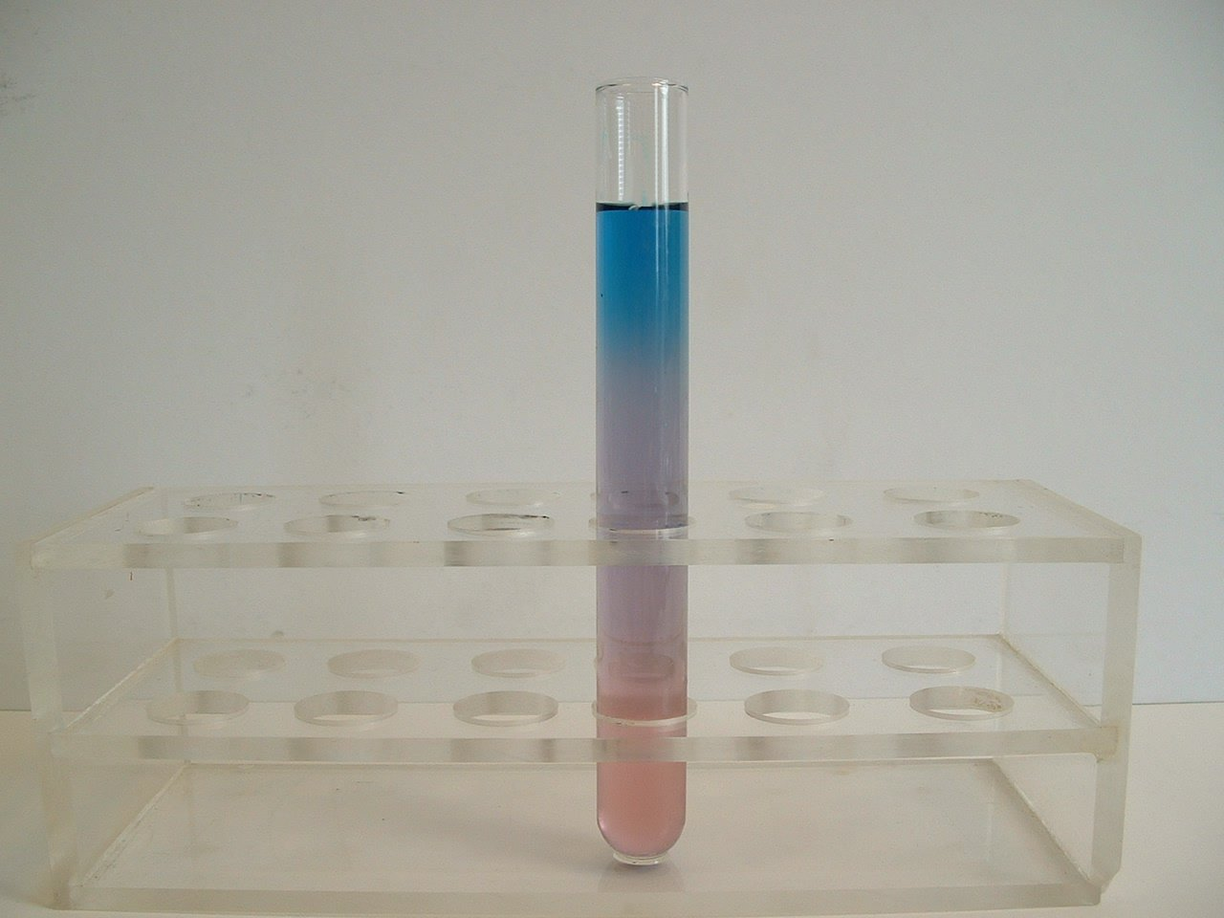
Background
The effect of temperature on the position of an equilibrium can easily be seen by observing the colour changes of the octahedral hexaaquocobalt(II) cation and the tetrahedral tetrachlorocobaltate(II) anion as the sample is moved from a low temperature to a high temperature.

The equilibrium equation can be expressed as follows:
Co (H₂O)₆²⁺ (aq) + 4Cl⁻(aq) CoCl₄²⁻(aq) + 6H₂O(l) ΔH+ve
Pink Blue

What you will need
- Cobalt(II) chloride
- Clear IMS (industrial methylated spirits)
- Distilled water
- Concentrated hydrochloric acid
- Balance
- Spatula
- Weighing boat
- 100cm³ measuring cylinder
- 250cm³ beaker
- Water bath at 50ºC (or a beaker of hot water and a thermometer)
- Small measuring cylinder or bulb pipette
- Test tube
- Hair dryer
- 100 cm³ beaker of iced water
- Small square of polystyrene with hole cut in it (diameter of the test tube)

Preparation of the solution
- Prepare a solution of the cobalt salt in the large beaker by dissolving 2g in 100 cm³ of IMS and 20 cm³ distilled water.
- Place 20 cm³ of the solution in the test tube.
- Place this in the water bath and bring it up to the required temperature of 50ºC.
- Using the measuring cylinder or bulb pipette, carefully add 2.0 cm³ of the concentrated hydrochloric acid to the solution. It will turn from pink to blue.
- Allow the solution to cool to room temperature. It should turn mauve in colour.

The demonstration
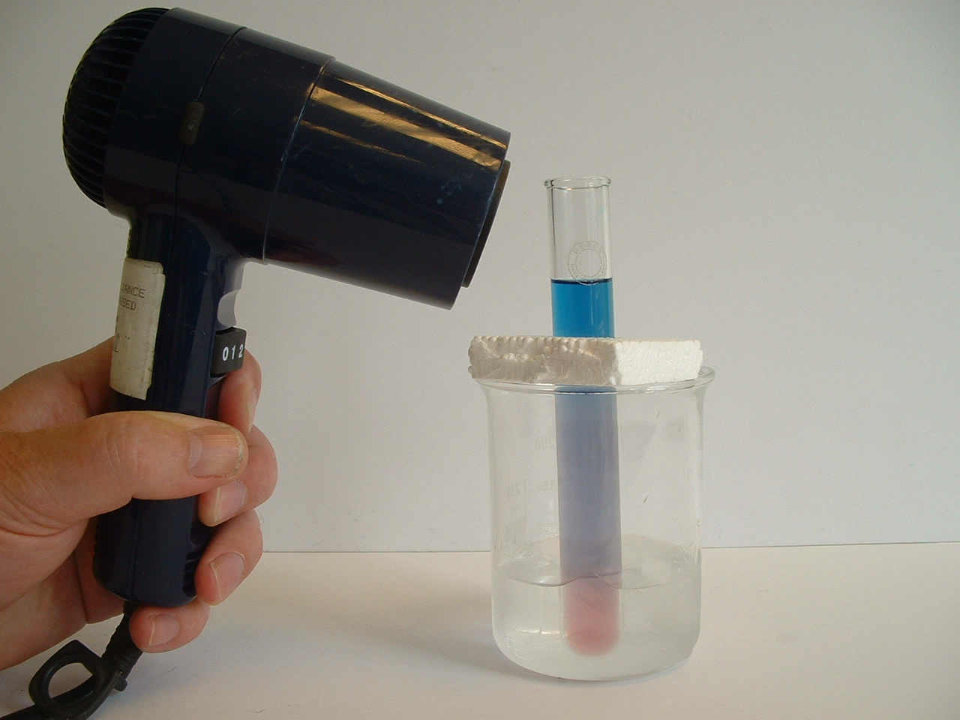
- Fill the test tube with the cooled solution.
- Place the polystyrene collar about a third of the way down the test tube.
- Place the test tube in the beaker of iced water to a depth of about a third its length. At the same time use the hair dryer to heat the top third of the solution above the polystyrene.
- (The polystyrene is to stop the middle third of the test tube heating up).
- Observe the colour changes!

If desired, test tubes of the solution can be prepared for students to carry out the experiment for themselves.
At Higher level, if they are given the equilibrium equation and the colours of the ions in solution, their observations of the colours at low and higher temperatures can lead them to predict if the ΔH for the forward reaction is positive or negative.

Safety
It is the responsibility of teachers doing this demonstration to carry out an appropriate risk assessment.

