Chemical Demonstrations
An Autocatalytic reaction

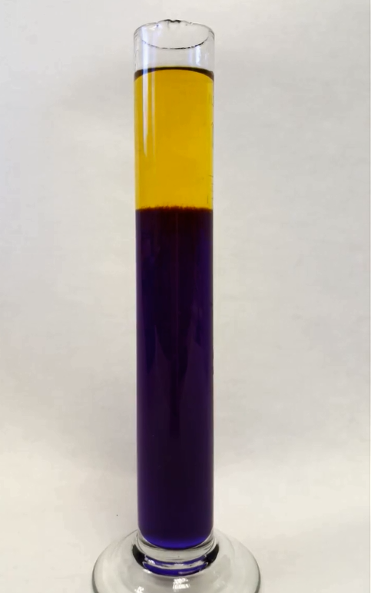
This reaction can be applied to curriculum for excellence.
Through experimentation, I can identify indicators of chemical reactions having occurred. ...
SCN 3-19a
CfE Higher: Chemistry in Society.
Equilibria
Introduction
Many reactions are speeded up by other substances, a phenomenon called catalysis. In some cases, though, the catalyst is one of the products of the reaction so once the reaction gets under way, the products catalyse its continuation and even sometimes speed it up.
In this rather attractive example, a small volume of acid is added to the top of the cylinder to initiate the autocatalytic reaction. A yellow layer is formed. Within a few minutes the yellow layer moves down the column as the autocatalysis effect takes place.
.
You will need
1 x 100 cm³ measuring cylinder | 10 cm³ 3M sulphuric acid*
5 mg (or so) bromophenol blue | 4g potassium chlorate (V)
12.5g sodium sulphite (anhydrous) NaSO₃ | Magnetic stirrer (optional)

To Do
Preparation
- 3M sulphuric acid can be prepared by adding 5 cm³ of concentrated sulphuric acid to 18 cm³ of distilled water.
* the concentration of the acid is quite critical. More concentrated than this and it will turn yellow too soon, more dilute and the reaction will be very slow.
- Dissolve 4g of potassium chlorate(V) in 50 cm³ of distilled water
Add to this 12.5g of sodium sulphite and stir well – it may not all dissolve yet but don’t worry
Now add 5mg of bromophenol blue (enough to give a good colour)
- Add 4 cm³ of your 3M sulphuric acid to 50 cm³ of water and mix well
- Slowly, with constant stirring, add the diluted acid from step c to the blue solution from step b. Stir until everything has dissolved.
The demonstration
- Fill a 100 cm³ measuring cylinder with the blue-violet solution
- Carefully add 3-5 cm³ of undiluted 3M sulphuric acid (from step a) to the top.

A yellow colour appears at the top of the cylinder and an interface will form between it and the lower, purple layer
Over the next few minutes, the yellow layer will work its way down the cylinder until it is entirely yellow.

Safety
Concentrated sulphuric acid is extremely corrosive so solutions should be made up with care.
3M sulphuric acid is also corrosive (wear goggles EN 166 3)
The reaction produces a significant amount of heat. Not enough to boil the solution but enough to make the cylinder uncomfortable to hold.
The reaction gives off some sulphur dioxide. Not much of this escapes as there is only a relatively small surface area but sensitive asthmatics should keep clear and the reaction should be carried out in a well-ventilated room.
The solutions can be disposed of by pouring down the sink – this released much more of the SO₂ so it should be done with caution, ideally in a fume cupboard.

What is happening?
This is a redox reaction:
ClO₃⁻ (aq) + 3HSO₃⁻ (aq) Cl(aq)+3SO₄²⁻(aq) + 3H⁺ (aq)
The reaction proceeds only in an acidic environment. Adding sulphuric acid to the top of the cylinder initiates the production of intermediate acids (producing extra H⁺ ions) that further catalyse the reaction. This is the autocatalytic effect.
Bromophenol blue indicator is yellow in highly acidic solutions. The blue solution has a pH between 6.5 and 7.0 due to the buffering effect of the bisulphite/sulphite ions.
As autocatalysis proceeds, the pH decreases and the blue colour of the indicator changes to yellow.

Notes
This experiment was found in a Kodak magazine from 1989. In origin, though, it seems to have come from Chemical Demonstrations: A Sourcebook for Teachers, Volume 1 by Lee Summerlin and James Ealy, 1985

