

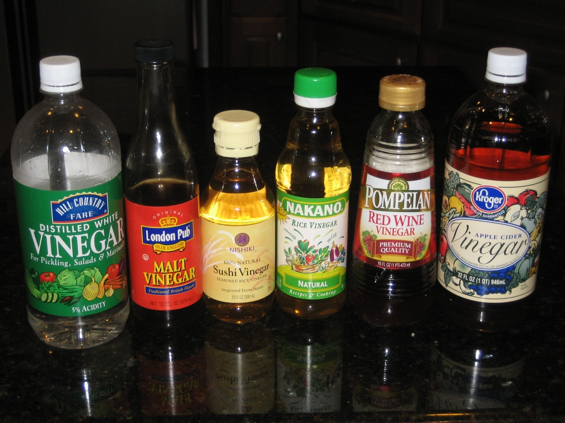

**Making a beetroot indicator**

Many palnts contain coloured compounds that will change colour depending on the pH. Because of this they can be used as indicators.

Beetroot is a good one to try and it is easy to get hold of.

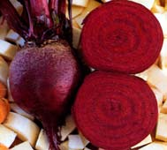

**What you do**

Wear gloves when preparing the indicator solution to avoid staining your hands.

This method uses about ¼ of a beetroot.

1. Chop the piece of beetroot into 2 cm pieces and place in a beaker.

2. Add 50cm3 hot distilled water from a kettle until the dye is removed from the beetroot.

3. Decant into a clean container. Keep the liquid, discard the beetroot.

4. Allow the indicator solution to cool before using.

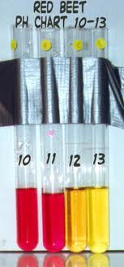Lots of other plants can be used to make indicators

Eg. Red cabbage, blueberries, cherries, etc etc as well as flowers and other things.

Experiment with different plants!

j0233055

One way of doing the experiment using the apparatus

and chemicals you have been given is like this:

You are going to mix vinegar (an acid) with sodium

hydroxide solution (an alkali). You may remember

that acids and alkalis will neutralise each other (cancel

each other out).

This equation shows what happens when you mix them:

Vinegar + An alkali A salt + Water

We can use a dye (called an indicator) to see when we have mixed the correct volumes of the solutions to make them neutral. The dye will change colour at this point (called the ‘end-point’). The volume of alkali added will tell us about the amount of ethanoic acid in the vinegar. The more alkali we need to add, the more acid there is in the vinegar. So a watered down bottle of vinegar will need less alkali to neutralise it than one that is not watered down.

The first task before you start is to see what colour change will take place in the indicator. So……………….

**Before you start**

1. Take two test tubes and place in the test tube rack.
2. Using Pasteur pipettes, put 1cm3 of the supermarket vinegar (an acid) in one test tube, and 1cm3 of the sodium hydroxide (an alkali) in the other.

**(Care – Wear Goggles at all times)**

1. Choose an indicator and put 3 drops of it in each test tube.

Shake the test tubes to mix the contents.

1. Note the colours of the dye and then set them aside – this will show you the colour change to expect when you do the experiment.

**Turn Over/……………………**

**Now for the neutralisation**

1. Measure out 1 cm3 of the supermarket vinegar into one of the test tubes.
2. Add three drops of the indicator - is the colour the same as the test tube of vinegar you set aside?
3. Now, using a Pasteur pipette, add the sodium hydroxide solution to the test tube of vinegar, drop by drop (counting the drops), swirl it gently after each 5 drops. Stop when the indicator just changes colour (check the test tube of sodium hydroxide you set aside).
4. Check how many drops of alkali you have added in total and record your results on the results sheet provided.
5. Repeat the experiment twice more in a clean test tube. Work out the average of the results.
6. Wash out the test tubes and repeat the whole experiment with each of the other vinegar solutions in turn.

1. Record your results in the table on the results sheet.



One way of doing the experiment using the apparatus and chemicals you have been given is like this:

You are going to mix vinegar (an acid) with chalk. (chalk is calcium carbonate). Chalk will neutralise the acetic acid in the vinegar (cancel it out).

The more acetic acid there is, the more chalk will be needed.

This equation shows what happens when you mix them:

Vinegar + Chalk A salt + Water + Carbon dioxide

When vinegar and chalk are mixed, you will see them start to fizz. This is the carbon dioxide gas being made and escaping. So the mass of the vinegar and chalk mixture will get less.

We can weigh the chemicals before and after the reaction and compare how much mass has been lost.

The amount of mass lost will tell us about the amount of acetic acid in the vinegar. The more mass lost, the more acid there is in the vinegar. So a watered down bottle of vinegar will lose less mass than one that is not watered down.

**Before you start**

1. Take the balance and carefully weigh out about 2g of powdered chalk. (it doesn’t matter whether it is exactly 2g but you need to know the exact mass*) Set this aside.
2. Write down the exact mass of the chalk on the results sheet.
3. Using a measuring cylinders, put 10cm3 of the supermarket vinegar in one of the small beakers.

**Turn Over/……………………**

1. Find the mass of the beaker plus the vinegar. Write this down on the results sheet.
2. Add the mass of the chalk to the mass of the beaker of vinegar. Write this down on the results sheet.

**Now for the neutralisation**

1. Add the chalk to the beaker of vinegar and stir until it stops fizzing.
2. Now reweigh the beaker. Write down the answer on the results sheet.
3. Subtract the mass from the total mass you started with to find how much mass has been lost.
4. Clean the beaker out and dry it carefully with paper towel. Repeat the experiment twice more to check no mistakes have been made. Record these results as well.
5. Work out the average mass lost in the experiments.
6. Clean out your beakers (there may be a container to pour this into).
7. Finally repeat the whole experiment with clean beakers and each of the other vinegar solutions in turn.

1. Record your results in a table for each of the vinegar samples in turn.

* Put about 2g of powdered chalk in the weighing boat and measure its mass **exactly**.

eg you might get a little under 2g but if the scales read 1.945g then that is what you record.

**Experiment 1**

|  |  |  |  |  |
| --- | --- | --- | --- | --- |
|  | Test 1  Drops of alkali added | Test 2  Drops of alkali added | Test 3  Drops of alkali added | Average  Drops of alkali added |
| Supermarket Vinegar |  |  |  |  |
| Burgers2Go Vinegar |  |  |  |  |
| Just Chips Vinegar |  |  |  |  |
| FatMan’s Heaven Vinegar |  |  |  |  |

Have any of the vinegars been watered down?

If so, which one(s)?

Which has been watered down the most?

By how much?

**Experiment 2**

|  |  |  |  |
| --- | --- | --- | --- |
| Vinegar Sample | ..................................................................................... | | |
|  | Expt 1 | Expt. 2 | Expt. 3 |
| Mass of chalk(g) |  |  |  |
| Mass of vinegar + beaker(g) |  |  |  |
| Total mass at start(g) |  |  |  |
| Total mass at the finish(g) |  |  |  |
| Mass loss(g) |  |  |  |
| Average mass loss(g) |  |  |  |

|  |  |  |  |
| --- | --- | --- | --- |
| Vinegar Sample | ..................................................................................... | | |
|  | Expt 1 | Expt. 2 | Expt. 3 |
| Mass of chalk(g) |  |  |  |
| Mass of vinegar + beaker(g) |  |  |  |
| Total mass at start(g) |  |  |  |
| Total mass at the finish(g) |  |  |  |
| Mass loss(g) |  |  |  |
| Average mass loss(g) |  |  |  |

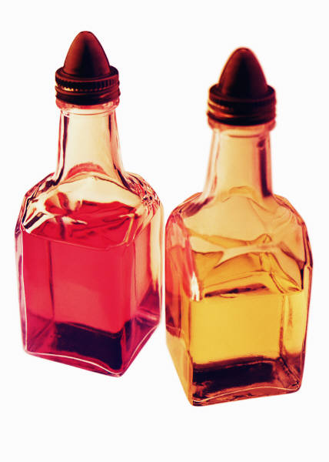

|  |  |  |  |
| --- | --- | --- | --- |
| Vinegar Sample | ..................................................................................... | | |
|  | Expt 1 | Expt. 2 | Expt. 3 |
| Mass of chalk(g) |  |  |  |
| Mass of vinegar + beaker(g) |  |  |  |
| Total mass at start(g) |  |  |  |
| Total mass at the finish(g) |  |  |  |
| Mass loss(g) |  |  |  |
| Average mass loss(g) |  |  |  |

|  |  |  |  |
| --- | --- | --- | --- |
| Vinegar Sample | ..................................................................................... | | |
|  | Expt 1 | Expt. 2 | Expt. 3 |
| Mass of chalk(g) |  |  |  |
| Mass of vinegar + beaker(g) |  |  |  |
| Total mass at start(g) |  |  |  |
| Total mass at the finish(g) |  |  |  |
| Mass loss(g) |  |  |  |
| Average mass loss(g) |  |  |  |



Have any of the vinegars been watered down?

If so, which one(s)?

Which has been watered down the most?

By how much?

How well do these results compare with your results from experiment 1?