

|  |
| --- |
| Metal Ores |
| Rocks to Riches |

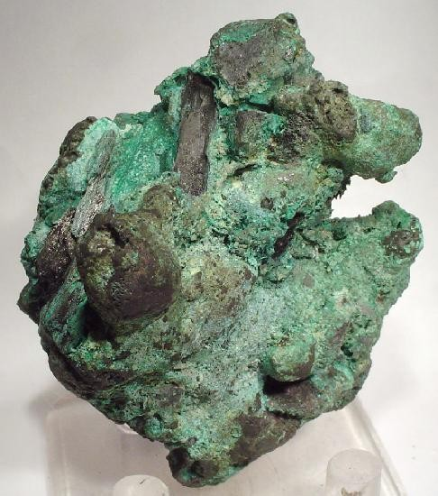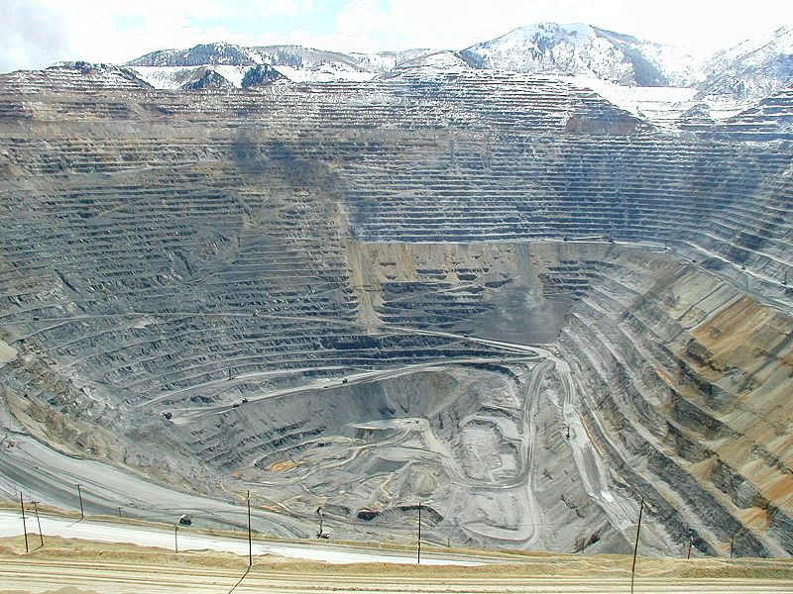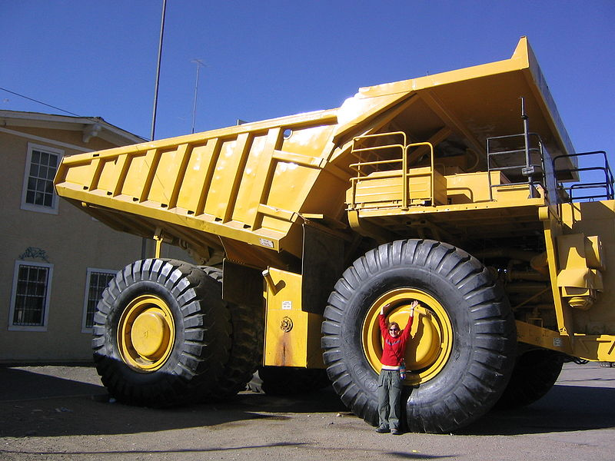

Rocks to Riches

# Overview

An ore is a mineral that can be worked for a profitable return.

Mineral and mining companies need to invest large sums of money from exploration through to marketing and so mineral concentrations found in the Earth’s crust must be viable.

Through simple colorimetric analysis of rock samples, you will be able to to determine the percentage of the mineral in the ore and work out if market demands make it feasible to extract it and refine it for the metal to be used in our everyday products.

The pictures below show what two common copper ores look like as they come out of the ground.

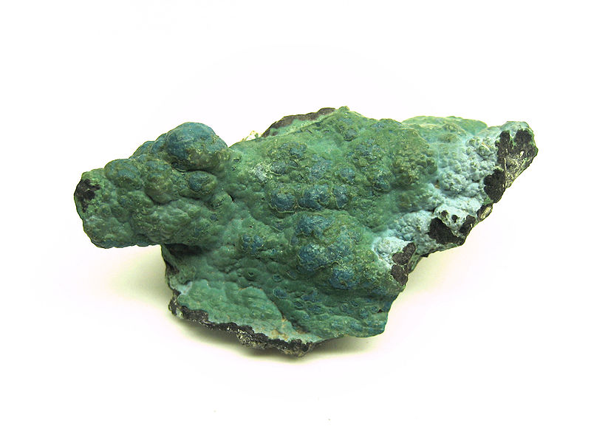

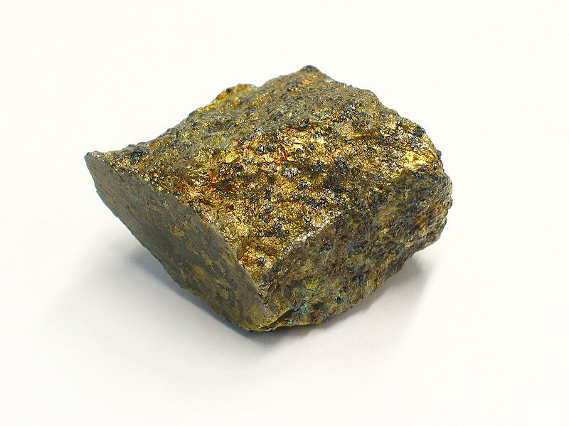Malachite Chalcopyrite

The ore you will be using is a different one and it has already been ground up for youComparison Solutions, Pupil Instruction Sheet

# What you apparatus you will need

Plastic cups x 2

10 cm3 syringe x 2

Test tube x 5

Test tube rack x 1

# What chemicals you will need

Solution 1 x 30 cm3

Distilled water as required

# What you will do

1. Place 30 cm3 of solution 1 into a plastic cup and 40 cm3 of distilled water into another plastic cup.
2. Using a 10 cm3 syringe add 2 cm3 of solution 1 and 8 cm3 of distilled water to a test tube and place in a test-tube rack.
3. Now make up the rest of the comparison solutions given in Table 1. Arrange the test tubes in the rack in the same order.

# Table 1

|  |  |  |  |  |  |
| --- | --- | --- | --- | --- | --- |
| Test Tube | 1 | 2 | 3 | 4 | 5 |
| Volume of Solution 1 (cm3) | 0 | 2 | 4 | 6 | 8 |
| Volume of Water (cm3) | 10 | 8 | 6 | 4 | 2 |

Percentage of Metal in Ore,

Pupil Instruction Sheet

# What you will need

250 cm3 glass beaker x 1

Plastic cup x 1

10 cm3 syringe x 2

Stirring rod

Filter funnel x 1 and paper x3

100 cm3 measuring cylinder x 1

Plastic sample bottles x 3

Test tube x 3

White piece of card

# What chemicals you will use

Ore Samples A, B and C

Solution 2 (irritant)

Distilled water as required

# What you will do

1. Add ore sample A to a 250 cm3 glass beaker.
2. Pour approximately 100 cm3 of solution 2 into a plastic cup.
3. Using a syringe, add 75 cm3 of solution 2 to the ore and carefully stir after each addition until there are no more bubbles being formed.
4. Using the filter funnel and paper, filter off any excess solid into the 100 cm3 measuring cylinder and make up to 100 cm3 with distilled water.

**This solution must be kept if the electro-winning is to be done later at a later stage**.

1. Pour about 10 cm3 of the filtered solution into a test tube. (to the same level as the reference samples)
2. Pour the remainder into a plastic bottle and label it ‘Ore A’
3. Match the intensity of the colour of filtered solution to one of the comparison solutions. This is best done by looking through the test tube against a white background.
4. Using Table 1 given below work out the percentage of metal found in the ore.

**Table 1**

|  |  |  |  |  |  |
| --- | --- | --- | --- | --- | --- |
| Test Tube | 1 | 2 | 3 | 4 | 5 |
| Percentage of Metal in Ore (%) | 0 | 0.13 | 0.26 | 0.39 | 0.51 |

1. Rinse out your 250cm3 beaker and measuring cylinder and repeat steps 1 to 8 for the other ore samples.
2. Keep the remainder of your solution 2 if you are going to go on to the electrowinning.

Electro-winning, Pupil Instruction Sheet

# What you will need

100 cm3 glass beaker

Low voltage power supply

Wires x 3 (Unless you do not need and ammeter)

Crocodile clips x 2

10 cm3 syringe

(Ammeter - if your power supply does not have one built in)

Timer

Emery paper

You will need access to a top pan balance (2 decimal places)

# What chemicals you will use

Copper square (8 x 8 cm)

½ a Nickel spatula

Leachate solution (harmful to the environment)

5 cm3 x 1M sulphuric acid (irritant)

# What you will do

1. As shown by your teacher, set up a circuit containing a power pack, the nickel spatula (electrode), the glass beaker (and an ammeter if needed). A circuit diagram is shown in figure 1 below.
2. Have the circuit checked by your teacher.
3. Using a piece of emery paper clean both sides of the copper strip.
4. Using a top pan balance weigh the copper strip. Record your results.
5. Take the copper strip and place it into the 100 cm3 beaker. **Make sure it is connected to the negative terminal (black connector).**
6. Now fill the beaker with the solution containing the greatest percentage of metal in the ore (the leachate) and add 5cm3 of the sulphuric acid solution.
7. Turn on the power supply, start the timer and adjust the output voltage until the ammeter reads 1 Amp.
8. Keep checking the ammeter and adjust the output voltage to keep the current at 1 Amp.
9. When the timer reaches 10 minutes turn off the power supply.
10. Using a hair dryer, carefully dry the copper strip and then weigh it on the top pan balance.

Electro-winning set up_2

Figure 1 Circuit Diagram for Electro-winning

Positive to Ni spatula

Negative to Cu foil

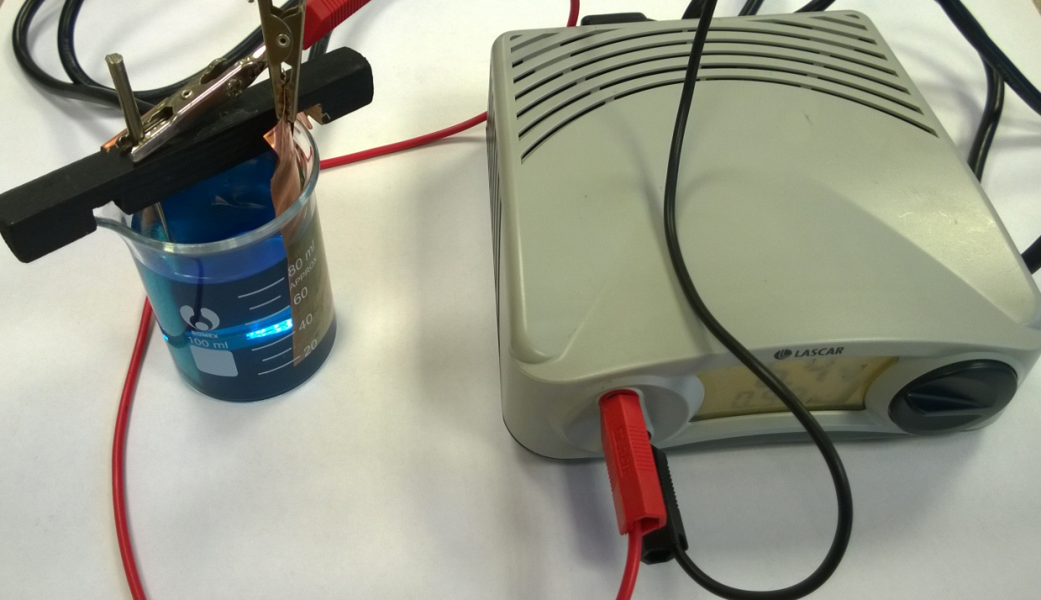Rock to Riches Pupil Results Sheet

# Solvent extraction (SX)

|  |  |
| --- | --- |
| Ore Sample | Percentage of metal in ore |
| A |  |
| B |  |
| C |  |

For the mineral company, *Makurhedrite*, to extract the metal from the ore there needs to be at least 0.25% of the metal in the ore.

From your results, which ore sample(s) are most likely to be mined? **EXPLAIN**

\_\_\_\_\_\_\_\_\_\_\_\_\_\_\_\_\_\_\_\_\_\_\_\_\_\_\_\_\_\_\_\_\_\_\_\_\_\_\_\_\_\_\_\_\_\_\_\_\_\_\_\_\_\_\_\_\_\_\_

\_\_\_\_\_\_\_\_\_\_\_\_\_\_\_\_\_\_\_\_\_\_\_\_\_\_\_\_\_\_\_\_\_\_\_\_\_\_\_\_\_\_\_\_\_\_\_\_\_\_\_\_\_\_\_\_\_\_\_

\_\_\_\_\_\_\_\_\_\_\_\_\_\_\_\_\_\_\_\_\_\_\_\_\_\_\_\_\_\_\_\_\_\_\_\_\_\_\_\_\_\_\_\_\_\_\_\_\_\_\_\_\_\_\_\_\_\_\_

\_\_\_\_\_\_\_\_\_\_\_\_\_\_\_\_\_\_\_\_\_\_\_\_\_\_\_\_\_\_\_\_\_\_\_\_\_\_\_\_\_\_\_\_\_\_\_\_\_\_\_\_\_\_\_\_\_\_\_

# Electro-winning (EW)

|  |  |
| --- | --- |
| Negative electrode | Mass (g) |
| Mass at the end |  |
| Mass at the start |  |
| Mass of metal gained |  |