|  |
| --- |
| Technician’s Guide |
| Rocks & Minerals |

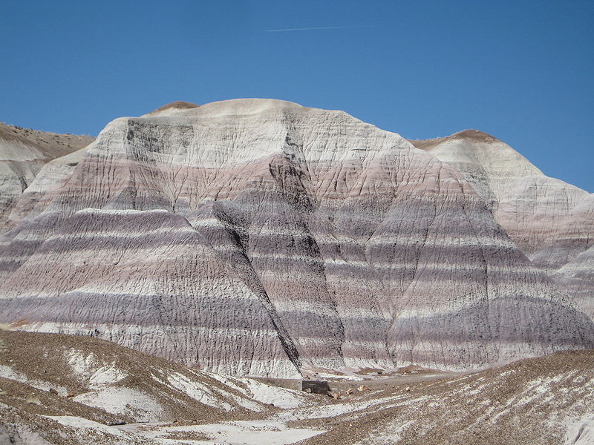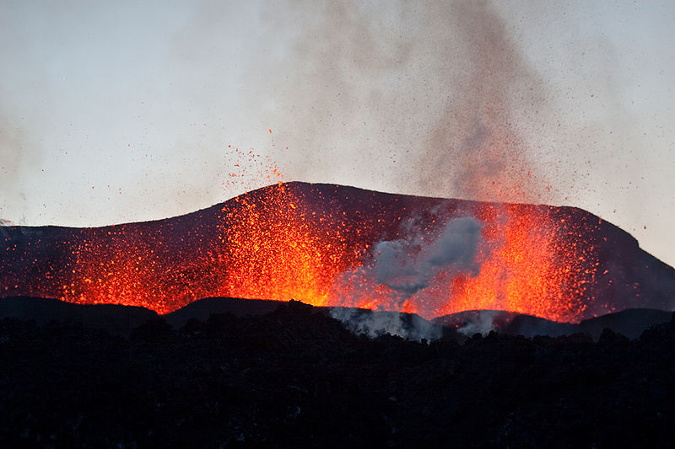

Rocks & Minerals Technician Sheet

# Rock 1 (Sedimentary) Apparatus (based on 20 pupils)

Small baking paper cups x 20

100 cm3 of saturated magnesium sulphate solution (rock solution)

Silver Sand (enough to ½ fill 20 baking cups)

Stirring rods x 20

Heat proof mat (150 mm x 150 mm) x 5

Pasteur pipettes (1 cm3) x 10

Spatulas x 10

Tongs x 10

Scissors x 10

Access to an oven (90oC for 90 mins)

# Rock 2 (Metamorphic) Apparatus (based on 20 pupils)

Tea lite candles cut into ¼’s (8 pieces of wax per pair)

Soft fudge (8 pieces per pair)

Plastic zip bag (95 mm x 150 mm) x 20

Stirring rod x 10

250 cm3 plastic beaker x 20

250 cm3 glass beaker x 20

Scissors x 10

Crushed ice

Access to a kettle

# Rock 3 (Igneous) Apparatus (based on 20 pupils)

12 g stearic acid x 10 bottles

250 cm3 glass beaker x 20

Large spatula x 10

Test tubes x 40

Test tube rack x 10

Test tube tongs x 10

Tongs x 10

Bunsen burner, tripod, heat proof mat x 10

Crystallising dish x 20

Silver sand x 10 bottles (enough to ½ fill the crystallising dish)

Small baking paper cups x 10

Paper towel x 10

Access to torch or small lamp

# Preparation of magnesium sulphate (rock solution)

Weigh out 26 g of anhydrous magnesium sulphate and dissolve into 100 cm3 of distilled water. Place into a 10 bottles and label as sediment solution.

# Preparation of stearic acid

Weigh out 120 g of solid stearic acid and place into 10 bottles with irritant pictograms.

| Step 1 | Step 2 | Step 3 | | Step 4 | | |
| --- | --- | --- | --- | --- | --- | --- |
| *List Significant hazards here:* | *Who might be harmed and how?* | *What are you already doing?* | *What further action is needed?* | *Action by whom?* | *Action by when?* | *Done* |
| Magnesium sulphate | Technician, teacher by inhalation and splashes | Avoid breathing any dust  Wear indirect vent goggles BNS 16 63 |  |  |  |  |
| Sediment solution | Technician, teacher and pupil by splashes | Wear indirect vent goggles BNS 16 63 |  |  |  |  |
| Stearic acid is irritant | Technician, teacher and pupils by contact on skin | Wear indirect vent goggles BNS 16 63  Wear gloves  If split on skin, wash off with copious amounts of water |  |  |  |  |
| Molten stearic acid is irritant | Teacher, pupils | Use test tube tongs to pour the acid into the paper cup and beaker of water |  |  |  |  |
| Silver sand | Technician, teacher, pupil | Wear indirect vent goggles BNS 16 63  If contact with eyes wash out sand with copious amounts of water |  |  |  |  |
| Hot objects | Teacher, pupils | Allow to cool properly and use tongs/ holders where appropriate |  |  |  |  |
| Boiling water | Teacher, pupils | Care when pouring into beakers  Ensure the beakers are no more than ½ full to avoid water displacement of zip lock bags |  |  |  |  |
| Molten candle wax | Teacher, pupil | Keep plastic zip bag sealed at all times |  |  |  |  |

|  |
| --- |
| **Description of activity:**  Making sedimentary rocks using a saturated solution of magnesium sulphate (Epsom salts) and silver sand. Mixing the 2 reagents and then drying in an oven.  Making metamorphic rocks by heating and squeezing a layered mixture of soft dairy fudge and candle wax in a sealed zip bag and allowing it to cool in crushed ice.  Making igneous rocks by heating solid stearic acid and quickly cooling it in cold water and slowly cooling it in a paper cup surrounded by sand. |

|  |
| --- |
| **Additional comments:** |