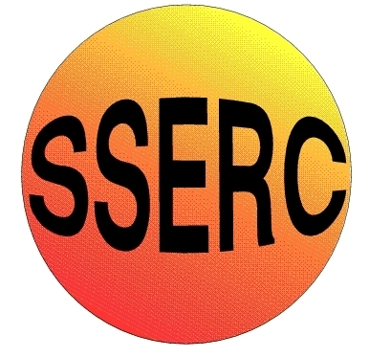
SSERC Risk Assessment (revised version November 2009)
(based on HSE ‘5 steps to risk assessment’)

2 Pitreavie Court, South Pitreavie Business Park, Dunfermline KY11 8UB
tel : 01383 626070 fax : 01383 842793
e-mail : sts@sserc.org.uk web : www.sserc.org.uk

Activity assessed | Rock & Minerals
Date of assessment | 6/1/10
Date of review (Step 5)
School
Department

Step 1 | Step 2 | Step 3 |  | Step 4
List Significant hazards here: | Who might be harmed and how? | What are you already doing? | What further action is needed? | Action by whom? | Action by when? | Done
Magnesium sulphate has no hazard | Technician, teacher by inhalation and splashes | Avoid breathing any dust  Wear indirect vent goggles BNS 16 63
Sediment solution | Teacher and pupil by splashes | Wear indirect vent goggles BNS 16 63
Stearic acid is irritant | Technician, teacher by contact on skin | Wear indirect vent goggles BNS 16 63  Wear gloves  If split on skin, wash off with copious amounts of water
Silver sand has no significant hazard | Technician, teacher, pupil | Wear indirect vent goggles BNS 16 63  If contact with eyes wash out sand with copious amounts of water
Hot objects | Teacher, pupils | Allow to cool properly and use tongs/ holders where appropriate
Molten candle wax | Teacher, pupil | Keep plastic zip bag sealed at all times

Description of activity:

Making sedimentary rocks using a saturated solution of magnesium sulphate (Epsom salts) and silver sand. Mixing the 2 reagents and then drying in an oven.

Making metamorphic rocks by heating and squeezing a layered mixture of soft diary fudge and candle wax in a sealed zip bag and allowing it to cool in crushed ice.

Making igneous rocks by heating solid stearic acid and quickly cooling it in cold water and slowly cooling it in a paper cup surrounded by sand.

Additional comments:

