# Sedimentary.jpg\\Staffserver1\CDO$\My Pictures\Microsoft Clip Organizer\bs01247_.wmfVolcanic Eruption 1.jpg

# Active Talk Activity

Clustering

Clustering is a way of helping students to transfer information between themselves whilst looking for and developing their own links between the statements and/or facts. Thus making them effective contributors.

### Method

1. A card with a statement or fact is given to each student.
2. Students read their statement to ensure that they understand its meaning.
3. Students move around and compare their statement with those on other students’ cards.
4. If two students decide that there is a link between their statements they form a cluster.
5. Another student can join the cluster if their statement is connected to other statements in the cluster.
6. Students can decide to break into sub-clusters if they see any patterns within the connections.
7. Students can give their cluster a name.
8. The teacher can ask groups to introduce their cluster and explain why they have formed a group and/or sub-group
9. It is a good idea if main findings are written on a board or flip chart whilst students are presenting their groupings.
10. A debrief afterwards is beneficial and can check for any new learning or interesting information gained.

The whole class discussion at the end allows the teacher to cover any gaps, address any misunderstandings or conceptual errors and plan for future learning.

j0293828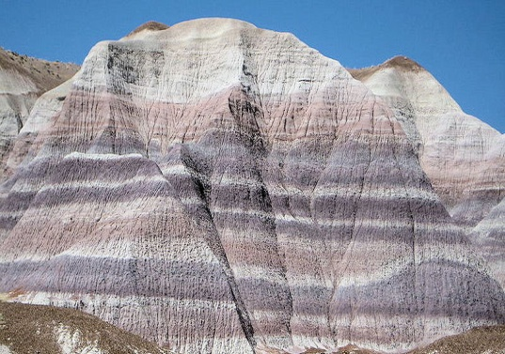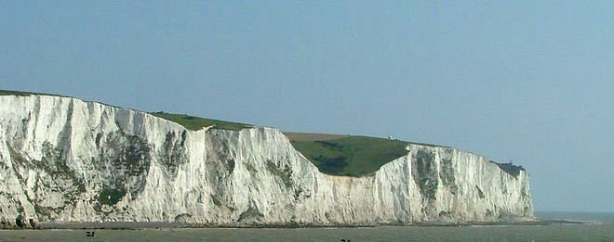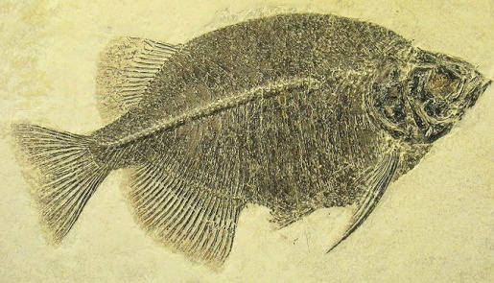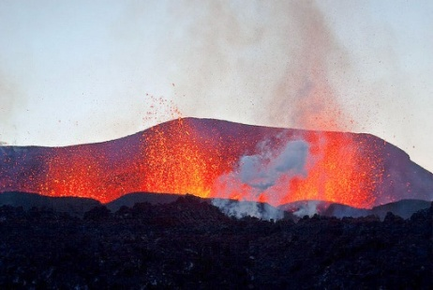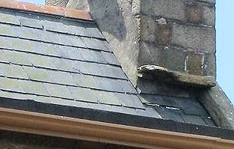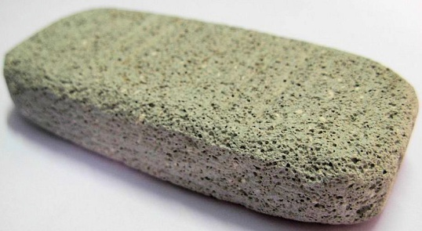

are igneous rocks that have been eroded by wind and rain

sedimentary rocks

can have fossils found inside them

are rocks like limestone, chalk and sandstone

are rocks that have come from cooled lava

igneous rocks

which cool down slowly form large crystals

which cool down form small crystals

are rocks like slate or marble

meta-morphic rocks

are rocks like granite, basalt and pumice

have come from rocks like granite that have been changed by heat and pressure

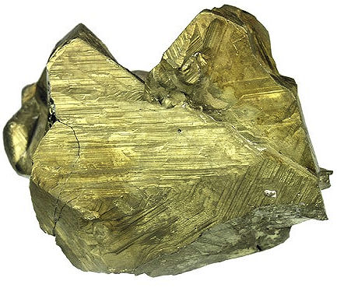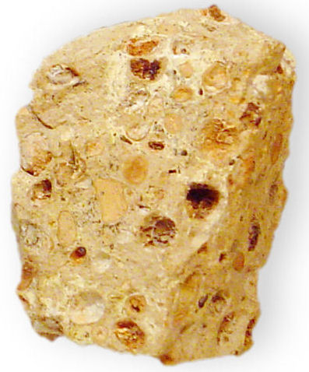bs01247_

the rock cycle

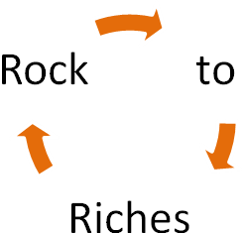

rocks and minerals

started over millions and millions of years ago



is continuous

chalcopyrite (CuFeS2) bauxite (Al2O3.2H2O) haematite (Fe2O3)

some mineral names are

copper ore, aluminium ore and iron ore

come from the Earth’s crust