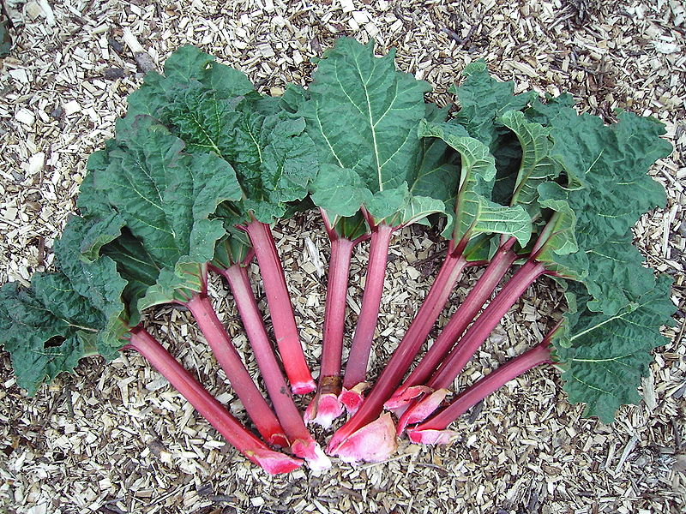
http://en.wikipedia.org/wiki/File:Rheum_rhabarbarum.2006-04-27.uellue.jpg

Investigating a chemical reaction using rhubarb

Apparatus needed – per group (not class)

- A bottle of stock potassium permanganate solution (0.0001M) 250 cm³ – 150 cm³ for the juice experiment and 100 cm³ for the surface area)
- 3x100 cm³ glass beakers (not necessarily 100 cm³ 1 for reaction, 1 for rhubarb juice (so syringes will fit) and 1 for pouring permanganate from – though this could be replaced with a bottle)
- Stirring rod
- Measuring cylinder or syringe to measure 25 cm³
- Pieces of white paper or card
- Safety goggles
- A stop-clock or suitable timer
- Knife (plastic knives are fine)
- Tile (for cutting on)
  - Pupil Investigation Cards

  - Rhubarb juice and some pieces of rhubarb

Preparing the permanganate solution.

What you will need

- Indirect vent goggles
- Gloves
- A jar of potassium permanganate crystals (harmful, oxidising agent)
- A bottle of 2 mol l⁻¹ sulphuric acid (corrosive, irritant)
- A 1 litre beaker
- Stirring rod
- Balance
- A brown bottle to store permanganate solution.

What you do

Make up the batch of acidified potassium permanganate solution for a number of demonstrations.
Acidify at the rate of 20 cm³ 2 mol l⁻¹ sulphuric acid per one litre of solution.

Preparing the Rhubarb juice.

Amount needed = 75 cm³ per group (allowing for 3x repetition)

From Fresh Rhubarb
Prepare rhubarb juice by cutting a stalk of rhubarb into slices about 0.5 cm thick. Place this in a 500 cm³ beaker and cover with distilled water.
Bring to the boil and simmer until the rhubarb falls to pieces. This will take about 5 minutes. Allow to cool and filter the juice. (It is easier to use muslin rather than filter paper for this)

From Frozen Rhubarb

Take 100g of frozen rhubarb. Place this in a 500 cm³ beaker and cover with 200 cm³ of distilled water.
Bring to the boil and simmer until the rhubarb falls to pieces. This will take about 5 minutes. Allow to cool and filter the juice. (It is easier to use muslin rather than filter paper for this)

You should get about 200 cm³ of juice from this.

Test juice with the permanganate to ascertain reaction times. Dilute juice accordingly to obtain convenient times for the reaction.
Using frozen rhubarb, the concentrated juice can be diluted 1:4 (25 cm³ made up to 100 cm³ with distilled water)

Preparing the Rhubarb (surface area)

From Fresh Rhubarb

Each group will need 4 pieces of rhubarb about 3 cm long

From Frozen Rhubarb

Each group will need 4 pieces of rhubarb – make sure they are defrosted before use.

The pieces of rhubarb in the packs are of varying sizes so try to make sure that the pieces for each group are roughly equal.

Surface area experiments A and B

In frozen rhubarb (at least) there is a large about of variation in results and there is a distinct possibility that an individual group will get results that do not match the predictions. If using frozen rhubarb it is probably easier to just use a whole piece and one that is sliced into quite a few pieces to make sure there is a difference.

