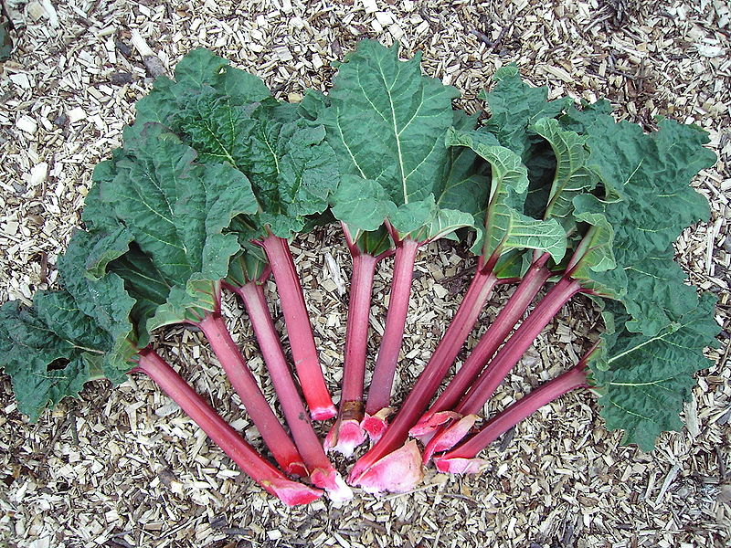
http://en.wikipedia.org/wiki/File:Rheum_rhabarbarum.2006-04-27.uellue.jpg

Investigating a chemical reaction using rhubarb

It is a good idea to laminate all cards to make them less consumable!
Background:
Rhubarb reacts with the purple manganate VII (permanganate) ions. Colourless manganese II ions are formed.
Rhubarb contains oxalic acid (ethanedioic acid) which has the formula C₂H₂O₄:
Oxalic acid reacts with potassium manganate (VII) in acidic solutions and is oxidised to carbon dioxide and water:
2MnO₄– + 5C₂H₂O₄ + 6H₃O⁺ 2Mn²⁺ + 10CO₂ + 14H₂O
The potassium manganate (VII) decolourises which provides a convenient and easy-to-measure end-point to the reaction. Aqueous solutions of Mn²⁺ are actually pale pink, but at these concentrations will appear almost colourless.
It is worth noting that the reaction is autocatalysed (catalysed by a product of the reaction) by the Mn²⁺ ions. This could lead to some confusing patterns for students if the results are analysed too closely, and an attempt is made to link the results to the equation.

Setting the scene:
Demonstrate the reaction as follows.
Add approximately 50 cm³ of the acidified potassium permanganate solution to a beaker. First stir with a glass rod to show that stirring does not have any effect on the solution. Now use a stalk of rhubarb to slowly stir this solution. The solution will slowly decolourise (this is different from ‘going clear’ - it is clear at the start!). Explain there has been a chemical reaction.

Possible variable to investigate:

Surface Area / Concentration
Four dependent variable readings should be recorded for each investigation to enable data to be plotted.
Divide the class into groups of 8 - 10 students and issue Rhubarb Investigation Sheets and set task.
Now issue each student with a Planning Sheet. Stress each member must record the decisions made by the Group and that the work of each Group must be checked after Part 2 (this is so you, the teacher, can ensure they are on the right track to carry out an investigation of a functioning variable).

Discussion with pupils is vital, not only to ascertain their level of understanding, but to possibly direct them to ways of changing the variables. It also gives you an opportunity to discuss the work with groups and to direct them as needed, and to ensure all conditions are being tested. Encourage group discussion to involve all students.
It is also a good idea to open discussion of results to the whole class and introduce the idea of reliability from repetition of experiments.
You should divide each of the groups into two, with one group going on to investigate the effect of surface area while the other investigates the effect of concentration. i.e. the lesson could develop as follows:

Whole class

A group of 8-10 A group of 8-10

A group of 4-5 A group of 4-5 A group of 4-5 A group of 4-5
(Surface area) (Concentration) (Surface area) (Concentration)

A group of 8-10 A group of 8-10
(Graphing and discussion) (Graphing and discussion)

Whole class
(Discussion)

Depending on the time available and the class, the whole group could investigate all the values of their variable. Alternatively, each student in a group could experiment with 1 value only of the variable and results pooled. This would still give a total of four results to enable a graph to be plotted.

Pupil Apparatus needed: (per group)
- A bottle of stock 0.0001 moll⁻¹ potassium permanganate solution 150 cm³ needed for the concentration investigation, 100 cm³ for surface area | - 2 x 100 cm³ glass beakers
- Stirring rod | - 100 cm³ measuring cylinders or 25 cm³ syringes
- 5 cm³ syringes | - Pieces of white paper or card
- Safety goggles | - Stop watch (or other suitable timer)
- Knives | - Stalks of rhubarb

Surface area:
The surface area can be increased in one of two ways:

- If using the stalk as a stirring rod, the surface area can be increased by making vertical cuts in the stalk with the knife.
i.e. 0 cuts, 1 cut, 2 cuts, 3 cuts. The ‘number of cuts’ can be used as an indication of increasing surface area when plotting the data.
Fresh pieces should be used each time.

- If using pieces, simply cut them the requisite number of times. After doing the experiment with a 4 cm piece, it can be repeated with a fresh 4 cm piece cut into 2 equal sizes, then with a fresh piece cut into 3 equal sizes, then with a fresh piece cut into 4 equal sizes. The ‘number of cut pieces’ can be used as an indication of increasing surfaces or surface area when plotting the data.

Discussion Points:

There are problems when using this method. (with frozen rhubarb at least)
It seems that there is quite a variation in the concentration of oxalic acid in otherwise similar pieces of rhubarb.

There are 2 ways of dealing with this.

- Use version A of the experiment where, instead of quantitatively graphing the time against number of pieces, compare a whole piece with one sliced into as many pieces as practicable. In this case, pupils can simply produce a bar graph of the two figures.

- Go ahead with version B, warning the pupils that they may not get the results they expect and then pool the results for the class. (When we did that here at SSERC, we did manage a perfectly decent curve.) There is a spreadsheet to calculate and produce the graph for pooled class results. See Surface Area Graphs.

The advantage of method 2 is the opportunity to discuss variability of results, validity, accuracy etc.

In what way is this not a fair experiment?

Each stalk will not have the same surface area even though the number of cuts used remains constant. Simply doubling the volume of juice does not equate to doubling the rate.

Why is it probably OK and can be ignored in this experiment.

At this level of experimentation qualitative not quantitative analysis is sought after.
General Hints:

If fresh rhubarb is available, the stalks themselves can be used as stirring rods when investigating surface area. Stalks can be cut shorter for ease of use by pupils. e.g. 10-12 cm long if used in this way.

Alternatively, short pieces 4 cm long can be provided for pupils to be placed in the permanganate and stirred with a stirring rod. Anything longer will not fit in the 100 cm³ beaker.

Ensure each group has stalks of the same diameter. This will avoid time inaccuracies due to different thickness of rhubarb being used in a series of similar experiments.

Beakers can be placed on white paper or card to make the reaction more visible and timing easier.

Concentration:

Change the concentration by changing the volume of rhubarb juice (use 1 cm³, then 2 cm³, then 3 cm³, 4 cm³, 5 cm³, and 6 cm³) being added to 25 cm³ of the permanganate solution. Time how long it takes for the solution to turn from purple to colourless. (decolourises)

Discussion Points:

Students should be able to observe that as the concentration of rhubarb juice increases, so does the rate of the reaction. The concentration has in fact been varied by putting in more of the rhubarb extract, so the total volume has been increased. You may like to discuss the implications of this with the students.

In what way is this not a fair experiment?

As the final total volumes are not remaining constant each time, simply doubling the volume of juice does not equate to doubling the rate.

Why is it probably OK and can be ignored in this experiment.

At this level of experimentation qualitative not quantitative analysis is sought after.

Sample Results

Surface area

