

http://en.wikipedia.org/wiki/File:Rheum_rhabarbarum.2006-04-27.uellue.jpg

[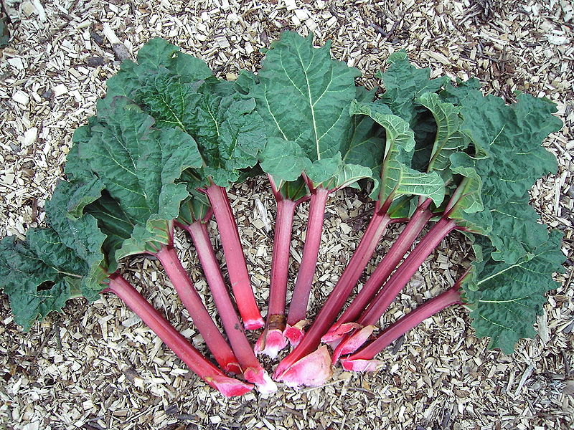](http://upload.wikimedia.org/wikipedia/commons/2/2b/Rheum_rhabarbarum.2006-04-27.uellue.jpg)

**Planning Sheet**

**(Keep this to help you write your report)**

**Names:**

|  |  |  |
| --- | --- | --- |
|  |  |  |
|  |  |  |
|  |  |  |

**Part 1**

Our experiment is to find the best conditions (called **variables**) for rhubarb or rhubarb juice to decolourise potassium permanganate (a purple liquid).

What needs to be measured to show the reaction is happening faster?

The variables we can change are

**Part 2 Now split your team into two groups. Each group will investigate one of the variables you decided on. After the experiments have been completed you will team up again to discuss both sets of results.**

My team will be changing the

To make it a fair experiment we will need to keep these variables the same

Our list of apparatus How we would set it up

**Now discuss your answers with your teacher before you continue.**

Check:

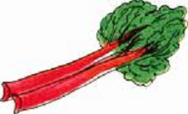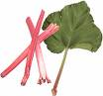**Rhubarb Investigation**

**Variable: Surface Area**

**What you need:**

|  |  |
| --- | --- |
| * A bottle of stock acidified potassium permanganate solution. | * Safety goggles |
| * 2 x 100 cm3 glass beakers | * A stop-clock or suitable timer |
| * A stirring rod | * Some pieces of rhubarb |
| * 1 x measuring cylinder or a syringe to measure 25 cm3 | * A knife |
| * A piece of white paper or card | r7 |

**What you do:**

1. Measure out 25 cm3 of the permanganate solution into a 100 cm3 glass beaker and place the beaker on a piece of white paper.
2. Take one of the pieces of rhubarb and add it to the 25 cm3 of permanganate solution



1. Start the stop clock.
2. Stir the mixture a few times and replace the beaker on the paper.
3. Stop the clock when the purple of the solution has become colourless. (it will go a raspberry pink first).
4. Record your answers on the Results Sheet provided.
5. Repeat the experiment with a whole piece of rhubarb 2 more times. Record your results and work out the average.
6. Do the experiment again with a fresh piece of rhubarb, but this time cut it in **two** lengthways before adding both bits to a fresh 25 cm3 portion of permanganate solution.
7. 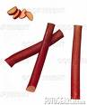Then repeat the whole experiment again with a piece cut equally into **three** pieces lengthways and finally once more with a **piece** cut into four lengthways.



r8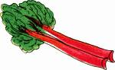**Rhubarb Investigation**

**Variable: Concentration**

**What you need:**

|  |  |
| --- | --- |
| * A bottle of stock acidified potassium permanganate solution. | * Safety goggles |
| * 2 x 100 cm3 glass beakers | * A stop-clock or suitable timer |
| * A stirring rod | * A bottle of rhubarb juice |
| * 1 x measuring cylinder or a syringe to measure 25 cm3 | * 1 x 5cm3 and 1 x 10cm3 syringe |
| * A piece of white paper or card | * Wash bottle of distilled water |

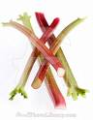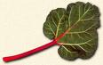

**What you do:**

1. Use a syringe to add 1 cm3 of the rhubarb juice to a 100 cm3 Beaker and place it on the paper/card
2. Measure out 25 cm3 of the permanganate solution in a 100 cm3 measuring cylinder. Pour it into the beaker and start the stop clock.
3. Stir the mixture a few times and replace the beaker on the paper.



1. Stop the clock when the purple of the solution has become colourless. (it will go a raspberry pink first).
2. Record your answers on the Results Sheet provided.
3. Empty the beaker and wash it with the wash bottle.
4. Repeat the experiment 2 more times with the same amount of rhubarb juice. Record your results and work out the average time.
5. Do the experiment again with 2 cm3, then 3 cm3, then 4 cm3, 5 cm3 and 6 cm3 of the rhubarb juice to fresh 25 cm3 portions of permanganate solution each time.

**Results Sheet**

**Investigating Team names:**

|  |  |  |
| --- | --- | --- |
|  |  |  |

**Our Tasks:**

**Our Results:**

**Concentration Results:**

|  |  |  |  |  |
| --- | --- | --- | --- | --- |
| Volume (cm3 of rhubarb juice) | Time for colour to disappear (s) | | | Avge Time (s) |
| **1** |  |  |  |  |
| **2** |  |  |  |  |
| **3** |  |  |  |  |
| **4** |  |  |  |  |
| **5** |  |  |  |  |
| **6** |  |  |  |  |

**A graph of our results:**

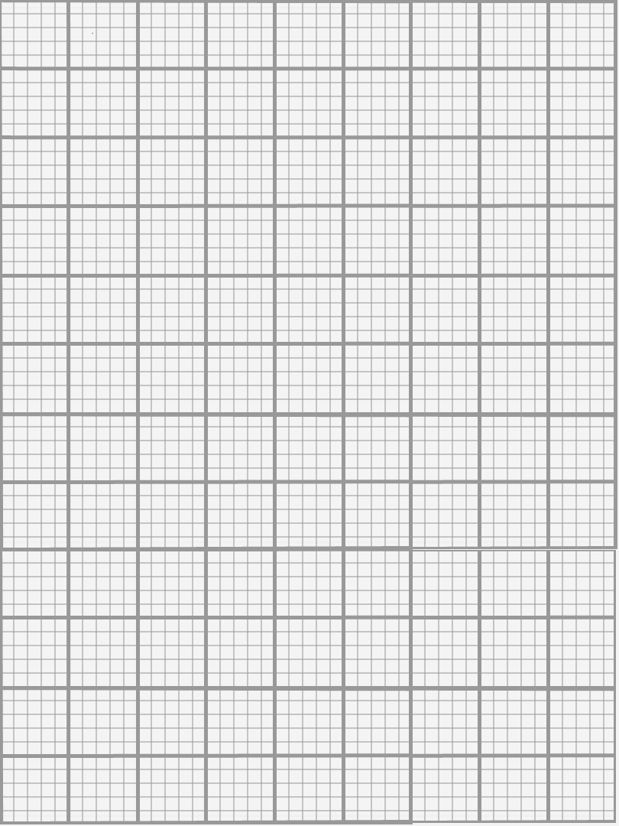

Su**rface area Results:**

Volume of Juice (cm3)

Time (s)

|  |  |  |  |  |
| --- | --- | --- | --- | --- |
| Surface area (number of cuts) | Time for colour to disappear (s) | | | Avge time (s) |
| **0** |  |  |  |  |
| **1** |  |  |  |  |
| **2** |  |  |  |  |
| **3** |  |  |  |  |
|  |  |  |  |  |

**A graph of our results:**



Time (s)

Surface Area

**Final Report Sheet**

**Q 1. What happened to the speed of the reaction as you increased the surface area?**

**Q 2. What happened to the speed of the reaction as you increased the concentration?**

**Q 3. What reaction conditions would you expect to give you the fastest reaction?**

**Write a report on your investigation. You should mention what you were trying to find out in the experiment, and include a list of the variables you investigated and a list of the ones you had to keep the same.**

**Describe how you did the investigation (a list of the apparatus you used would be helpful here), and any conclusions you came to from your results.**

**My Report**

Signed