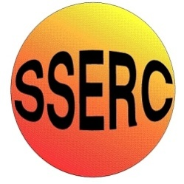
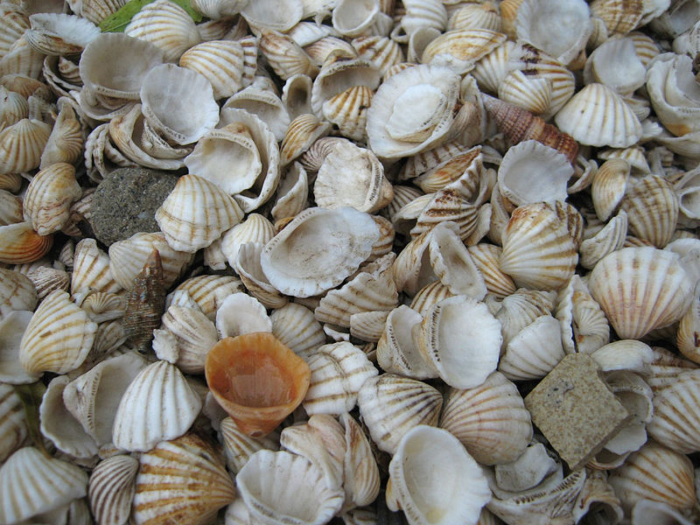
Ocean acidification is the name given to the ongoing process whereby increased CO₂ in the atmosphere leads to increased CO₂ in the oceans, as the gas is soluble in water. This in turn leads to a decrease in pH.
To be picky for a moment, the term ‘acidification is a little misleading. The waters of the world’s oceans are actually slightly alkaline, around pH 8.2 on average. Between 1754 and 1991, surface ocean pH is estimated to have decreased from pH 8.25 to pH 8.14. (1).
Clearly, pH 8.14 is still alkaline but de-alkalisation does not trip off the tongue as well as acidification.
While the scientific community is united in thinking this change is not a good idea, there are differing opinions as to what changes may actually happen in the oceanic biome and how these will affect the organisms that live there.
One common suggestion is that increasing acidity (or decreasing alkalinity) will cause problems for shellfish. They will produce thinner shells and take longer over it, all of which will have potentially catastrophic effects on the many organisms higher up the food chain that depend on them.
Most of the experiments that seek to demonstrate this effect do so at a very simple, but rather misleading, level.
Shells of some sort, either seashells or eggshells, are weighed and placed in dilute acid, often vinegar, left for a while and then removed and re-weighed. They lose mass due to the reaction of the carbonates with acid. However, given that the oceans are still alkaline, this cannot be an accurate model of the real situation.
In ‘real life’ the situation is more complex but essentially is boils down to the equilibrium between carbonate ion and hydrogen carbonate ions in seawater.
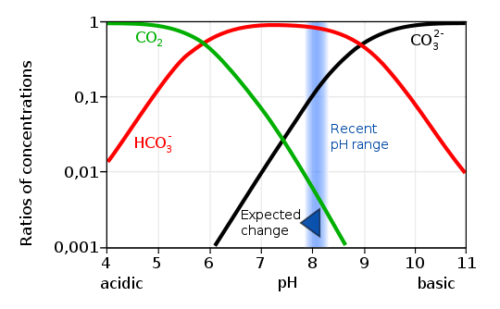
As you can see from the graph, reduction of pH shifts the position of the equilibrium, leading to a slight increase in hydrogen carbonate ions but a significant decrease in carbonate ions.
As it is carbonate ions in seawater that are used by marine organisms to make their shells, reduction of the amount of carbonate in seawater is not a change to be welcomed.

The experiment set out below seeks to demonstrate this shift in equilibrium by means of titrations of seawater. Two titrations are carried out:
- Using cresol red as an indicator (which changes colour around pH 8.3) gives a measurement of the amount of carbonate ions in the water.
- Using bromocresol green as an indicator (which changes colour around pH 4) gives a measurement of the total carbonate/hydrogen carbonate content.
Once readings have been obtained, the titrations are repeated but this time CO2 is bubbled through the solution before titration.
This time the reading for the first titration is reduced, showing a drop in the amount of carbonate present, but the second reading stays roughly the same. This shows that the equilibrium has shifted towards the hydrogen carbonate.
It is arguable how accurate, quantitatively, these figures might be but the experiment is looking at the change in rather than the numbers themselves so the figures are still valid
For a comprehensive overview of ocean acidification, and its potential consequences, see this publication produced by the Royal Society in June 2005. (2)

You will need:
2 x Burettes (Plus clamps and stands)
1 x 25cm³ burette
1 x 100 cm³ beaker or flask
1 x white tile
1mM Hydrochloric acid
10mM Hydrochloric acid
‘Seawater’*
Cresol red indicator
Bromocresol green indicator
1 x Plastic bag
1 x 50cm³ syringe

* The experiments have been carried out using ‘seawater’ prepared to the CLEAPSS recipe:
Dissolve the following salts in 250 ml of pure water and dilute to 1000 ml.
• 23.99 g of sodium chloride
• 0.74 g of potassium chloride
• 2.24 g of calcium chloride-6-water
• 10.89 g of magnesium chloride-6-water
• 4.01 g of anhydrous sodium sulphate(VI) [OR 9.10 g of sodium sulphate(VI)-10-water]
• 0.20 g of sodium hydrogencarbonate
• 0.09 g of sodium bromide
The full recipe also calls for small amounts of Boric acid but this can interfere with the titration.

EXPERIMENT 1 – Baseline equilibrium
A – Carbonate titration
- Pipette a 25cm³ aliquot of seawater into a small beaker or flask.
- Add 4 drops of cresol red indicator*
- Titrate with 1mM HCl until there is no further colour change.**
- Repeat until you have concordant results.***
* The amount of cresol red is not critical but it must be kept the same. Indicators are usually weak acids and at the very low concentrations you are working with, the amount of indicator can affect the titre.
** The indicator changes from blue to yellow but not the bright yellow you get with a more concentrated acid. It is recommended to use the first run to give yourself a reference sample to place on the tile next to your sample so you can tell when the end-point is reached.
*** Due to the very dilute reagents, the end-point is rather ‘stretched’. It is possible with practice however to determine the point at which the addition of more acid gives no further colour change. You will not get titres within 0.1cm³ but it is quite possible to get them to within 0.5cm³.
B – Hydrogen carbonate titration
- Pipette a 25cm³ aliquot of seawater into a small beaker or flask.
- Add 4 drops of bromocresol green indicator
- Titrate with 10mM HCl until there is no further colour change.
- Repeat until you have concordant results.
The same caveats outlined above obtain for this titration as well. In this case, the indicator changes from yellow to green (a more concentrated acid will give blue) but, as above, a consistent end colour is easy to find.

Results
The results from your first titration will tell you the amount of carbonate in the solution.
The results from your second titration will tell you the amount of carbonate/hydrogen carbonate combined in your solution.
Work out the percentage of first over second and you will have a figure for the amount of carbonate in the solution.

EXPERIMENT 2 – The effect of CO₂
- Take a plastic bag and exhale fully into it. This gives you a sample of air with about 5% CO₂.
- Insert a syringe into the bag, holding round the barrel or using an elastic band, and draw up 50cm³ of exhaled air.
- Put a 25cm³ aliquot if ‘seawater’ into a 100cm³ beaker and slowly bubble the exhaled air from the syringe into the water – over 30s or more.
- Add cresol red and titrate as before.
- Repeat the procedure and titrate with bromocresol green.

Results
The titre for the cresol red titration is significantly lower, indicating that there is less carbonate present.
The titre for the bromocresol green titration is the same (or slightly higher) indicating that there is no major change in the total amount of CO₃/HCO₃
Work out the percentage of first over second and you will have a figure for the amount of carbonate in the solution. You will note that it is significantly lower.

Experiment 1 - Baseline
 |  | Cresol Red |  | Bromocresol Green
 | Start | Finish | Vol | Start | Finish | Vol
1 | 0 | 5.6 | 5.6 | 5.6 | 69.5 | 63.9
2 | 0 | 6 | 6 | 0 | 6.5 | 65
3 | 7.6 | 13.8 | 6.2 | 6.7 | 13.4 | 67

The value for the cresol red titre as a percentage of the bromocresol green, representing the % carbonate, is 9.23%

Experiment 2 – 50cm³ exhaled air
 |  | Cresol Red |  | Bromocresol Green
 | Start | Finish | Vol | Start | Finish | Vol
1 | 14 | 17.1 | 3.1 | 13.6 | 20.3 | 67
2 | 17.1 | 21.1 | 4 | 20.3 | 27.2 | 69
3 | 21.1 | 24.6 | 3.5 | 27.2 | 34.1 | 69

The value for the cresol red titre as a percentage of the bromocresol green, representing the % carbonate, is 5.17%

Experiment 3 - 100cm³ exhaled air
 |  | Cresol Red |  | Bromocresol Green
 | Start | Finish | Vol | Start | Finish | Vol
1 | 0 | 0 | 0 | 34.3 | 41.3 | 70
2 | 0 | 0 | 0 | 41.3 | 48.2 | 69
3 | 0 | 0 | 0 | 0 | 7.1 | 71

The value for the cresol red titre as a percentage of the bromocresol green, representing the % carbonate, is 0% (the indicator turned yellow before any acid was added)

- Jacobson, M.Z. (2005). "Studying ocean acidification with conservative, stable numerical schemes for nonequilibrium air-ocean exchange and ocean equilibrium chemistry". Journal of Geophysical Research – Atmospheres 110: D07302. Bibcode2005JGRD..11007302J. doi:10.1029/2004JD005220.

- Raven, J. A. et al. (2005). Ocean acidification due to increasing atmospheric carbon dioxide. Royal Society, London, UK.

