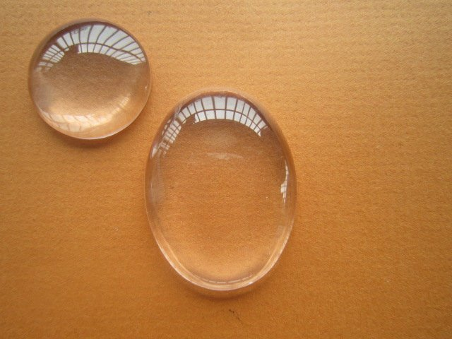
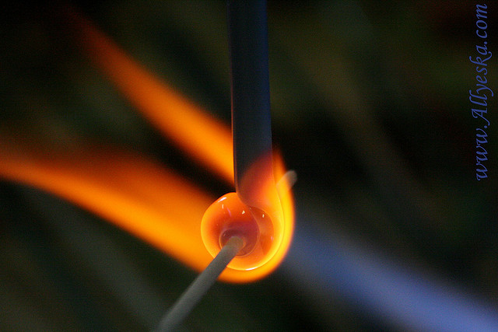

Making Glass
A sample of glass is made by heating a mixture of lead oxide, zinc oxide and boric acid strongly until it melts. The glass formed can be coloured by adding traces of various transition metal oxides.
- Set up your Bunsen burner, tripod and pipe-clay triangle. Place the crucible in the pipe-clay triangle making sure it is a good fit and won’t overbalance.
- You have been given a small bottle with a mixture of lead II oxide, boric acid and zinc oxide.
- Shake the contents to ensure thorough mixing, and transfer into the crucible.
- Straighten out a paper clip to form a wire stirrer, and stir the mixture again.
- Place the lid on the crucible, and carefully into seat the crucible onto a pipe clay triangle on your tripod on a heat resistant mat.
- Heat carefully at first, then strongly with a hot Bunsen flame, until the mixture becomes molten and runny.
- Taking great care, remove the Bunsen flame from underneath the crucible, then use tongs to remove the lid and lift the crucible off the tripod. Pour a few drops of the molten glass onto the heat resistant mat. Replace the crucible onto the tripod, and keep heating.
- Allow the glass beads to cool on the mat for 5 minutes and then examine them.
- Use the straightened paper clip to pick up a tiny speck of one of the metal oxides provided and stir this into the remaining molten mixture. Do not add too much powder or you will produce a very dark piece of glass.
- Remove the Bunsen flame, and use tongs to pick up the crucible and pour out the coloured glass from the crucible to form beads on the mat. Note the colour of the glass you have now produced. Place the crucible on the mat to cool.
- Allow all the apparatus to cool before clearing away.

Wear eye protection. Avoid inhaling lead oxide dust. Wash hands after handling lead compounds.

