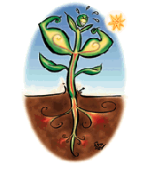

Equipment List

3- 2.5 Litre plastic bottles
Copper test strips-Quantofix (see web link)
Seeds e.g. Radish, mustard seeds, lettuce, parsley
0.1M Copper Sulphate solution
0.05M Copper Sulphate solution

1M Hydrochloric acid
Distilled Water
Filter paper 12cm diameter.
Soil-multi purpose compost from a garden centre e.g. John Innes No1
Measuring cylinder
Pipettes

Microwave

Evaporating basins

Mortar and pestles

Making the Growth Chambers

If the students are to prepare these themselves, a sheet is provided with instructions for them.

.

Procedure

- Make a growth chamber by cutting a plastic bottle in half as shown in Fig 1.
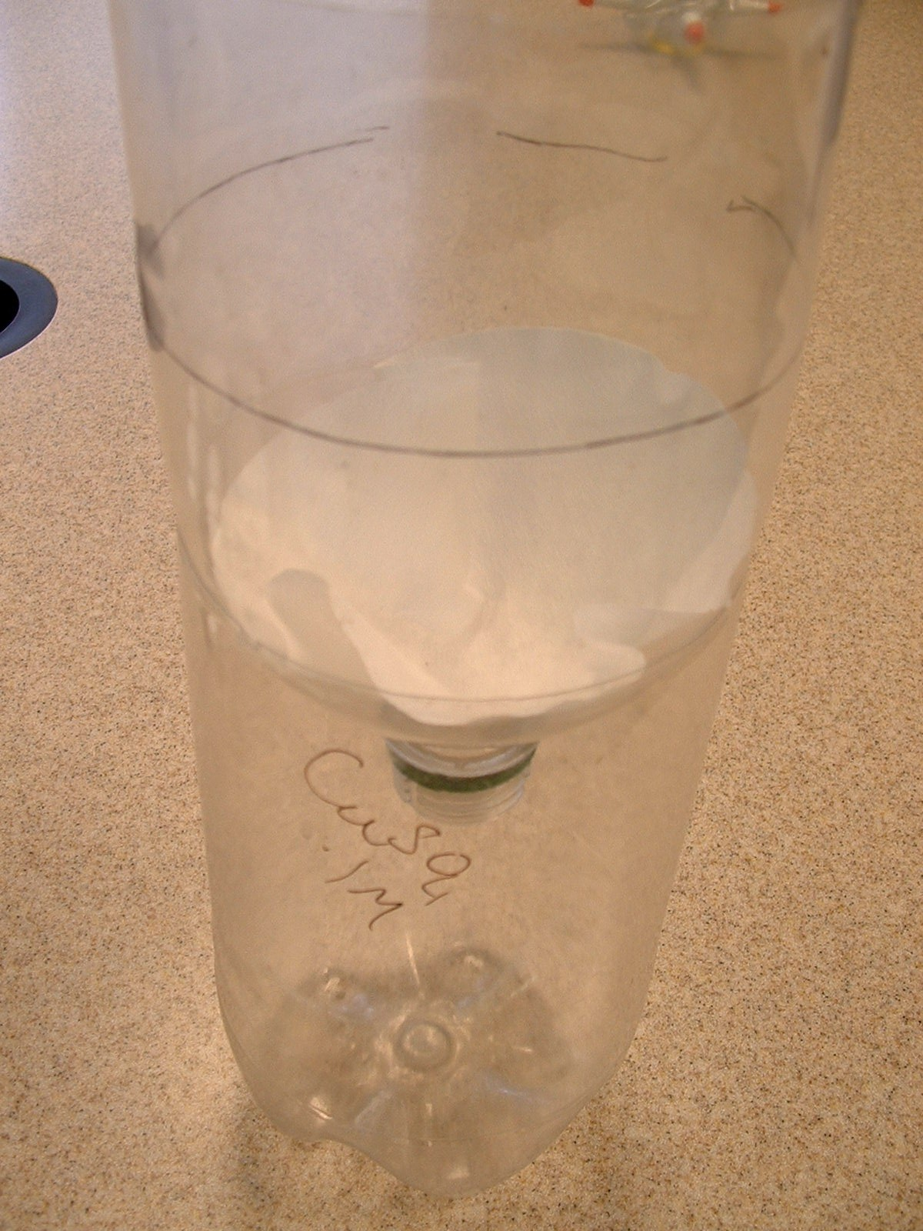
Place a piece of filter paper in the top half of the bottle and then fit the pieces of plastic bottle together to make a growth chamber as shown in Fig 2.
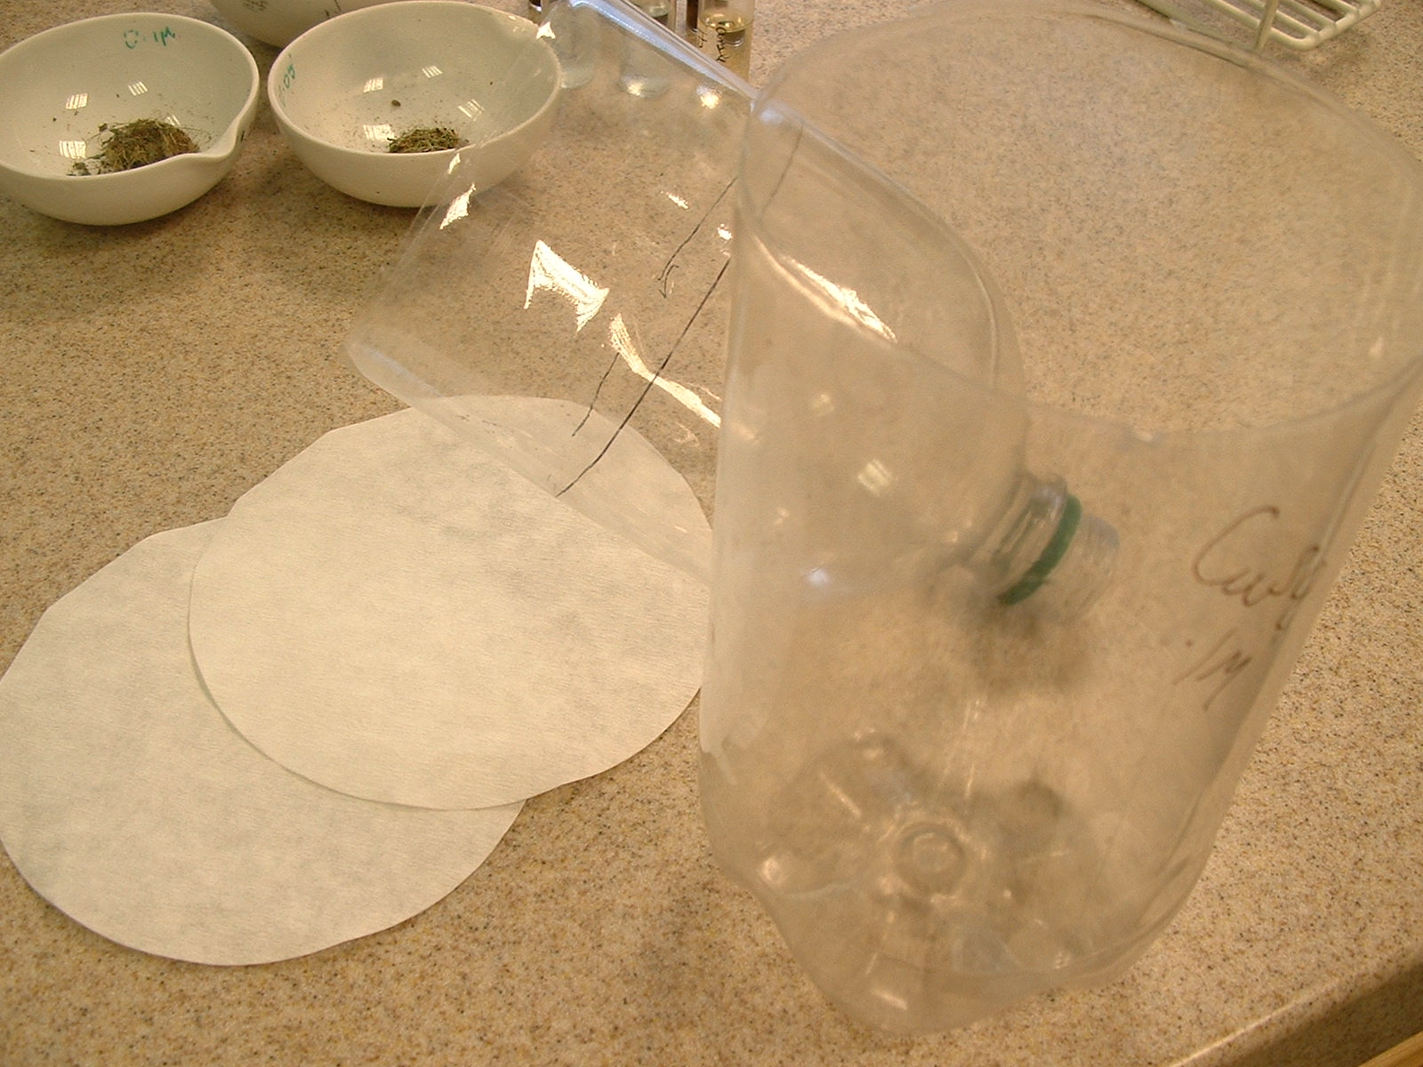

Fig 1.

Fig 2.

- Fill the chamber with equal amounts of soil
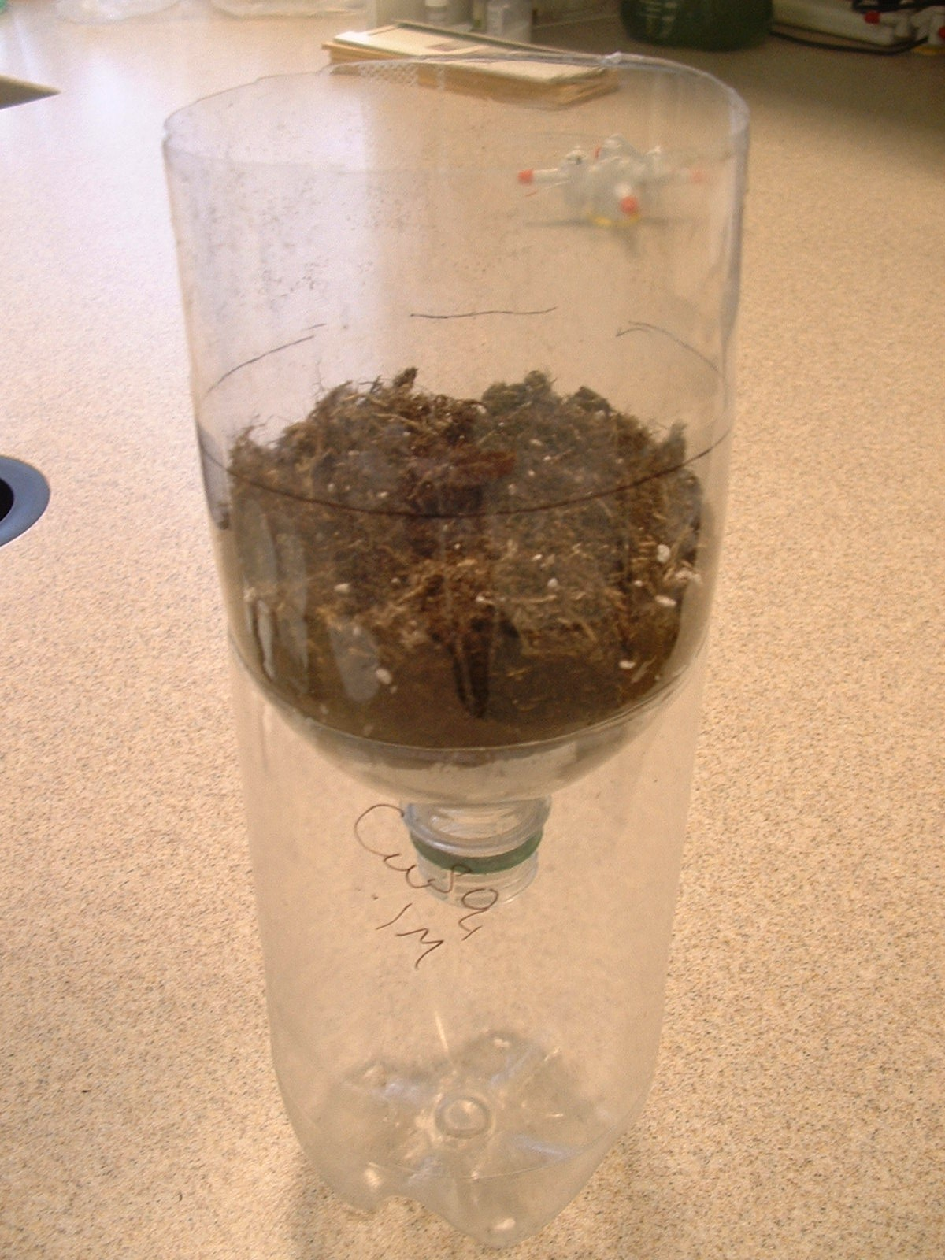
(Fig 3). Plant the given seeds in dishes
(Chinese take-away containers are useful
for this) to obtain strong seedlings.
This should take approx a week.
Plant enough for approximately 25 seedlings
per growth chamber.

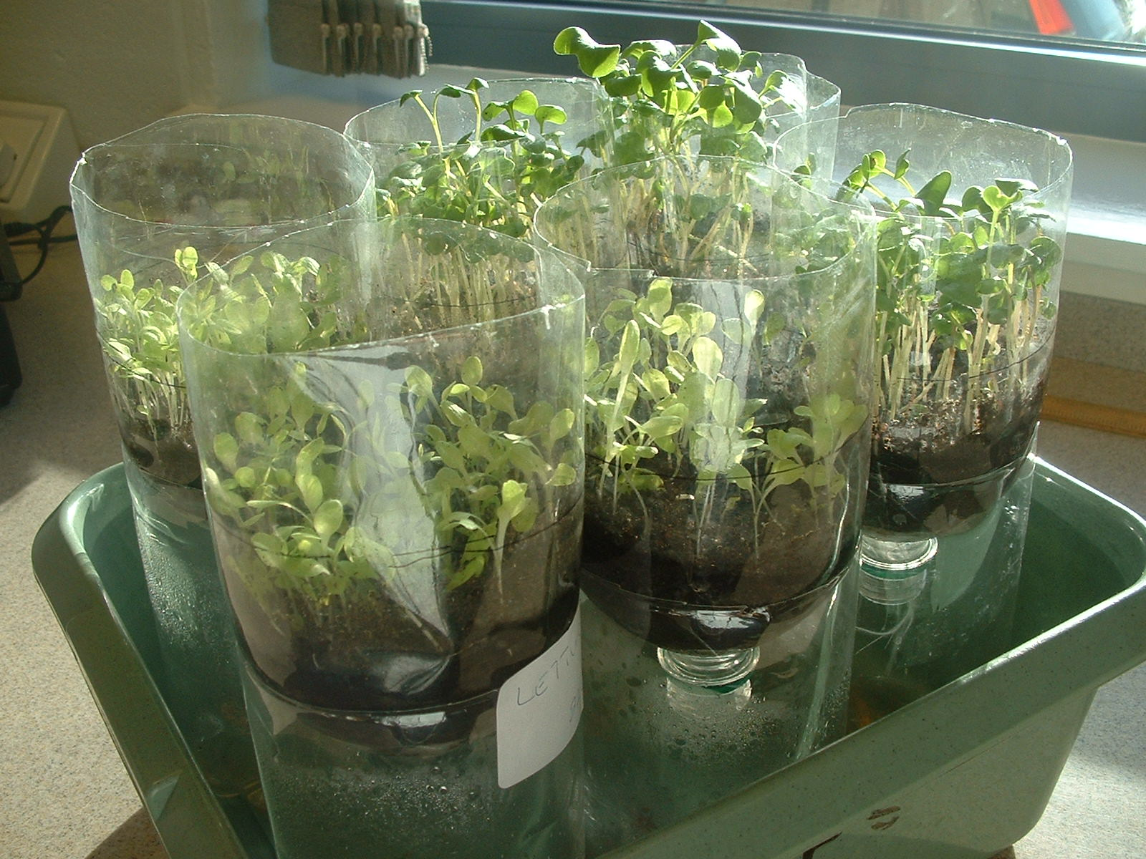

Fig 3

- Take three equal clumps of seedlings and plant them into three different growth chambers. Fig 4

Fig 4

- Allow these seedlings to settle in by watering all with 50mls water and leave overnight.

- Treat the three samples of your seedlings for a minimum of 4 days and a maximum of 7days with 50ml amounts of water or copper sulphate solutions as follows:

 | Sample 1 | Sample 2 | Sample 3
Day | Water Treatment | 0.05 M copper Sulphate Treatment | 0.1 M copper Sulphate Treatment
1 | 50mls | 50mls | 50mls
2 | 50mls | 50mls | 50mls
3 | 50mls and Recycle contents of reservoir | 50mls and Recycle contents of reservoir | 50mls and Recycle contents of reservoir
4 | Recycle contents of reservoir | Recycle contents of reservoir | Recycle contents of reservoir
5 | 50mls | 50mls | 50mls
6 | 50mls | 50mls | 50mls
7 | Recycle contents of reservoir | Recycle contents of reservoir | Recycle contents of reservoir

The plants are affected by the copper(II) sulphate as Fig 5 shows:
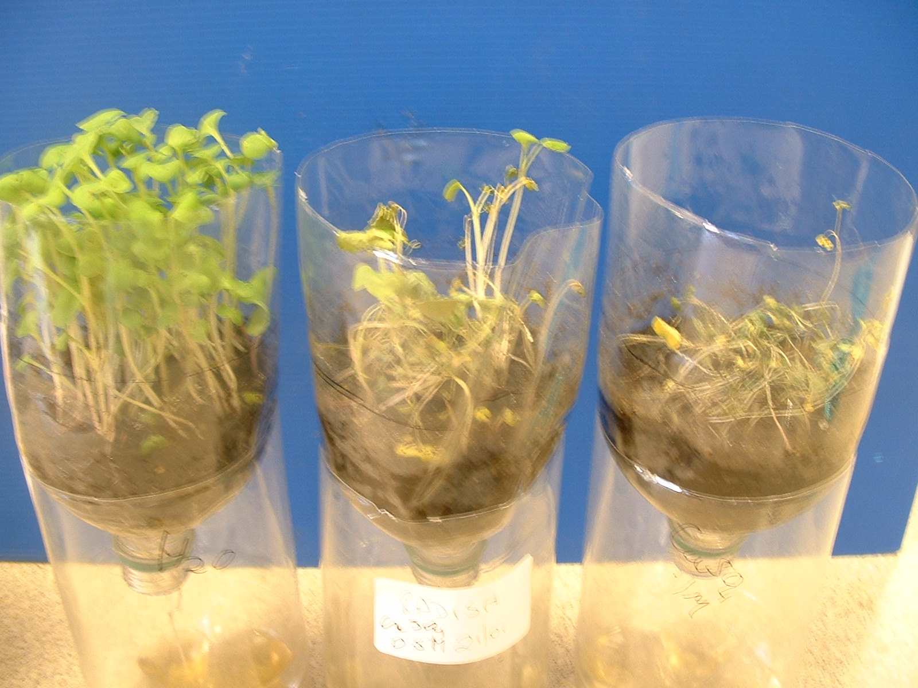
Fig 5

If the students are not going to harvest the plants themselves (can be messy), proceed as follows:

Harvest the plants carefully, best to wash gently under running water to remove as much soil as possible and to have root stem and leaves of the seedlings intact (even the stunted yellow plants). Blot dry with paper towel. This is important for the next step.
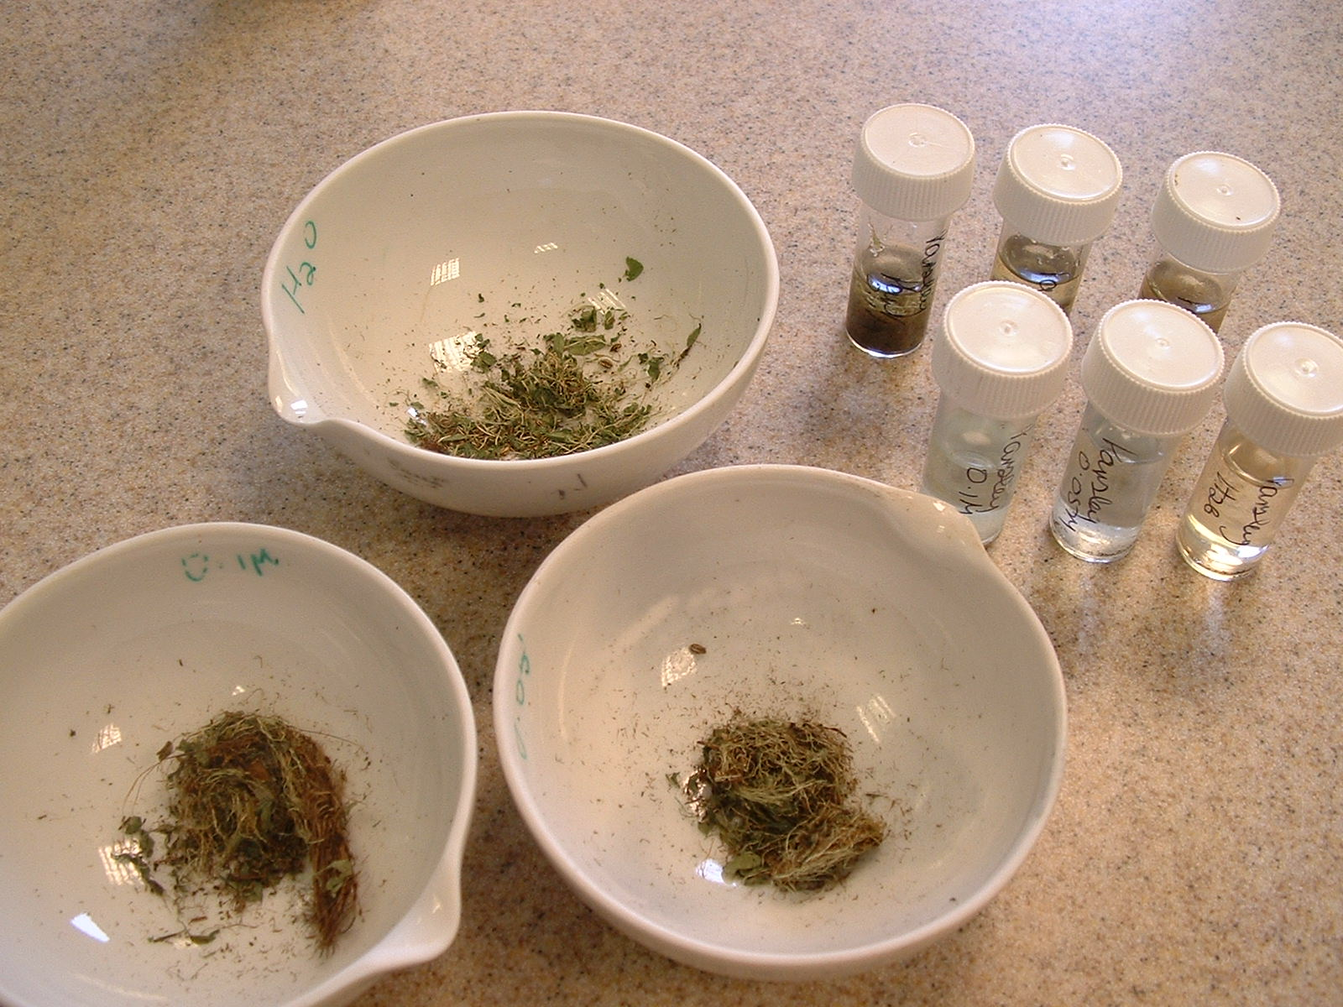
Fig 6
Place in an evaporating basin and dry in a microwave. One-minute intervals may be useful depending on the power of the microwave.
Take care not to set your samples on fire.

Either way, the reservoirs should be provided for the students so they can test liquid in them with the copper indicator strips.

Typical Results
 | FILTRATE | PLANT
H₂O | 0mg/l | 0mg/l
0.05M | 100mg/l | 300mg/l
0.1M | 200 mg /l | >300mg/l

Sample can be diluted and re-tested.

The link to the original document
http://www.seeingscience.cclrc.ac.uk/Environment/KS3/howplantsguzzle.aspx

Supplier of Copper Test strips
http://www.camlab.co.uk/item.asp?itemid=21336&categoryid=204&key=&letter=&browsecategoryid=307

If the students are to prepare the plants themselves, a sheet is provided with instructions on how to proceed.

SSERC Risk Assessment (revised version November 2009)
(based on HSE ‘5 steps to risk assessment’)

2 Pitreavie Court, South Pitreavie Business Park, Dunfermline KY11 8UB
tel : 01383 626070 fax : 01383 842793
e-mail : sts@sserc.org.uk web : www.sserc.org.uk

Activity assessed | Guzzling Plants
Date of assessment | 14/01/2013
Date of review (Step 5)
School
Department

Step 1 | Step 2 | Step 3 |  | Step 4
List Significant hazards here: | Who might be harmed and how? | What are you already doing? | What further action is needed? | Action by whom? | Action by when? | Done
Copper sulphate is harmful and a skin/eye irritant  Copper sulphate solution is harmful for the environment with long-lasting effects. | Technician/teacher making up solutions. | Wear goggles (BS EN 166 3) and nitrile gloves. Avoid raising dust. Wash hands after use.  Collect waste solutions and recycle or dispose of appropriately (See SSERC website, Hazardous Chemicals)  Collect soil and either store for future use or put in a plastic bag and store for collection by a licensed contractor.

Description of activity:
Seeds are germinated and grown in solutions of copper sulphate of differing concentrations. The leaves and stems are then collected and analysed for copper content.

Additional comments:

