

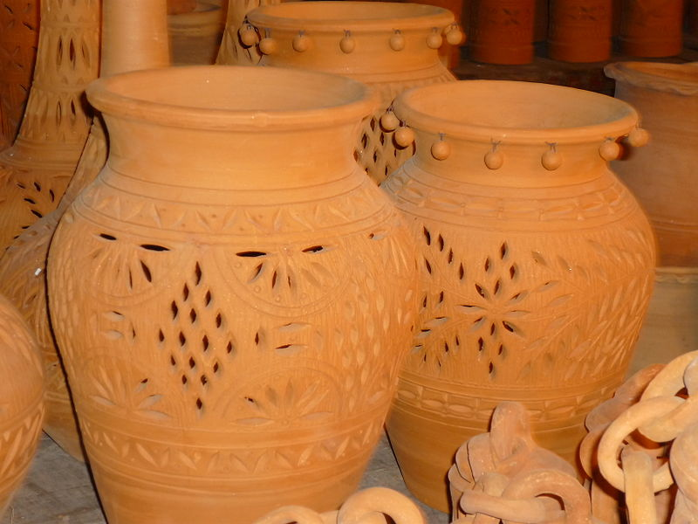

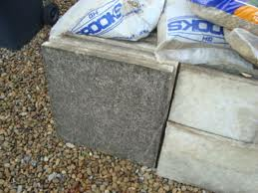

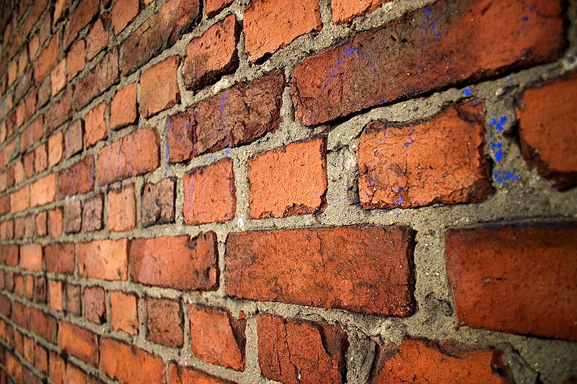

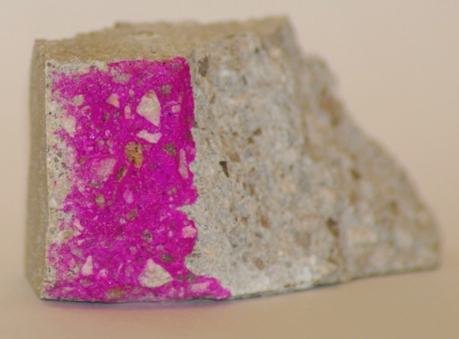

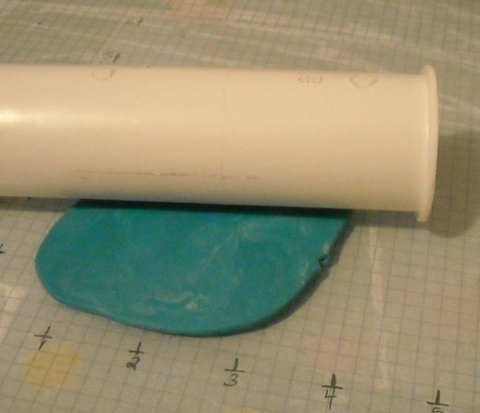Making a pseudo-ceramic

‘Proper’ ceramics such as porcelain and earthenware need to be heated to well over 1000ºC. This can be done in a kiln with the cooperation of your friendly art department.

It is possible, however, to make a material in the lab that looks and behaves quite like a real ceramic.

The easiest version involves heating a mixture of starch (cornflour) and sodium hydrogen carbonate(bicarbonate of soda) with water. It soon coalesces to form a clay-like material which can be moulded (once it is cool enough to handle).

The ‘clay’ can be coloured by putting paint (or even food colouring) in the mix.

Once an article has been made, it is ‘cooked’ in an oven at about 50 - 60°C. After which it can be varnished or painted.

**Method**

*You will need*

* 20g cornflour (starch)
* 70g sodium hydrogen carbonate
* 40cm3 cold water
* 250 cm3 beaker
* Stirring rod or spatula

1. Put all the ingredients into a beaker and mix to form a smooth slurry.
2. Light your Bunsen burner and adjust the flame so it is as low as you can manage without blowing out.
3. ‘Cook’ on low heat stirring constantly for a few minutes or until a dough forms and begins to come away from the sides.
4. Take the beaker off the heat and leave it for a few minutes until it is cool enough to handle.
5. When it is cool enough to handle, take it out of the beaker, knead gently and then it is ready to use.

* You can leave your sample for a few days at room temperature to set or you can speed up the process in a cool oven at around 60ºC.

Natural Cement

C:\Documents and Settings\esoc\Local Settings\Temporary Internet Files\Content.IE5\3U3JFC65\MC900363940[1].wmfMany people are unaware that cement and concrete are ceramics – they are.

Ordinary Portland cement has a long history of use in the classroom but it has the disadvantage of taking quite a long time to set.

Natural cement is a powder made purely from a ground up rock, a very specific type of limestone that has specific amounts of clays in it. It sets much faster than Portland cement, within a few minutes in fact.

**To do:**

1. Measure out 65 cm3 of water and pour into the bag.
2. Take a bag of Natural cement / sand (containing 100g of each).
3. Pour the water into the bag of cement.
4. Close the bag and squish with your fingers to make sure the water and powder are thoroughly mixed. It will still be very runny.
5. Hold the bag in your hand (continue to squish it if you want) and feel the rise in temperature.
6. Once it has set hard, place to one side.
7. Assemble your mould. (Fold up the ends and sides and tape them into place.)
8. Measure out another 65 cm3 of water and mix with another bag of cement/sand, just as before.

*C:\Documents and Settings\esoc\Local Settings\Temporary Internet Files\Content.IE5\NGW7IPYO\MC900217466[1].wmf(You will need to be quick as the cement becomes unworkable after 3 minutes or so)*

1. Cut the corner off the bag and pour the mortar into the mould, moving the bag up and down to get a fairly even spread. Once all the mortar is in, gently shake the mould a bit to get the mixture to settle evenly.
2. Place to one side to set*

Properties of Ceramics

1. **Carbonation of concrete**

Many people are aware that concrete produces a lot of CO2 in its manufacture. Fewer though are aware that it absorbs CO2 as well. In fact, by the end of its lifespan, a piece of concrete will have absorbed all the CO2 it gave off in its manufacture – apart from that due to fuel usage.

CO2 permeates the concrete and reacts with the Calcium hydroxide to give calcium carbonate.

  Ca(OH)2 + CO2 🡪 CaCO3 + H2O

C:\Documents and Settings\esoc\Local Settings\Temporary Internet Files\Content.IE5\RCWRPZTT\MC900151959[1].wmf

Normal carbonation results in a decrease of the porosity making the carbonated mixture stronger. Carbonation is therefore an advantage in non-reinforced concrete. However, it is a disadvantage in reinforced concrete, as pH of carbonated concrete drops to about 7; a value below the level at which steel will rust.

It is this pH change that allows you to detect carbonation. Phenolphthalein, will give its characteristic purple on the parts that have not been carbonated but areas of carbonation have a higher pH and remain clear.

1. Look carefully at the side marked with a dot. Can you see anything different about the structure of the concrete close to the edge nearest the dot?

1. Take the dropper bottle of phenolphthalein and coat that surface of the block.
2. Look again at the edge. What do you see now?

1. Place the lump of concrete in the sandwich box.
2. Take the bag of marble chips (or take some small pieces of concrete) and empty it into the cut-down drinking cup.
3. Place the cup in the sandwich box.
4. Empty the bottle of hydrochloric acid into the cup and place the lid on. Place it carefully to one side and leave for 30 minutes.

(The acid will react to produce a high level of carbon dioxide in the box.)

1. Open the box up and take out the concrete. What has happened to the phenolphthalein-stained side?

1. 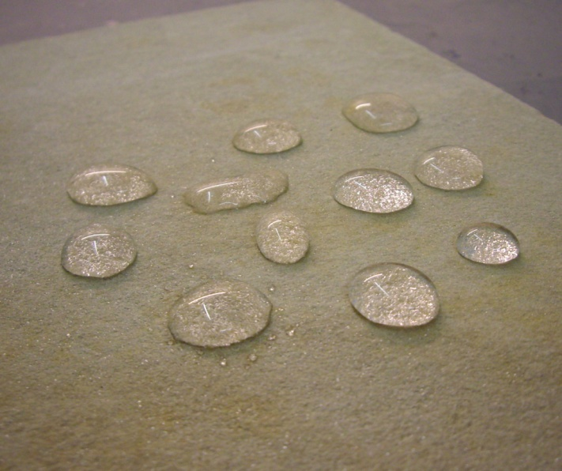**Porosity**

A very simple test for porosity is just to put some drops of water on the surface and see if it is absorbed.

We are going to use a slightly more quantitative method.

You have been given pieces of four ceramics: concrete, brick, glass and porcelain.

1. Weigh each piece and record the mass.
2. Place the pieces of ceramic in a container of water and leave for 10 minutes.
3. Take them out, dry off with paper towel and re-weigh.
4. Have any of them changed mass?

|  |  |  |  |
| --- | --- | --- | --- |
| **Sample** | **Initial mass** | **Final Mass** | **% change** |
| *Concrete* |  |  |  |
| *Brick* |  |  |  |
| *Glass* |  |  |  |
| *porcelain* |  |  |  |

*You can extend this in a variety of ways*

*Do calculations of surface area to relate the rate of absorption to.*

*Remove, dry and weigh your sample every 2 minutes and then return it to get a graph of the rate of absorption.*

*See if the rate of absorption is temperature dependent.*

***While you are waiting***

**Dissolve some glass in water!**

It is a well-known fact that glass does not dissolve in water. Or is it?

1. Take the small tub labelled soda glass and empty it into a mortar. Grind it up very finely

**NB Wear eye protection! Bits WILL fly around.**

1. Put the powder into a small beaker and add some distilled water.
2. Add a few drops of phenolphthalein. What happens?

1. **Reactions with acid**

Most ceramics we are familiar with are fairly inert. Some, however, will react with a few reagents.

1. Place the small pieces of each of your ceramics into 4 test tubes.
2. Add a small amount of 1M hydrochloric acid to each.
3. What do you observe?

|  |  |  |
| --- | --- | --- |
| **Sample** | **Appearance** | **Smell** |
| *Concrete* |  |  |
| *Brick* |  |  |
| *Glass* |  |  |
| *porcelain* |  |  |