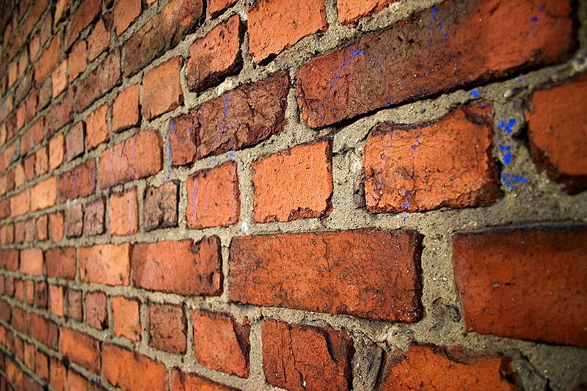
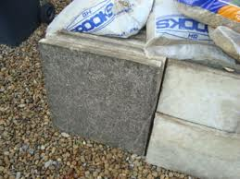
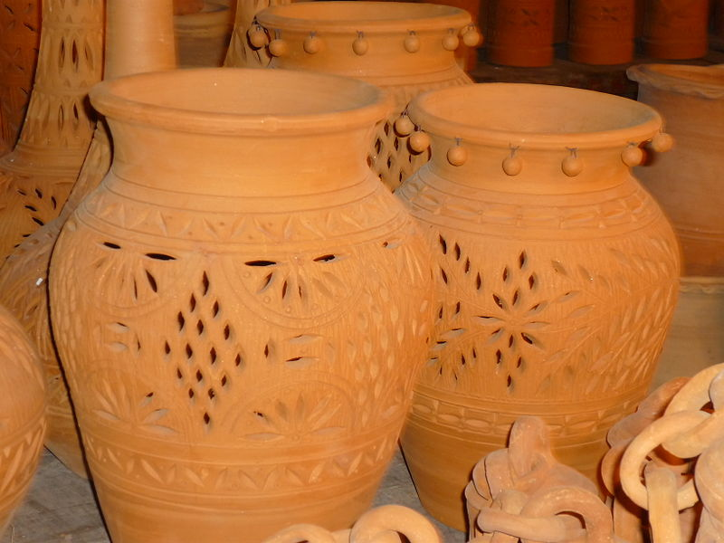

Making a Pseudo-Ceramic
Each group will need – per batch
20g cornflour (starch)
70g sodium hydrogen carbonate
40cm³ cold water
250 cm³ beaker
Stirring rod or spatula

Carbonation of concrete
Each group will need
1 x piece of freshly broken concrete (from a paving slab or any other source)
1 x dropper bottle of phenolphthalein solution (or bottle + pipette)
Some marble chips (or small chips of concrete)
Dilute HCl (1M is fine)
An ice cream tub or similar container with a tight-fitting lid
A small beaker or plastic cup that can fit in the ice-cream tub.

The piece of concrete need not be too large but must have one freshly broken edge.
The pieces can be broken the day before but they must be stored in an airtight container – ideally a resealable bag from which you can squeeze out the air so as to prevent CO₂ reacting with your new surface.
The instructions mention marking with a black dot – it may be useful to mark the freshly broken side thus but it is not essential.

Porosity
Each group will need
Sample pieces of glass, brick, concrete and porcelain (and others if you wish)
Access to a balance – 2dp
Container of water
Access to a timer

The size of the pieces is not crucial. They need to be large enough to get a measurable change but small enough to fit in the container.
It is a good idea to make sure the pieces are thoroughly dry beforehand. You can put them in a cool oven for this or even leave on a radiator.
Porcelain is quite porous except where it is glazed. To display the porosity take samples of normal white kitchen tiles (as commonly used in a lab) as these are only glazed on one surface.
An interesting comparison could be made with pieces of broken plate/cup etc where only the broken surface will absorb water.

Dissolving Glass
Each group will need
Some soda glass either ground or at least broken up small
Pestle and mortar
Test tube
Water
Phenolphthalein solution
You will need to break the soda glass up quite small – 1-2mm maximum so that the pieces can be ground up relatively easily. With care, you can do this with a hammer. Wear eye protection!

Reactions with acids
Each group will need
Test tubes
Test-tube rack
Small pieces of brick, glass, porcelain and concrete (and any other ceramic available)
Dilute Hydrochloric acid 1 – 2M

The pieces only need to be small enough to fit into the test tube.
Check the brick. Some, the ones we want, will produce a noticeable smell of hydrogen sulphide from reactions with the clay but they don’t all.

