

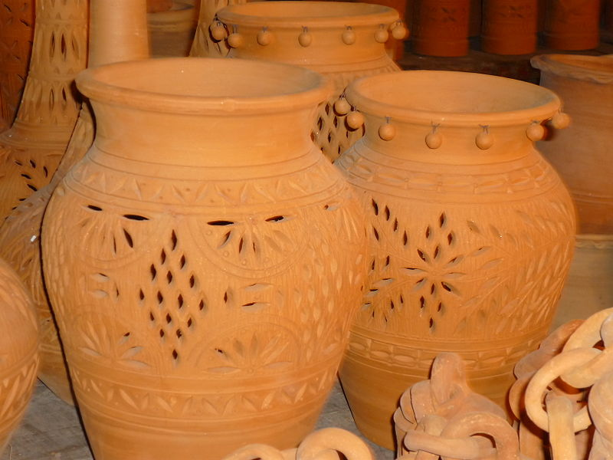

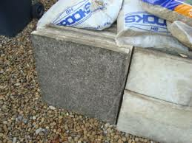

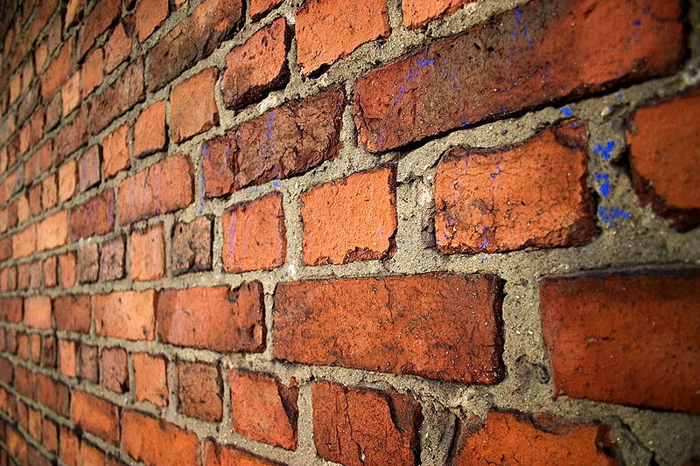

Making a pseudo-ceramic

A ceramic is defined as “an [inorganic](http://en.wikipedia.org/wiki/Inorganic), [nonmetallic](http://en.wikipedia.org/wiki/Nonmetal) [solid](http://en.wikipedia.org/wiki/Solid) prepared by the action of [heat](http://en.wikipedia.org/wiki/Heat) and subsequent cooling.”

Ceramic materials may have a [crystalline](http://en.wikipedia.org/wiki/Crystalline) or partly crystalline structure, or may be [amorphous](http://en.wikipedia.org/wiki/Amorphous) (e.g., a [glass](http://en.wikipedia.org/wiki/Glass)). Because most common ceramics are crystalline, the definition of ceramic is often restricted to inorganic crystalline materials, as opposed to the noncrystalline glasses.

The problem with ceramics in the classroom is that, while it is possible to investigate their properties easily enough, to make them requires very high temperatures. ‘Low-Temperature’ ceramics need a temperature of 1,000 – 1,200°C! Out of range of most science laboratories. Though co-operation with an art/technology department with access to a kiln would be a fruitful avenue to explore.

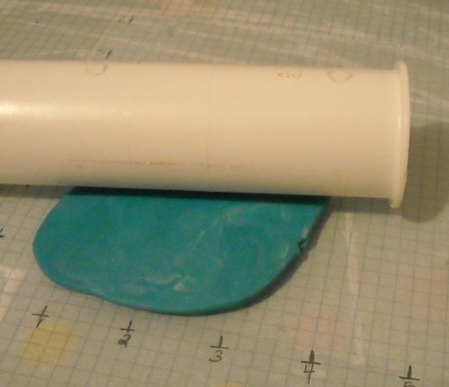It is possible, however, to make a material that behaves in many ways like a genuine ceramic.

**Polymer clay** is the name given to a range of sculptable materials, most commonly based on the polymer polyvinyl chloride (PVC). They usually contain no clay minerals, and are only called "clay" because the texture and working properties resemble those of mineral clay

The mixture we are using is even easier; it is simply a mixture of sodium hydrogen carbonate, starch and water which is heated until it forms a ‘clay’.

Once cool enough to handle, the ‘clay’ can be moulded into shapes and designs like any other clay can. It is cured by being heated in a cool oven (60ºC) or it can be left for longer at room temperature. Once hard, it can be painted or varnished.

The ‘clay’ itself can be coloured by mixing in paint or even food dye in small quantities but be warned this can lead to very stained hands!

If you mix starch with cool water and heat it, the starch granules swell, break down and release some of their contents into the water. In other words, they **gelatinise. S**tirring the mixture vigorously -- the mechanical action of stirring will also help break the granules down.

It is mixed with the particles of sodium hydrogen carbonate and the tangle of hydrated, gelatinised starch molecules mix with the bicarbonate produces the dough.

As the dough dries out, accelerated by heat, water is lost from the starch which dries out and hardens.

This is not entirely dissimilar from clay. There are particles of ceramic and particles of silicon dioxide all mixed together in clay in a suspension of water. When the clay dries, it is not held together very strongly. When you fire clay, you heat it up enough so that the silicon dioxide melts, and it cements all the particles of ceramic together.

Natural Cement

C:\Documents and Settings\esoc\Local Settings\Temporary Internet Files\Content.IE5\2AROA0C7\MC900320984[1].wmfConcrete is the most widely used man-made material in the world. As of 2006, about 7.5 cubic kilometres of concrete were made each year—more than one cubic metre for every person on Earth.

The three basic ingredients of concrete are aggregate, cement and water.

**C:\Documents and Settings\esoc\Local Settings\Temporary Internet Files\Content.IE5\NGW7IPYO\MC900217466[1].wmfAggregates** are just chemically inert substances that are bound together by the cement. They are there to give bulk to the concrete and are not involved in the chemical processes. A common example is the stone chippings in normal concrete.

**Cement** is made by mixing **crushed clay and limestone together** and roasting it in a kiln. The roasted lumps are then ground to a fine powder.

*The resulting powder is a mixture of five chemicals. There are lots of variations but a typical composition is:*

|  |  |
| --- | --- |
| *Chemical* | *Percentage in cement* |
| *tricalcium silicate* | *50%* |
| *dicalcium silicate* | *25%* |
| *tricalcium aluminate* | *10%* |
| *tetracalcium aluminoferrite* | *10%* |
| *gypsum or hydrated calcium suphate* | *5%* |

When cement is mixed with water, its constituents are hydrated. The calcium silicates form calcium silicate hydrate, calcium hydroxide and heat.

These products contribute to the strength of the concrete.

**C:\Documents and Settings\esoc\Local Settings\Temporary Internet Files\Content.IE5\RCWRPZTT\MC900151959[1].wmfThe chemistry of these reactions is complex.**

Cement sets when mixed with water by way of a complex series of chemical reactions still only partly understood.

1. The different constituents slowly crystallise and the interlocking of their crystals gives cement its strength.
2. When the calcium silicates first come into contact with water, reactions occurs in which calcium ions are formed and the water molecules are broken down to form hydroxide ions. It is this bond breaking that produces heat. (Tricalcium silicate reacts quickly producing a lot of heat. Dicalcium silicate reacts more slowly and produces less heat.)
3. Calcium hydroxide is not very soluble so it is soon saturated and forms a solid.
4. At the same time, calcium silicate hydrate is formed which is also a solid.
5. As long as water is in contact with the cement, these reactions continue but they get slower and slower, and can take several years to reach full strength.
6. Carbon dioxide is slowly absorbed to convert the calcium hydroxide into insoluble calcium carbonate.

The aggregate is not involved in the reaction, but forms a surface for the solids to form on. This will be easy at first, as there are large areas of water and cement mixed together. As the solid is formed, however, there is less and less space between the grains of aggregate and silicate hydrate for the water to move around and reach un-reacted cement. This means that the reaction will slow down as the pores between the aggregate get smaller.

Starting with this basic mixture, all sorts of other substances can be added (admixtures) to give the concrete different properties.

* Some admixtures improve the workability and plasticity of the concrete so that less water is needed, improving the strength.
* Other admixtures help construction forms adapt to different environmental factors.
  + There are retarding admixtures to delay the setting time in hot climates (for example sugar).
  + There are also accelerating admixtures to speed up setting in colder climates (for example calcium chloride).

A typical concrete sets in about 6 hours and develops its strength as follows:

|  |  |
| --- | --- |
| Time after setting | Compressive strength  *In principle, the strength continues to rise slowly as long as water is available for continued hydration, but concrete is usually allowed to dry out after a few weeks and this causes strength growth to stop* |
| 24 hours | 8 MPa |
| 3 days | 15 MPa |
| 1 week | 23 MPa |
| 4 weeks | 35 MPa |
| 3 months | 41 MPa |

There is a bit of a problem though using cement in the classroom.

Bags of cement routinely have health and safety warnings printed on them because not only is cement highly alkaline, but the setting process is exothermic.

As a result, wet cement is corrosive and can easily cause severe skin burns if not promptly washed off with water.

Similarly, dry cement powder in contact with mucous membranes can cause severe eye or respiratory irritation. Cement users should wear protective clothing.

That is why the method we are using involves mixing the dry mortar and water in a Ziploc bag.

Appropriate precautions still need to be taken by anyone handling the dry powder. (see risk assessment)

**Natural cement**

The Prompt natural cement we are using is not as alkaline as ordinary Portland cement so is much less corrosive.

It is made from a particular type of argilaceous (clay-containing) limestone. This is simply roasted and crushed. The chemistry is the same as Portland cement but the proportions of the various silicates is different.

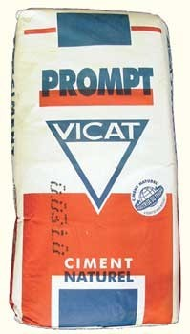Natural cement is not quite as strong or consistent as portland cement but it used for various historical conservation projects.

The main difference in use is that the initial set is **much** faster. At room temperature, it will be hard in about 5 minutes.

In fact the cement is usually bought along with a retardant to keep the mortar workable for longer. The retardant is in fact citric acid. This opens up the possibility of some interesting project work looking at setting time against acid concentration or different acids.

Natural cement is not widely available but it can be obtained from Masons Mortars. They have branches in Edinburgh and Glasgow but do have an online shop as well for those of you further afield

The activities involving natural cement, such as looking at strength of concrete admixtures etc, can be done perfectly well with ordinary cement but it takes longer to set.

Properties of Ceramics

**Carbonation**

It is well known that making cement produces CO2. 60% of this CO2 roughly, comes from the heating of the calcium carbonate, a process called calcination.

CaCO3  🡪 CaO + CO2

What is less well known is that, during its lifespan, the cement (or concrete) reabsorbs most if not all of this CO2. This process is called carbonation.

The concrete will carbonate if CO2 from air or from water enters the concrete and reacts as follows:

  Ca(OH)2 + CO2 🡪 CaCO3 + H2O

When Ca(OH)2 is removed from the paste hydrated cement will liberate CaO which will also carbonate. The rate of carbonation depends on porosity & moisture content of the concrete.

The carbonation process requires the presence of water because CO2 dissolves in water forming H2CO3. If the concrete is too dry, CO2 cannot dissolve and no carbonation occurs. If on the other hand it is too wet, CO2 cannot enter the concrete and the concrete will not carbonate. (about 50% humidity is optimal).

Normal carbonation results in a decrease of the porosity making the carbonated paste stronger. Carbonation is therefore an advantage in non-reinforced concrete. However, it is a disadvantage in reinforced concrete, as pH of carbonated concrete drops to about 7; a value below the level at which steel will rust.

**How do you recognize carbonation?**

Carbonation may be recognized in the field by the presence of a discoloured zone in the surface of the concrete. The colour may vary from light gray and difficult to recognize to strong orange and easy to recognize.

Cement paste contains 25-50 wt% calcium hydroxide (Ca(OH)2), which mean that the pH of the fresh cement paste is at least 12.5. The pH of a fully carbonated paste is about 7.

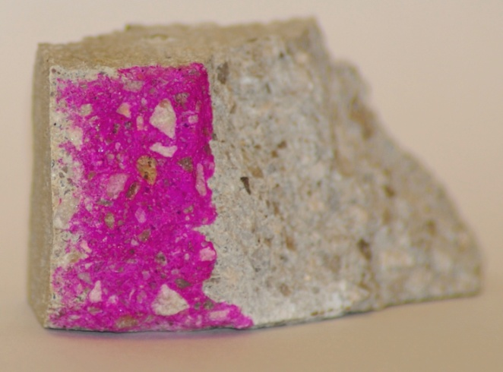Because the carbonation process results in a drop in pH, it can be made easier to see by using a suitable acid/base indicator such as penolphthalein.

The photo on the right shows a thin clear layer that has not been stained by the phenolphthalein.

The depth of this layer will increase over time but there are so many variables (temperature, humidity, the precise structure of the cement etc) that it is not possible to accurately age a piece of concrete by measuring the depth of the carbonation.

## Porosity

We tend to think of ceramics as being pretty watertight but they are often surprisingly porous.

Most of the materials we normally think of as ceramic will absorb water quite readily, that is one of the purposes of the glazes that are put onto porcelain.

Bricks too are not naturally water resistant and need treating in order to improve this.

Concrete will also absorb water and, as was mentioned earlier, this helps with the strengthening process.

Glass, by and large, is much more water resistant than most other ceramic, although even that can dissolve very slightly.

## Chemical Resistance

Most ceramics tend to have quite a good resistance to chemical attack. Concrete, however, is vulnerable to acids, as the curing process involves the formation of calcium carbonate.

Glazed porcelain is very resistant – which is why it is commonly used in laboratories for sinks (and crucibles).

Glass, too, has very good chemical resistance, apart from with Hydrofluoric acid.

New Ceramics

New types of ceramics are constantly being developed and new uses found for older ones.

Some examples

Ceramic knives. These are now available as kitchen knives and their advantages are based on the extreme hardness (and strength) of this particular ceramic. This allows for the creation of an extremely sharp blade that will not need sharpening. (The inspiration, I believe, came from research into stone-age tools. Flint (which could possibly be considered as a naturally occurring ceramic) is capable of creating remarkably sharp edges; sharper than a scalpel blade. The new ceramics retain that while having improved strength.

Ceramic discs are often used in car brakes as they are resistant to abrasion at high temperatures.

Work is ongoing into the development of ceramic turbine blades for jet engines and they are more resistant to deformation under the extreme stresses found in that environment.

Ceramics can be magnetic – most of the magnets in schools (and indeed elsewhere) now are ferrite ceramics.

Ceramics are showing great promise as relatively high temperature superconductors, while other ceramics are in common use as electrical insulators!

And there are many, many more.