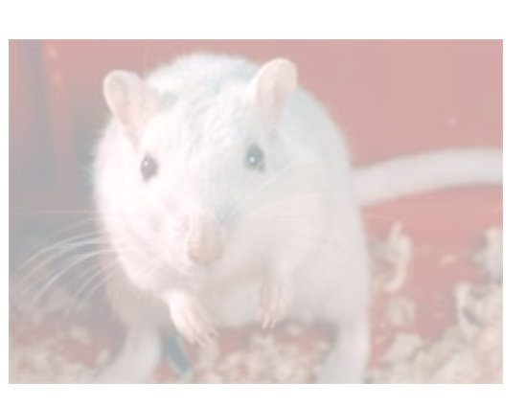

Discussion Activity - 1

# Reasons For

# Testing On Animals



# Reasons Against

# Testing On Animals

Antibiotics, HIV drugs, insulin and cancer treatments rely on animal tests. Other testing methods aren't advanced enough

Scientists claim they can allow for differences between lab animals and humans in their tests

Operations on animals helped to develop organ transplant and open-heart surgery techniques

Animal testing has helped to develop vaccines against diseases like rabies, polio, measles, mumps, rubella and TB

Animals are still used to test items like cleaning products, which benefit mankind less than medicines or surgery

The stress that animals endure in labs can affect experiments, making the results meaningless

Animal experiments can be misleading. An animal's response to a drug can be different to a human's

Successful alternatives include test tube studies on human tissue cultures, statistics and computer models

Human life is more valuable than animal life

The Law protects all lab animals from cruelty or mistreatment

Millions of animals are killed for food every year - if anything, medical research is a more worthy death

When locked up animals suffer tremendous stress. Can we know they don't feel pain?

Few animals feel any pain as they are killed before they have the chance to suffer

Animals have as much right to life as human beings

Deaths through research are absolutely unnecessary and are no different from murder

Strict controls have not prevented researchers from abusing animals - although such instances are rare

Discussion Activity - 2



# Reasons For

# Testing On Animals



# Reasons Against

# Testing On Animals

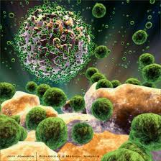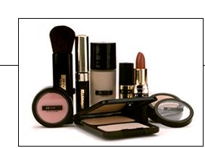

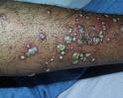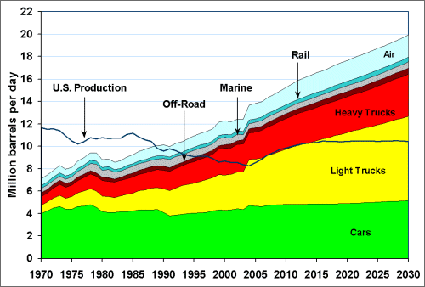

**a hospital handwash (against MRSA)**

www.nwcleangear.com

**a chemical to reduce petroleum**

**usage**

www1.eere.energy.gov

a household

cleaner

www.itsyourlife.uk.com

a facial cosmetic

www.judirivers.com

a product that kills the AIDS virus

www.nanomed.hbi.ir



a product that kills the AIDS virus

www.nanomed.hbi.ir

**a hospital handwash (against MRSA)**

www.nwcleangear.com

**a chemical to reduce petroleum**

**usage**

www1.eere.energy.gov

a household

cleaner

www.itsyourlife.uk.com

a facial cosmetic

www.judirivers.com



a product that kills the AIDS virus

www.nanomed.hbi.ir

a hospital handwash (against MRSA)

www.nwcleangear.com

**a chemical to reduce petroleum**

**usage**

www1.eere.energy.gov

a household

cleaner

www.itsyourlife.uk.com

a facial cosmetic

www.judirivers.com

a facial cosmetic

www.judirivers.com

a product that kills the AIDS virus

www.nanomed.hbi.ir

**a hospital handwash (against MRSA)**

www.nwcleangear.com

**a chemical to reduce petroleum**

**usage**

www1.eere.energy.gov

a household

cleaner

www.itsyourlife.uk.com

a product that kills the AIDS virus

www.nanomed.hbi.ir

**a hospital handwash (against MRSA)**

www.nwcleangear.com

**a chemical to reduce petroleum**

**usage**

www1.eere.energy.gov

a household

cleaner

www.itsyourlife.uk.com

a facial cosmetic

www.judirivers.com



a product that kills the AIDS virus

www.nanomed.hbi.ir

a facial cosmetic

www.judirivers.com





a household

cleaner

www.itsyourlife.uk.com



**a chemical to reduce petroleum**

**usage**

www1.eere.energy.gov



**a hospital handwash (against MRSA)**

www.nwcleangear.com

Animal experimentation - the facts

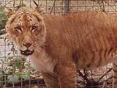**Animal experiments in the UK**

A liger - half lion, half tiger - has been experimentally bred

UK law both requires and regulates experiments on animals.

Any new drug must be tested on at least two different species of live mammal, one of which must be a large non-rodent.

The way scientists can use animals has been controlled by legislation since 1822, and the law has grown much stricter since then. The Animals Act of 1986, for example, insists that no animal experiments be conducted if there is a realistic alternative.

Testing on animals now requires three Home Office licences - for the institution, the scientist and the project.

*Under the 1986 Act, project licences are only granted for specified permissible purposes:*

* *where there are no non-animal alternatives*
* *when the benefits expected from the programmes of work are judged to outweigh the likely adverse effects on the animals concerned*
* *the number of animals used and their suffering must also be minimised*

*(Home office website -* [*http://www.homeoffice.gov.uk/science-research/animal-research/*](http://www.homeoffice.gov.uk/science-research/animal-research/)*)*

Random inspections and on-site vets are mandatory.

The number of experiments has been broadly static for a number of years and is about half the figure in the 1970s.

**Basic facts**

* The total number of animal testing procedures increased in 2011 by 2% on 2010 to just over 3.79 million in the 12 months of 2002[1]
* About 80% are for research and drug development
* Safety testing accounts for most of the rest

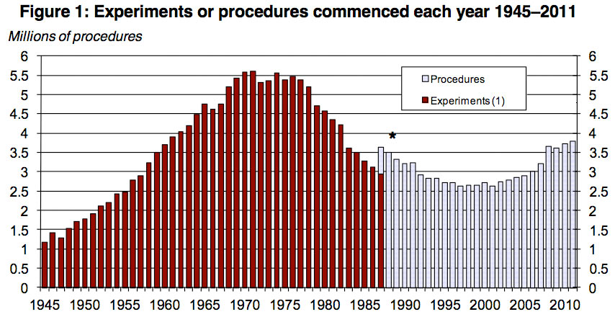

The data released today also shows that genetic tests, mostly on mice, seem to be a large factor in this change.[2]

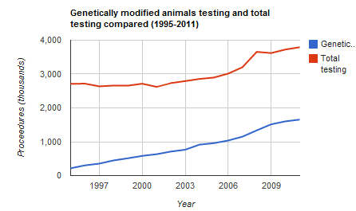

NB: These figures are not complete and take no account of 'wasted' animals - animals bred for their tissues and then discarded or animals rejected because their genetic modifications did not work.

If these were included in the annual statistics, the figures for animal use would be considerably higher.

**Which animals are used?**

|  |  |
| --- | --- |
| Rodents | 78.27% |
| Reptiles/amphibians | 0.43% |
| rabbits | 0.41% |
| dogs/cats | 0.17% |
| primates | 0.07% |
| birds | 4.29% |
| fish | 14.87% |

* Great apes such as chimpanzees cannot be used in experiments

**Future trends**

Experts believe the figures have now probably bottomed out.

They suggest that new classes of drugs now in development that act in very specific ways in the body may lead to more animals being used in future years, and to the use of more primates.

For example, as science seeks to tackle the neurological diseases afflicting a 'greying population', it is said we will need a steady supply of monkeys on which to test the safety and effectiveness of the next-generation pills.

Experts say the extremely specific way these novel pharma products will work means primates - because their brain architecture is very similar to our own - will be the only animals suitable for experimentation.

It's also possible that new EU proposals on the health and safety aspects of chemicals may also substantially push up the numbers of animals needed for testing.

**Genetically modified animals**

The numbers of genetically modified animals used in UK labs continues to rise.

**Objections to these figures**

Animal rights campaigners have criticised these official figures, claiming that they give little information as to how much the animals concerned suffer.

**More information**

A great set of Home Office data from 2011 is available on the Guardian Datablog here

<http://www.guardian.co.uk/news/datablog/2012/jul/10/animal-testing-risk-suffering>

1. Home office figures from the Guardian website <http://www.guardian.co.uk/news/datablog/2012/jul/10/animal-testing-risk-suffering>
2. Home office figures from the Guardian website <http://www.guardian.co.uk/news/datablog/2012/jul/10/animal-testing-risk-suffering>