The Problem with Lactose.... Teacher / Technical Guide
In this activity, students immobilise the lactase in calcium alginate beads held within a small column, over which the milk is passed. Glucose may be detected in the whey leaving the column after a few minutes using the glucose test strips.

Novo Nordisk Lactozym®, (available from the NCBE) £14.00 for 100cm³

Materials per pupil or group
Lactase enzyme 2 cm³
2% sodium alginate solution, 8 cm³
1.5% calcium chloride solution, 100 cm³
Milk, 100 cm³ (not UHT)
Semi-quantitative diabetic glucose test strips (e.g. Boehringer Mannheim Diabur-Test®5000 or Ames Diastix)
Small beakers (e.g. 100 cm³) or disposable plastic cups, 2
Tea strainer
Dropping pipette
Stirring rod
Stop watch

For the ‘treatment column’ (see Fig 1)
Small piece (about 1 cm²) of nylon gauze e.g. net curtain
10 cm³ plastic syringe (without a needle)
4 mm diameter aquarium airline tubing to fit syringe, about 10 cm in length
Retort stand, boss and clamp (to support enzyme column)
Small beakers (e.g. 100 cm³) or disposable plastic cups, 2
Tea strainer
Dropping pipette
Stirring rod
Stop watch

Practical details
- All solutions must be made up using distilled or deionised water (calcium ions in tap water will cause the sodium alginate to ‘set’).
- Sodium alginate is not readily soluble and requires constant stirring. Sodium alginate takes several hours of stirring with a magnetic stirrer to dissolve but be patient it will dissolve. If possible leave stirring overnight. If this is not an option then set the stirrer going first thing in the morning and leave for most of the day
Figure 1 shows how to set up the immobilised enzyme column using a syringe barrel. It is important to use a small piece of nylon gauze inside the barrel, as the beads are just the right size to block the syringe outlet.

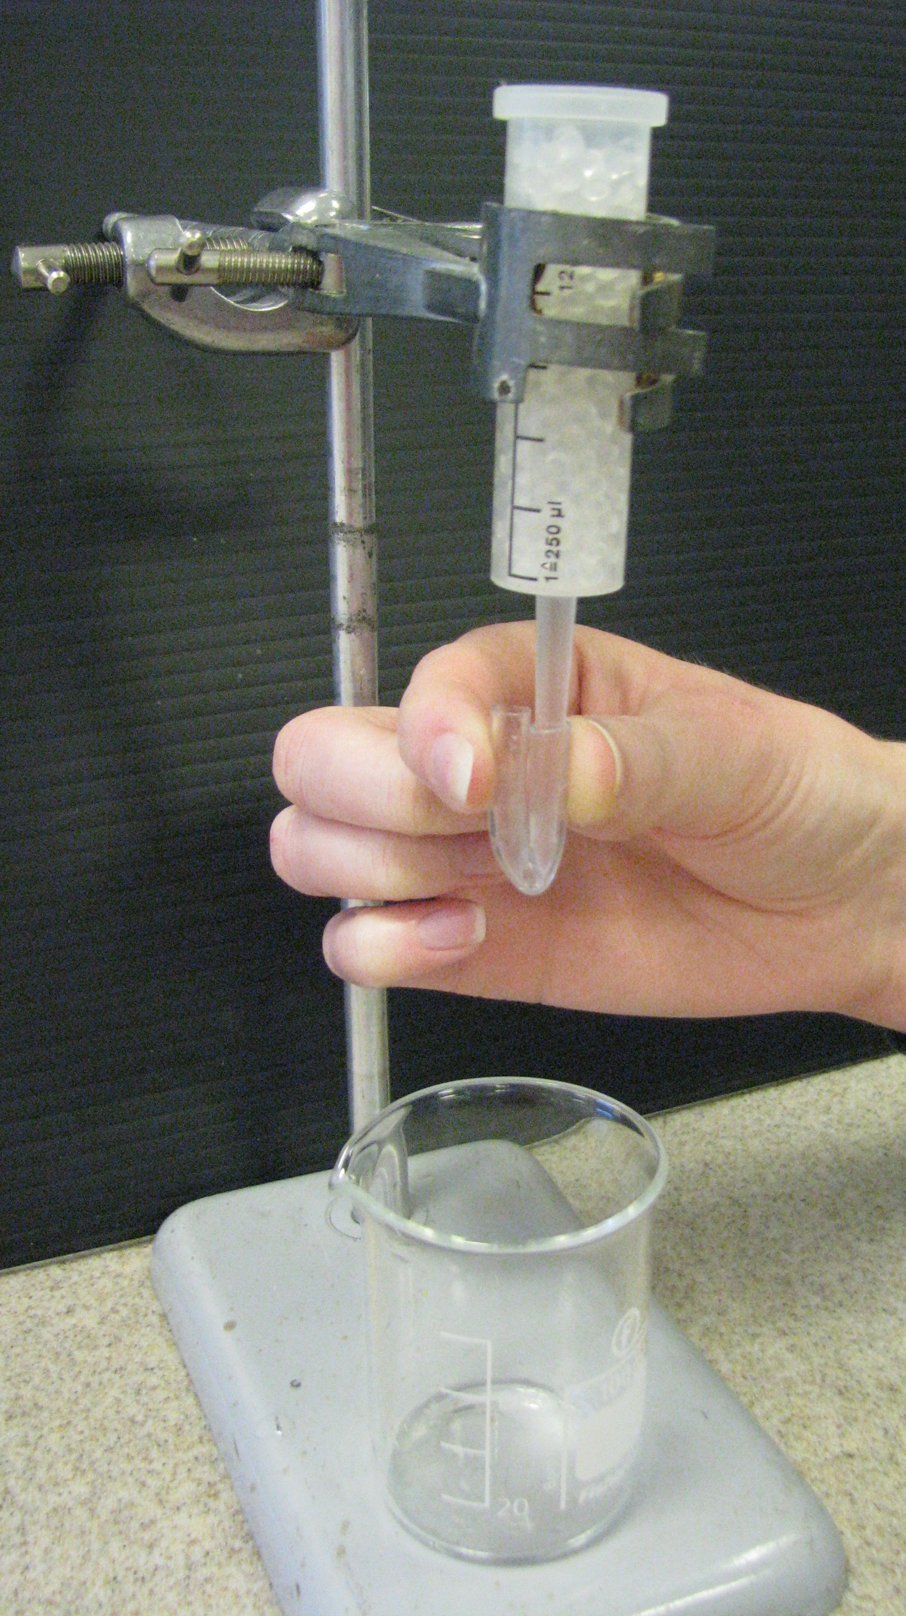
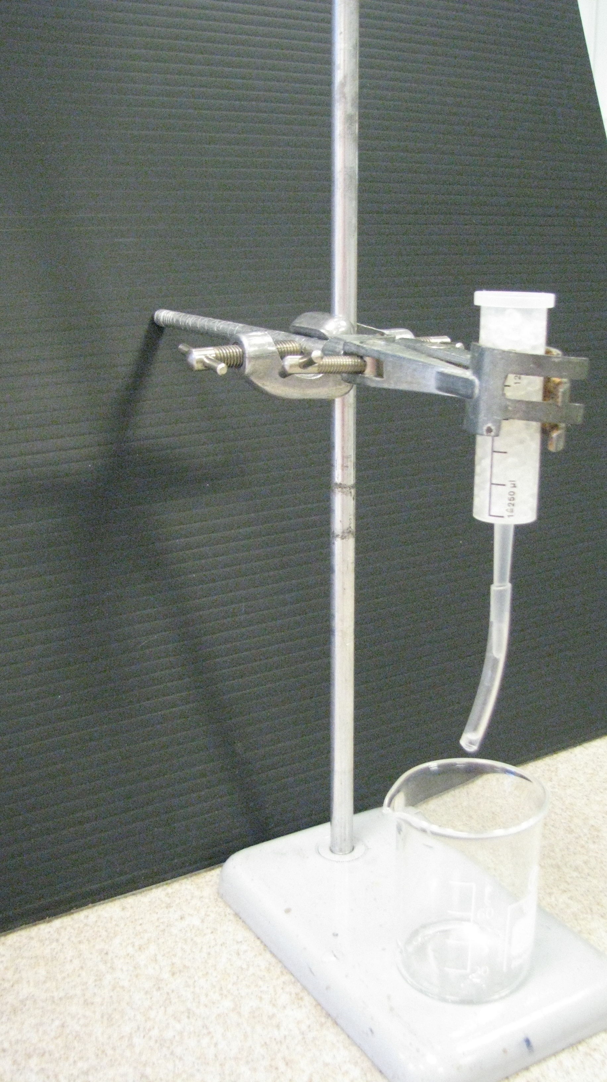

Fig1 Fig2

Figure 2 shows how the plastic tubing can be folded back to stop the flow of milk from the column.
Safety
Lactase is a relatively safe enzyme (it is produced naturally by babies to digest their mother’s milk). However, unnecessary contact with the enzyme or inhalation of dust from dried-up enzyme spills should be avoided. In case of spillage or contact with the eyes, rinse by flushing with water.
Further activities
The immobilised enzyme column may also be used to treat whey, producing a sweet whey syrup, which is widely used in confectionery (it is usually described on labels as ‘hydrolysed whey syrup’ or just ‘whey syrup’).
Lactase (or b-galactosidase) is strongly inhibited by galactose (one of the prodcts of its action on lactose). Hence the flow rate of the substrate over the column is critical to the rate of the enzyme-catalysed reaction: too fast and there isn’t time for the reaction to occur; too slow a rate and galactose will accumulate and then inhibit the reaction. Students can therefore investigate the effect of flow rate on the conversion of lactose to glucose and galactose.

