Technology: Risk Assessment Title: Polishing and Buffing Machines NOVEMBER2015
This is a generic Risk Assessment that must be modified to suit your place of work. The Risk Assessment modifications should take into consideration the activity, age/stage/pupil ability, department/working environment and the experience of the teacher in charge. If Control Measures Required as described are implemented the risk is reduced to an acceptable level for mainstream students.
Identify the Hazards | Who is at Risk? | What is the Harm? | Activity Taking Place | Control Measures Required | Additional Information
Employees should be made aware of the following hazards.  1. Entanglement of Hair  or Clothing  2. Ejected Work Pieces  3. Hot Work Pieces  4. Electric Shock  5. Sharp Edges  6. Inadvertent Starting  7. Inhalation of Dust  8. Operator Pushed  9. Falling on Slippery Floor  10. Unauthorised Use | Technology teachers, technicians and students  Technology teachers, technicians and students  Technology teachers, technicians and students  Technology teachers, technicians and students  Technology teachers, technicians and students  Technology teachers, technicians and students  Technology teachers, technicians and students  Technology teachers, technicians and students  Technology teachers, technicians and students  User | Long hair, loose clothing etc. can become entangled with the spindle, mop or brush.  Work pieces, wires from brushes and particles from the polishing process can be ejected from the machine.  Hot work pieces can cause burns.  Polishing machines can present a hazard of electric shock.  Sharp edges can cause cuts.  Inadvertent starting of the machine can present a hazard.  Dust can accumulate and can be inhaled.  Lack of space around the machine can lead to the operator being pushed by passers-by.  Slippery floor surfaces or loose items around the machine can cause slips that result in contact with moving parts.  Unauthorised use. | Polishing or Buffing  Polishing or Buffing  Polishing or Buffing  Polishing or Buffing  Polishing or Buffing  Polishing or Buffing  Polishing or Buffing  Polishing or Buffing  Polishing or Buffing  Polishing or Buffing | The school should decide which machinery is suitable for use by each group of learners. The decision should be based on student maturity and competence, the level of supervision, and local authority/employer and national guidelines.  Long hair and loose clothing should be secured so as to not come into contact with moving parts. Jewellery should also be removed. Gloves should not be worn when using this machine.  PPE including suitable eye protectors conforming to BS EN 166:2002 1F (low energy impact) should be used when operating the machine.  Wire brushes and mops should be suitable for the work and should be mounted so as to not come loose whilst in motion.  Short bursts of contact with the polishing or buffing surface should be used to reduce the risk of high temperatures. Models may be cooled prior to finger feeling for levels of smoothness.  The machine should be included in a planned maintenance programme that should include electrical safety inspections and tests.  Smaller items such as bracelets, bangles, chains and other items with linked parts should be polished by hand due to their small size and awkward holding.  The machine should be provided with a means of electrical isolation using a fused isolating switch on or adjacent to the machine, and that it is controlled by a starter incorporating overload protection and no-volt release. A conveniently positioned and accessible, emergency stop switch (which could be the normal “off” switch) or other suitable control device that can be quickly stop the machine in an emergency. Fixed guards (removable only with the use of tool), or alternatively interlocked guards that enclose the drive mechanisms should be used. A suitable guard to protect the brush or mops should be present. The only gap in the guarding should be at the front to allow access for the work piece. The guard should be able to prevent entanglement with the spindle ends and threaded mandrel.  Normal room ventilation may be sufficient for dust from grinding machines but depending on the materials and scale of use, additional LEV might be required as determined by the department.  There should be sufficient clear space around the machine to prevent the operator being accidently pushed by passers-by.  The floor surface should not be slippery and should be kept free of loose items.  The machine should not be left unattended and powered. An interlocking system is best practice. | Reference BS 4163:2014  Manufacturer’s instruction guide should be followed and kept within the department for future reference.  The risk of electric shock is reduced by good maintenance and the use of double insulated machines.  Where possible hand tools should be used to smooth sharp edges of smaller model objects.  The machine should not be left powered on whilst not in use.  If additional LEV is not available when required then a dust mask conforming to BS EN 149:2001+A1:2009 class FFP3 should be used.

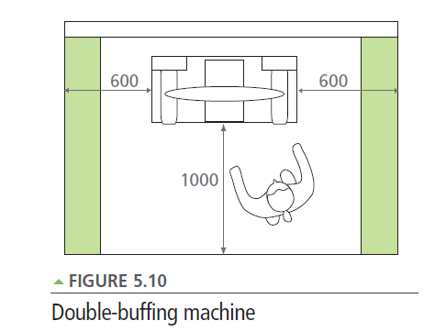

The green area is an overlap of space allocated to machines only (250mm unless otherwise stated.)

from Design and Technology Accommodation in Secondary Schools – A Design Guide (DfES 2004)

